HEALTH APP

Author: | Bianca CIOBANU
- Theme Requirements:
Nowadays, more and more people ignore their lifestyle. Creating a healthy lifestyle doesn't have to mean drastic changes. Making gradual small changes to your diet and activity habit can have a big impact. Taking more steps each day,﻿ adding fruit to your cereal, having an extra glass of water, or saying no to that second helping of buttery mashed potatoes.
Taking into account the problem of raising awareness about people’s body condition, the application shows 4 cases regarding different BMI (Body Mass Index) values.

- Chosen Solutions:
In order to solve the previous problem presented, there will used the following functions: „printf”, „scanf”, „exit”, so that the data wanted would be read and displayed. First of all, we will declare variables, memory locations, also the data and messages needed to be shown.
The stages of the program are presented in the following diagram:
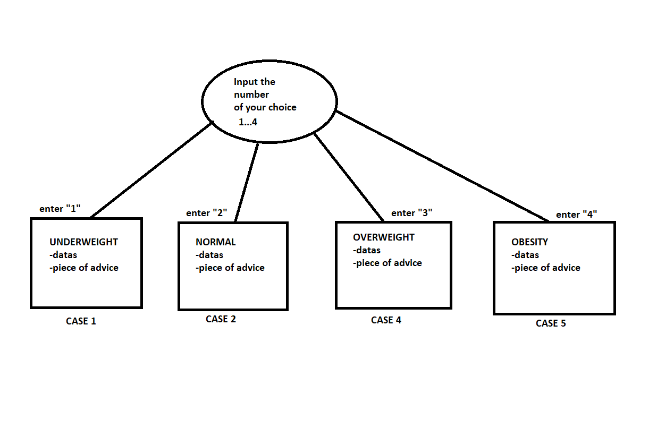
The program is divided into 2 main parts: the requested user input and the displaying part of each case approached.

- Obtained Results:
The application consists of 4 procedures, each one being called depending on the input chosen.
The window displayed after we build and run the program:

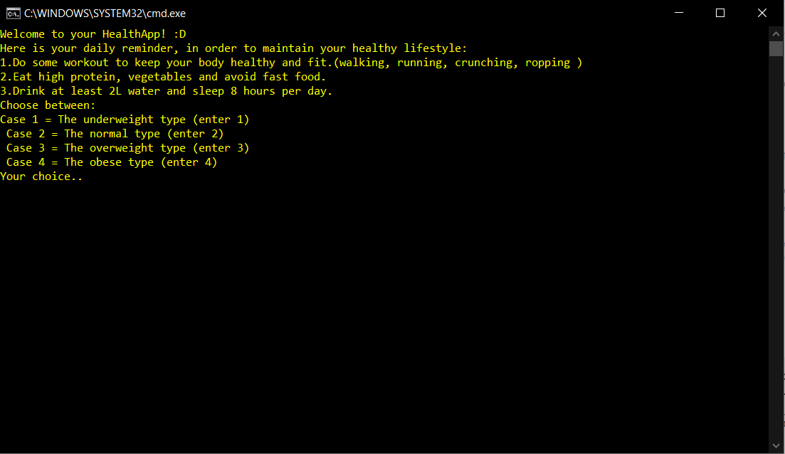
The displayed message when we enter “1”:
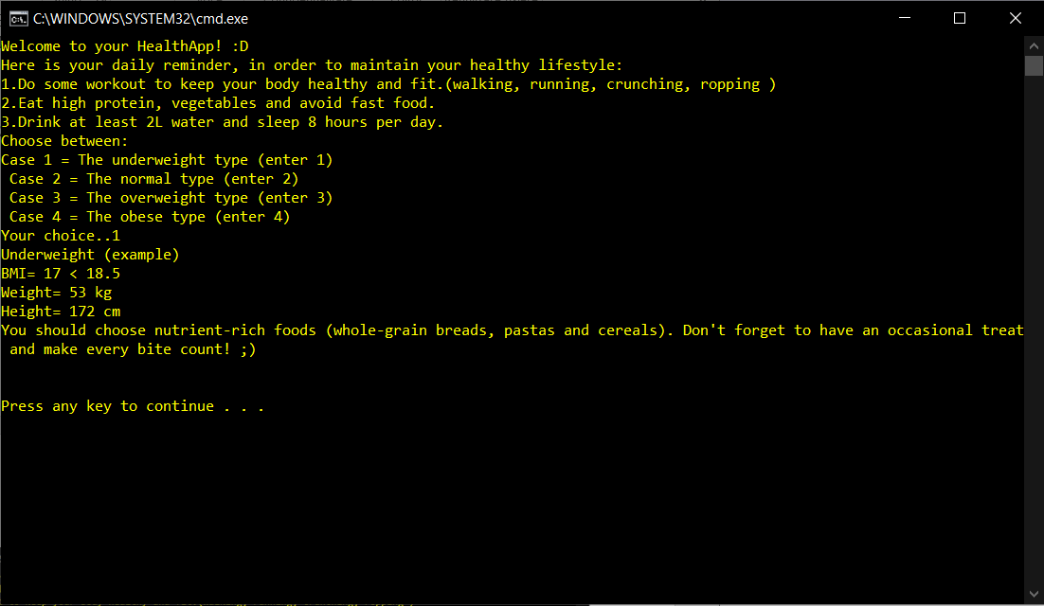

The displayed message when we enter “2”:
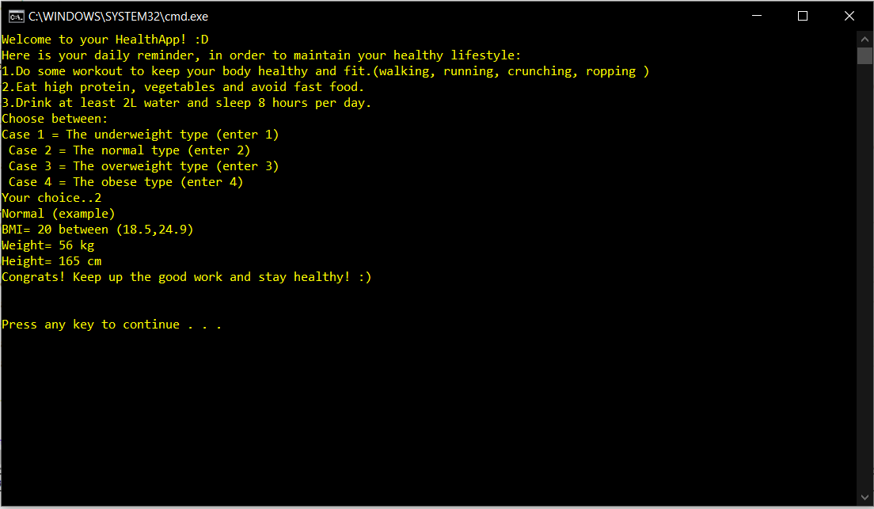
The displayed message when we enter “3”:
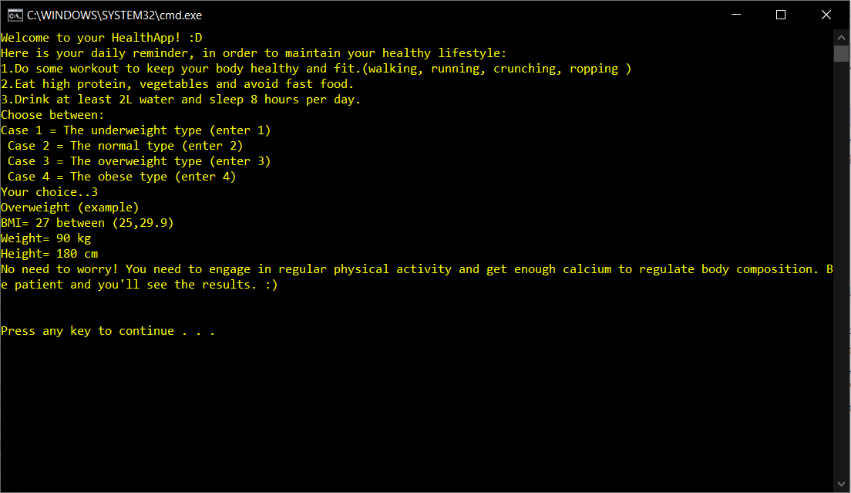

The displayed message when we enter “4”:

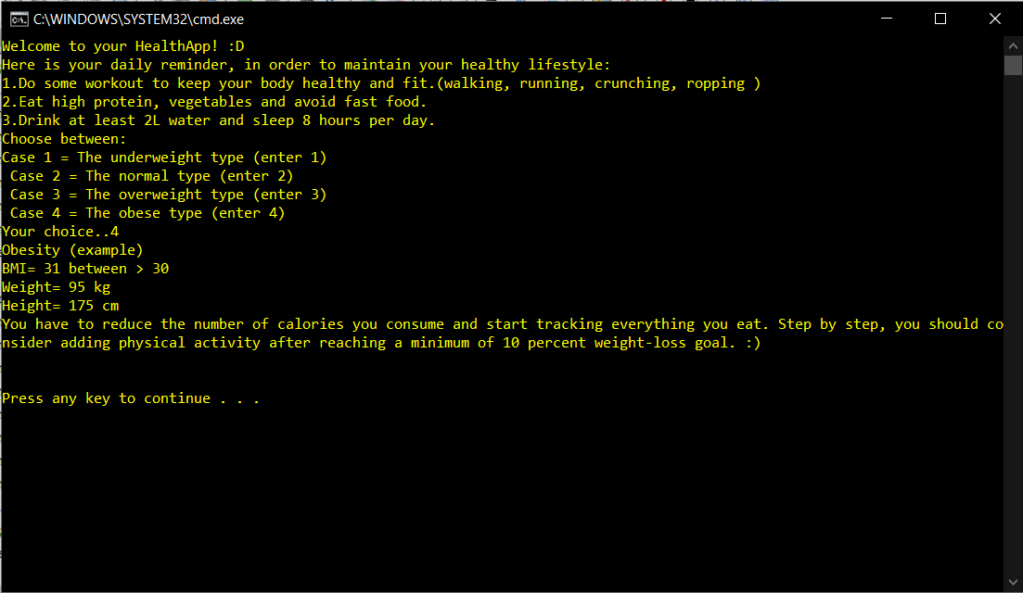

The displayed message when we enter a number different from {1 , 2 , 3 , 4}
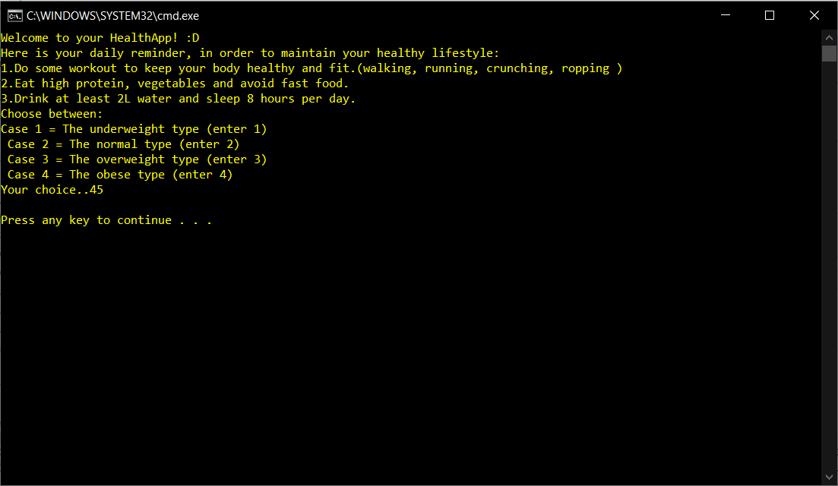

- Tests and verification:

The application requests a number between 1-4 to be inserted by user. Then, it will be displayed a message in accordance with the number assignated with each case proposed.
If the user presses “1”, ”2”, “3”, “4” and “Enter”, it will be displayed the data according with each case and a specific message alongside.

Date:

21.05.2021

