Jobs Management Application

Use-Case Model

Version 1.0

Revision History

|  |  |  |  |
| --- | --- | --- | --- |
| **Date** | **Version** | **Description** | **Author** |
| 15.03.2018 | 1.0 | First version | Galeata Bianca-Floriana |
|  |  |  |  |
|  |  |  |  |
|  |  |  |  |

Table of Contents

1. Use-Cases Identification 4

2. UML Use-Case Diagrams 5

# Use-Cases Identification

**Use case:** Searching for a job

**Level:** sub-function

**Primary actor:** Unemployed

**Main success scenario:**

The first step is to access the application. The opened page will show the searching page where the actor can select filters. Suppose that the actor chooses to search by city and domain. He selects from the fields which refer to those criteria, the city and the domain, respectively. Let’s say that the City is Cluj and the domain is IT. To see the jobs that correspond with his request, the actor has to click on the button name “Find”. One the button is clicked he will be redirected on a new page where he can see the jobs he was looking for.

**Extensions:**

Another scenario may start the same, but after clicking on the button the new page will not show any jobs. This is happening because there are no jobs which match with the criteria.

**Use case:** Applying for a job

**Level:** user-goal level

**Primary actor:** Unemployed

**Main success scenario:**

Let’s suppose that the actor has found a job that is suitable for him and wants to apply. The scenario starts with a page with jobs and the actor decide to apply for one. The first step is to identify the button “Apply” corresponding with the desired job. Once the button is clicked a new window is opened where the actor has to put his CV. Let’s say that the actor puts his CV and not another document. After the CV is loaded, the actor has to push the button “Send”.

**Extensions:**

Another scenario may be when the actor mistakenly loads something else and not his CV. Before to send it, he can change the document loaded, clicking on the button “Apply” again.

**Use case:** Add a job

**Level:** user-goal level

**Primary actor:** company’s representative

**Main success scenario:**

Suppose that the actor has an account. Beside accessing the application, the actor has to log in. This can happen if from the opened page the actor clicks on the button “Log in”. In this moment he will be redirected on the login page. Here the actor has to introduce the name and password. Suppose that those are correct. After clicking on the new button named “Log in” he is redirected on his personal page. There he can manage the company jobs. To add one, he has to click on the button “Add job”. A window will open where the actor has to write the date about the job. Suppose that the data are correct. After finish to introduce the data, the actor has to push the button “Add”. The job will be now visible in his list of jobs and on searching.

**Extensions:**

The first derivation of the initial scenario would be if the name or password are wrong. If the button “Log in” is click an error message will appear, which will say “The name or password is wrong”. He will log with success if will write the correct name and password.

# UML Use-Case Diagrams

2.1. Agent

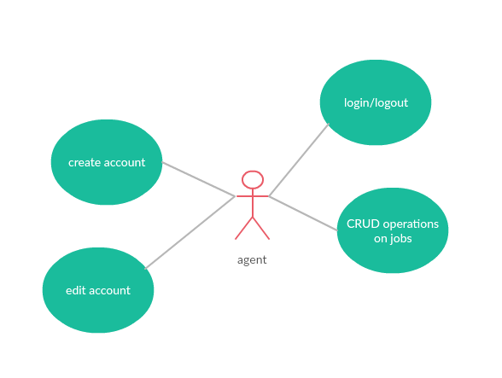

In this diagram is illustrated what an agent can do:

* Create an account
* Edit account
* Login/Logout
* CRUD operations on company jobs (add, remove, modify)

**2.2 Unemployed**

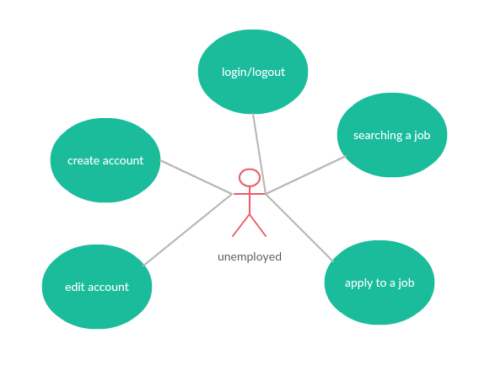

In this diagram is illustrated what an unemployed person can do:

* Create account
* Edit account
* Login/Logout
* Searching a job
* Apply to a job