AI Programming
Introduction
{Title}
AI Programming - Introduction to Artificial Intelligence
{Description}
In this course, learners will be able to learn about artificial intelligence, what they are, how they can be used and classifications in order to better understand this evolving space.
{Objectives}
Objectives for this introduction include:
- Understand how AI algorithms can learn and adapt based on new information
- Find out how AI algorithms can be integrated into systems
- Discover how AI can help us in our work and life

{Contents}
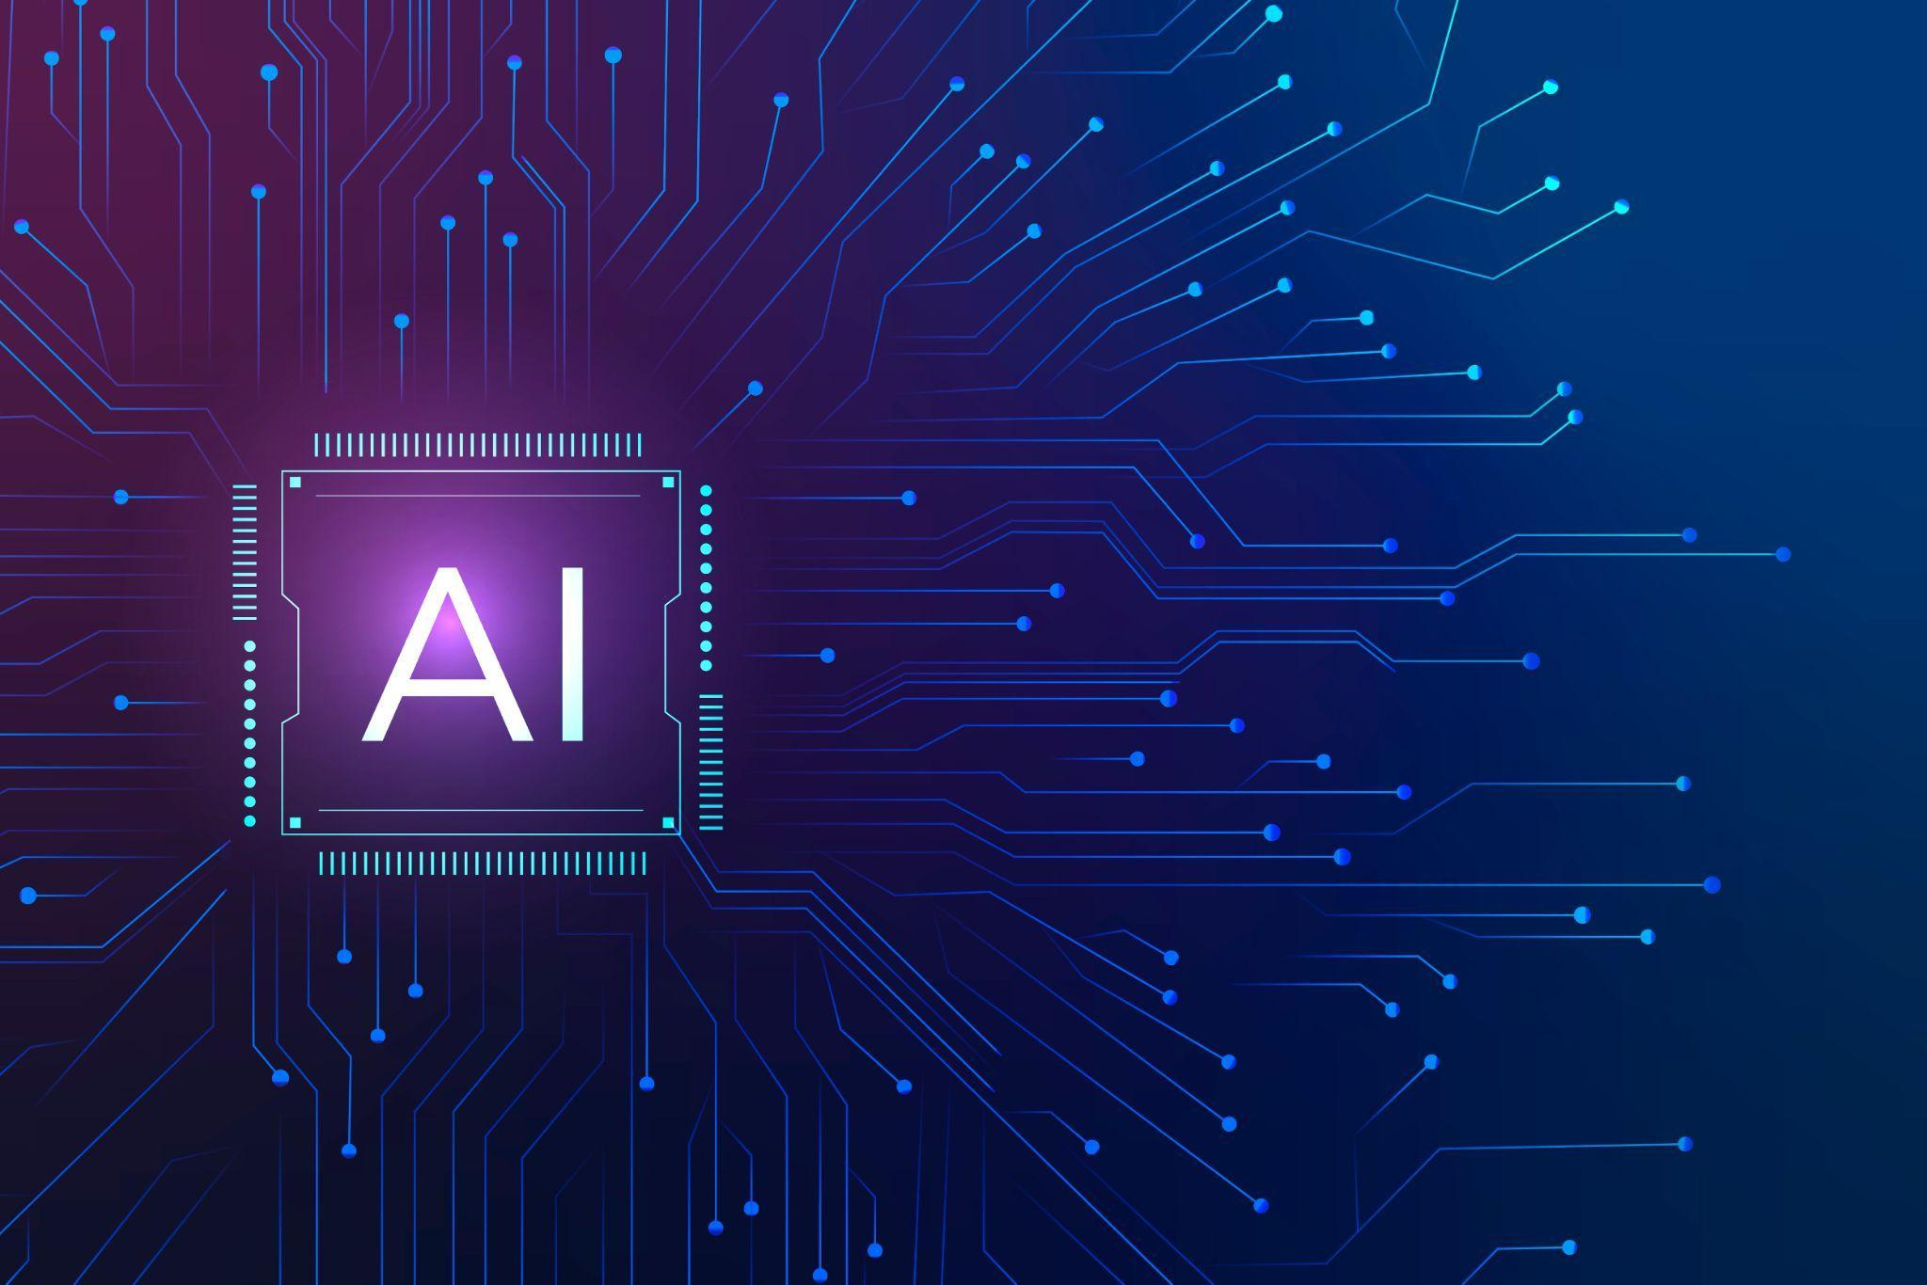
Figure 1:
<a href="https://www.freepik.com/free-photo/ai-technology-microchip-background-digital-transformation-concept_17122527.htm#query=artificial%20intelligence&position=4&from_view=search&track=ais">Image by rawpixel.com</a> on Freepik
The ability of machines to carry out tasks that typically require human intelligence is known as artificial intelligence (AI). Artificial intelligence (AI) systems are capable of reasoning, learning new knowledge, and making judgments. Machine translation, natural language processing, and image identification are just a few of the many uses for AI.
Here are a few instances of modern AI in action:
- Computer vision: Artificial intelligence (AI) powers facial recognition software, which recognizes faces in images and videos. Computer vision is used in the car industry, in recognition.
- Natural language processing: Chatbots, which may respond to queries and offer customer support, are powered by AI. NLP is used for chatbots that are embedded in support services by many companies.
- Recommendation engines: (AI) is utilized in recommendation engines, which can recommend content or solutions based on previously learned information. Those systems can be used in online shops or for ads.
Before building and integrating AI into systems, people in charge need to make sure that the algorithms are aligned with the human values, those systems are transparent, accountable, fair and unbiased.
Another important aspect is that those systems can be trusted. We need to test all algorithms and ensure they have great level of quality. Their quality can be measured by accuracy, precision and recall of the algorithm.
As AI becomes more embedded in our lives it is important to ensure that everyone has access to this technology. Thus investment needs to be done in education and training so that all people have the minimum skills and knowledge to use AI. Also AI needs to be developed in a responsible way, that makes those tools affordable and accessible. All of this needs to stay true as a downside of AI is that traditional jobs may disappear and new ones will be created.
The future of humanity is linked to AI, as non creative, repetitive human tasks will be replaced with AI, while it will enable us to solve challenges that seemed impossible, but also help us in day to day tasks becoming a vital part.
{Activities}
To learn more about Artificial Intelligence you can try the following:
- Design an AI assistant: Think of a domain that is close to your area of interest. Describe what actions can be automated with the help of AI.
- AI impact on job market: Think of the job market 20 years from now. What jobs can become obsolete due to AI? What jobs can be created with the help of AI?
- Take one of the streaming platforms you use for music or videos. What information do you think is used by AI for generating recommendations?

{Questions for self-assessment}
- What is the ability of machines to perform tasks that would normally require human intelligence?
- Artificial intelligence
- Data science
- Data learning
- Machine intelligence
- What is the name of the field of AI that focuses on developing algorithms to extract information from images and videos?
- Computer vision
- Natural language processing
- Video translation
- None of the answers
- What is the most important thing to keep in mind when developing and deploying AI systems?
- All the answers
- AI systems should be aligned with human values
- AI systems need to be transparent and accountable
- AI systems should be made to be fair and unbiased
- What is the most important thing that we need to do to ensure that AI is accessible to everyone?
- All the answers
- Invest in education and training to ensure that everyone has the skills and knowledge to use AI
- Promote the responsible development and use of AI
- Develop affordable and accessible AI tools and resources
- What is the future of AI?
- All the answers
- AI will be used to replace humans for manual tasks
- AI will be used to solve challenges that humans can’t
- AI will become a big part of our lives
{Questions for official-assessment}
- What is artificial intelligence (AI)?
- All the rest
- The ability of machines to mimic human behavior.
- The ability of machines to think and learn like humans.
- The ability of machines to perform tasks that would normally require human input.

- What is the name of the field of AI that focuses on developing algorithms to understand and generate natural language?
- Natural language processing (NLP)
- Speech recognition
- Computer vision
- None of the answers
- What type of AI algorithm can be used for ads?
- Recommendation engine
- Guess engine
- Ads learning
- Tracking engine

- Which of the following is NOT a potential benefit of AI?
- Making certain jobs not needed anymore
- Increasing productivity
- Creating new products and services
- Improving decision making
- Which of the following is NOT a way to measure the success of an AI system?
- Social impact
- Recall
- Accuracy
- Precision

