AI Programming
Deep Learning
{Title}
AI Programming - Deep Learning
{Description}
In this course you will understand more about Deep Learning, which is a subfield of Artificial Intelligence and what it can be used for.
AI Programming - Deep Learning is an Artificial intelligence subfield that uses artificial neural networks that have multiple layers to learn from data and provide predictions and classifications. The artificial neural networks are inspired from nature, the structure of the human brain. Models created with deep learning can perform complex tasks and learn from vast amounts of data.
{Objectives}
Objectives for this course include:
- understand what Deep Learning is
- in what industries it can be applied
{Contents}
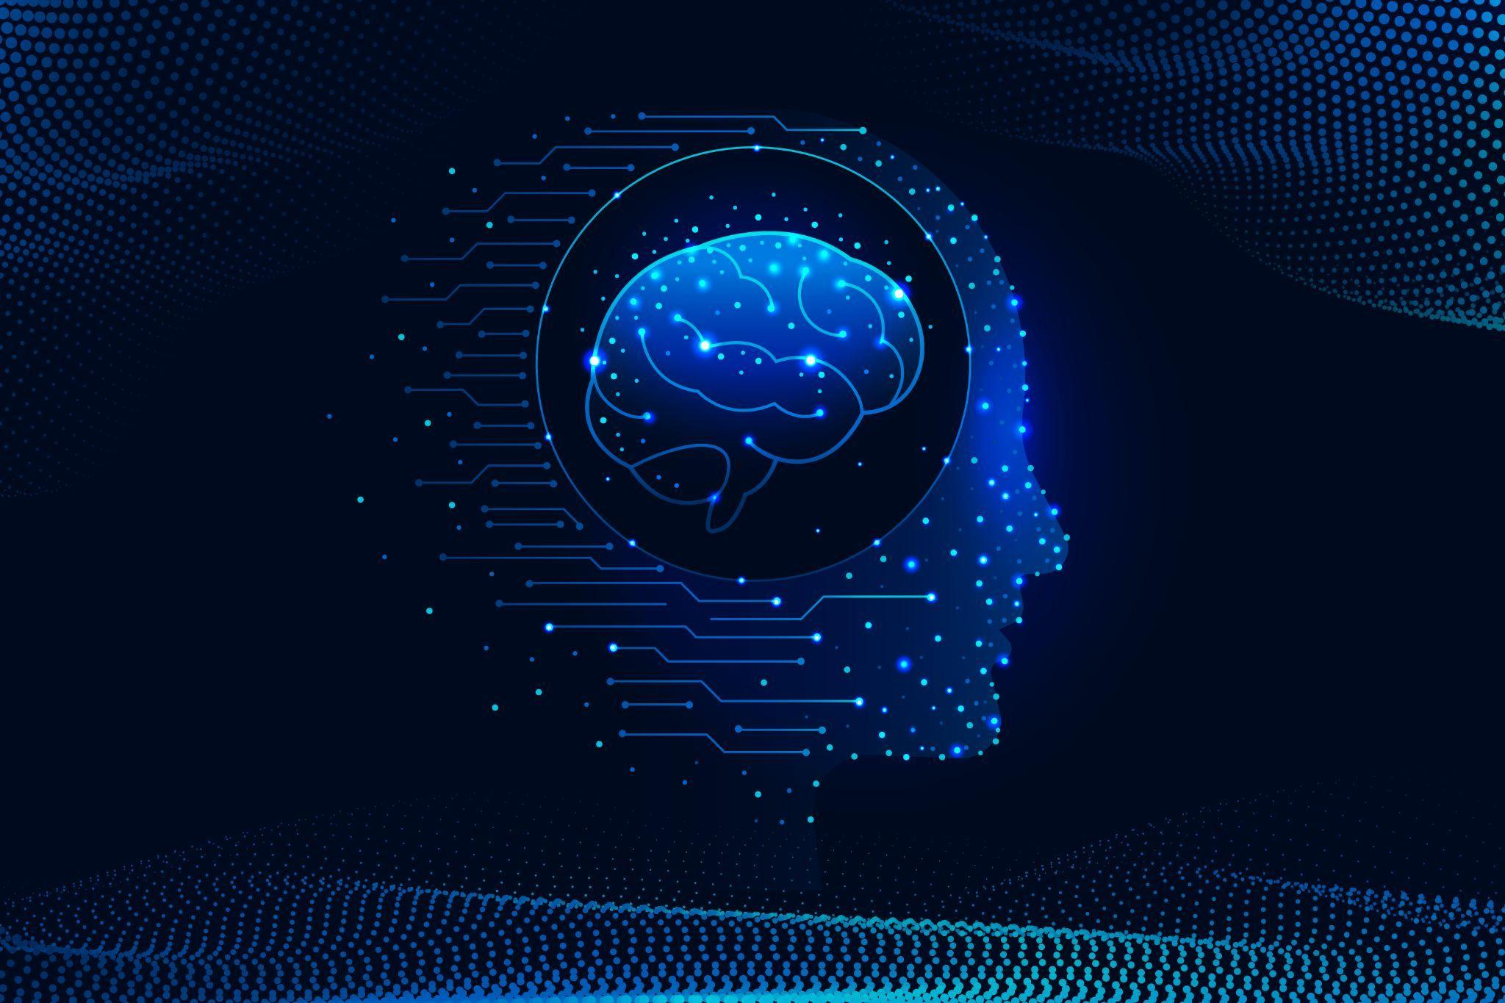
Figure 1:
Image by <a href="https://www.freepik.com/free-vector/gradient-brain-background_44416634.htm#query=deep%20learning&position=26&from_view=search&track=ais">Freepik</a>
Deep learning is a subset of machine learning that makes use of multiple-layered artificial neural networks to learn from data. Artificial neural networks can understand intricate patterns and relationships in data because they are modeled after the structure of the human brain.
Deep learning algorithms mimic the structure of the human brain. The most basic item of a deep learning model is the neuron (an artificial one). Neurons are put together in multiple layers.
There are multiple types of deep learning algorithms, each of them having plusses and minuses, and areas where they perform better. Most common ones are:
- Convolutional neural networks (CNNs): CNNs are best used for image recognition and classification tasks, as They are able to understand the spatial relationships between pixels which create an image, thus they can identify objects and features inside them.
- Recurrent neural networks (RNNs): RNNs are best used for natural language processing (NLP) tasks. Natural language processing is used to understand text written by humans. They are able to understand the relationship and meaning of words inside a text, thus they are best used for text translation, summarization and with chatbots
- Generative adversarial networks (GANs): GANs are a type of deep learning algorithm that are used to create images, text, and other data items. Those types of algorithms are used for generative AI.
- Autoencoders: Autoencoders are a type of deep learning algorithm that is used to identify patterns and insights in large amount of data
Deep learning is a tool that is becoming used more and more in multiple domains. Common use cases for deep learning include: image recognition and classification, natural language processing, speech recognition, fraud detection, anomaly detection.
Industries like medicine, financial, gaming industry, car industry use deep learning more and more in their products.
{Activities}
To discover more about deep learning you can try the following:
- Think of a domain from the ones listed above. What complex human tasks can be done with deep learning?
- Try using ChatGPT and Gemini for the same question (how to create a website). Look at the differences. Describe what differences you see.
- Try to think where deep learning and the humans partner the best for improved results.

{Questions for self-assessment}
- Which of the following is NOT a type of deep learning?
- Random Forest Logic
- Generative Adversarial Network
- Recurrent Neural Network
- Convolutional Neural Network
- Which of the following domains can benefit from deep learning?
- All the rest
- Medicine
- Financial sector
- Car industry
- Which deep learning technique is best suited for image recognition tasks?
- Convolutional Neural Network
- Autoencoder
- Recurrent Neural Network
- Generative Adversarial Network
- Which deep learning technique is best suited for language interpretation tasks?
- Recurrent Neural Network
- Generative Adversarial Network
- Convolutional Neural Network
- Autoencoder
- What does deep learning mean?
- A type of machine learning that uses artificial neural networks with multiple layers to learn from data
- A type of machine learning that is used only for hard tasks
- A type of machine learning that does not use neural networks
- A type of machine learning that uses only high volumes of data
{Questions for official-assessment}
- Which one is the basic part of an artificial neural network?
- Neuron
- Layer
- Weight
- Function

- Which one is the layer that receives data to feed the neural network?
- Input layer
- Output layer
- Hidden layer
- Outside layer
- Which of the following is a type of machine learning that uses artificial neural networks with multiple hidden layers?
- Deep learning
- Supervised learning
- Layer learning
- Reinforcement learning

- Which of the below is a challenge for deep learning?
- Explainability
- Cost
- Finding data
- Finding people who can create the programs
- Which of the following is a type of deep learning model?
- Convolutional Neural Networks
- k-Nearest Neighbors
- Support Vector Machine
- Logistic Regression

