Developing digital content
AI Programming: Ethics
{Title}
AI Programming, ethics - bias
{Description}
The space of AI programming is developing at a really fast pace. An essential component of this development are ethical considerations. These are essential to ensure products, systems and services are fair, help all the people and don’t discriminate. In this EDU you will learn about bias which is a big problem in AI.
{Objectives}

- Understand what bias in AI ethics means: Understand how bias can occur in an AI product.
- What are the different types of bias: Differentiate between data and algorithmic bias and what are the characteristics of them.
- Consequences of bias in AI: Learn about the outcomes of bias in an AI product.
- How we can address bias: Understand techniques and processes that must be put in place in order to fight bias.

{Contents}
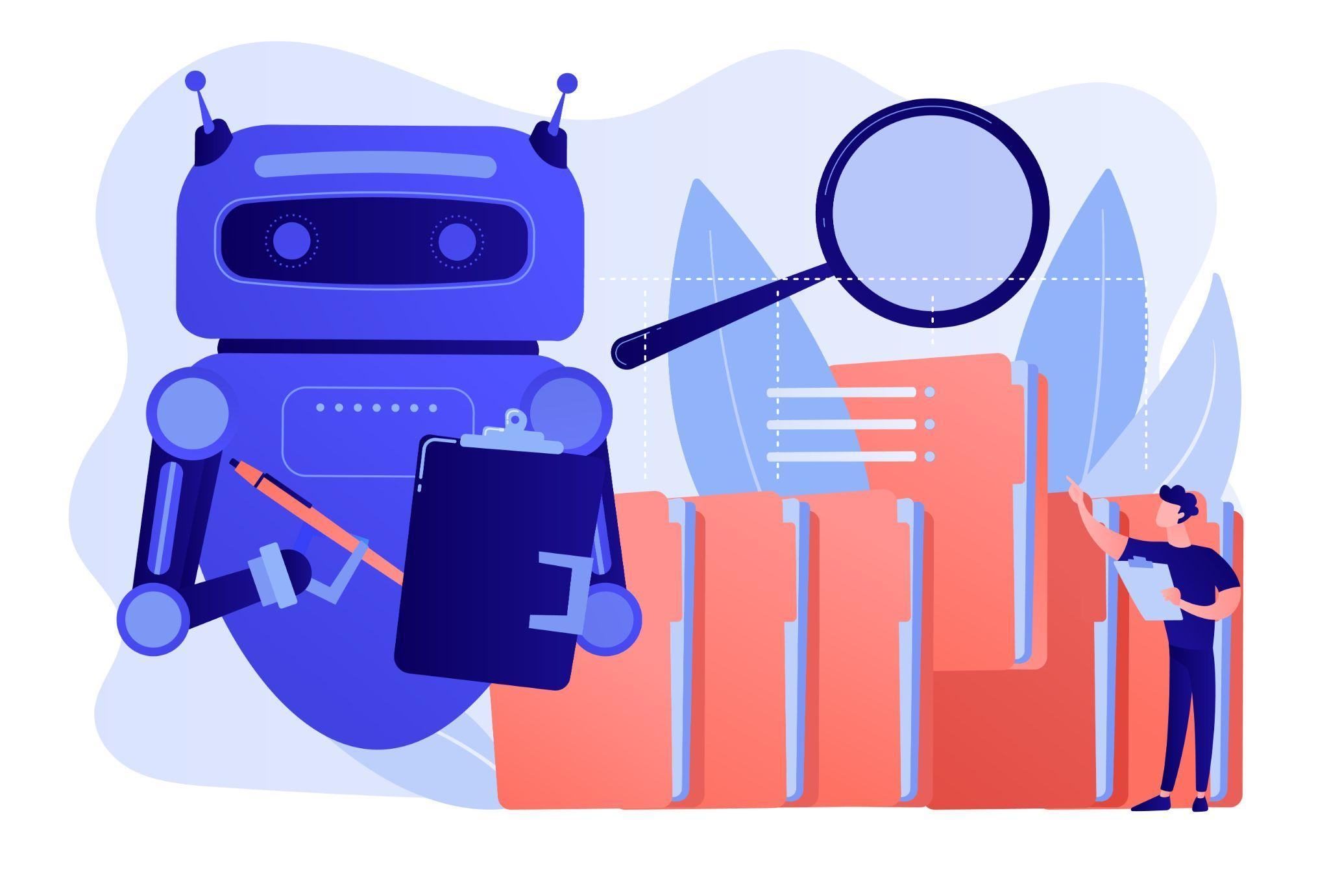
Figure 1: https://www.freepik.com/free-vector/robot-doing-repeatable-tasks-with-lot-folders-magnifier-robotic-process-automation-service-robots-profit-automated-processing-concept_11668590.htm#query=ai%20bias&position=5&from_view=search&track=ais">Image by vectorjuice on Freepik
When talking about AI ethics in programming, one of the main concerns is related to bias. As AI apps and systems are introduced to make decisions in different domains, those can have a high impact on our society. Imagine having an AI system that can be used in a bank to decide who should get a loan, or in hiring, making a decision on who should come to the interview based on a resume, or in medicine to prescribe a treatment. If those systems have bias in their decision making process, each of the above processes can become discriminatory having a negative impact on the life of people, while also putting companies and legal entities at risk.
In AI ethics we can differentiate to main type of biases:
- Algorithmic bias: This type of bias can occur when the algorithm governing the AI is biased. This behavior can occur when the solution was designed to favor a certain group of people over the others, based on their ethnicity, sex, religion etc . A few examples include:
- a recommendation system that can work better only for rich people
- a resume screening system that is more likely to accept younger people
- a self driving car that is more likely to break for tall pedestrians
- Data bias: This type of bias can occur due to the fact that the data being used to train the AI model is also biased. As AI models use a huge amount of data to train and validate the algorithms, discrepancies in the data used can lead to bias, as some of the groups may not be represented. A few examples includes:
- a dataset of medical images that are coming only from one group of persons
- a dataset of resumes which have only a few universities in them
- a dataset of criminal records skewed towards a group of people or a minority
Bias in AI programming can lead to a number of consequences.
- Discrimination: An AI product that is biased can discriminate against a certain population creating unfairness when it comes to outcomes and equality of chance.
- Unfair outcomes: As described above, due to bias in AI, discrimination and unfair outcomes can happen. From targeting certain groups, to not being able to help at all some of the users.
- Loss of trust: Bias can lead people to distrust AI systems and products, making the adoption of them into society harder. At the same time this can create disparity as the groups who don’t feel discriminated against will use those products and gain advantages.
- Legal liability: Companies and public organizations can be held liable from a legal perspective due to discrimination and lack of equality if those systems are biased.
Removing the bias completely from AI programs is something that will take time and effort from all the parties involved: programmers, companies, NGOs, public sector and the government. Some of the actions that must be taken in order to fight bias include the use of a diverse dataset, constant auditing of the system, giving users control over their data, making systems transparent.
It is important that all parties involved work together to ensure that AI is being used in a fair and ethical way.

{Activities}
To understand better how bias impacts AI you can try the following activities:
- Think of an application that creates with the help of AI videos to showcase traditional dances for a community. What types of dances would need to be included so that there is no bias?
- Think of a medical app that diagnoses skin cancer. What type of pictures would you include to ensure that the dataset is diverse and it can detect cancer for everyone?
- Describe how would you validate that an application that has a recommendation engine (e.g. ads) doesn’t have bias?

{Questions for self-assessment}
- How can we mitigate bias in AI?
- use a diverse dataset
- use more data
- use biased data
- use less data

- What possible consequences can bias in AI lead to?
- discrimination
- efficiency
- accuracy
- transparency

- What is the main cause of bias in AI programming?
- data bias
- human bias
- algorithmic bias
- judgment bias
- Which of the following is NOT an example of algorithmic bias in AI?
- A search engine that is more likely to return results for popular websites than for less popular websites.
- A spam filter that is more likely to flag emails from women than from men.
- A resume screening algorithm that is more likely to recommend male candidates for high-paying jobs than female candidates.
- A facial recognition algorithm that is more accurate at identifying white people than black people.

- Which can be an option to avoid bias in AI-powered decisions?
- have human oversight
- don’t use AI to take those decisions
- create a separate AI to validate the first one
- only use AI for small decisions
{Questions for official-assessment}
- Which one is a way to mitigate bias in AI?
- Create audit systems for bias
- Don’t use the products
- Highlight the bias and ignore it
- Don’t question the output of the application
- What is a possible consequence of bias in AI?
- Unfair outcomes
- Transparent outcomes
- Good enough outcomes
- Accurate outcomes
- What is a correct definition for bias in AI?
- Bias in AI programming can lead to apps that favor a certain group of people or certain result
- Bias in AI programming can lead to apps that make mistakes
- Bias in AI programming can lead to apps that are inefficient
- Bias in AI programming can lead to apps that are created only for a certain situation

- What is a cause of bias in AI?
- All the rest
- Data used to train the AI is not representative for the whole population
- The AI inherits the bias of the programmers
- The AI is too rudimentary to differentiate human nuances
- Who is responsible for fighting and mitigating bias in AI programming?
- All the rest
- The programmers
- The private companies
- The public sector

