Developing digital content
Artificial Intelligence (AI) Generated Content
{Title}
Modify, refine, improve and integrate new digital content using AI
{Description}
At level 4 of "Modify, Refine, Improve, and Integrate New Digital Content Using AI" learners are expected to demonstrate advanced proficiency in leveraging artificial intelligence (AI) to enhance digital content creation.
{Objectives}
- Understand the role of AI in modifying, refining, improving, and integrating digital content.
- Identify various AI techniques for content modification, refinement, and improvement.
- Apply AI tools and techniques to enhance digital content.
- Integrate AI-generated content into existing digital platforms.

{Contents}

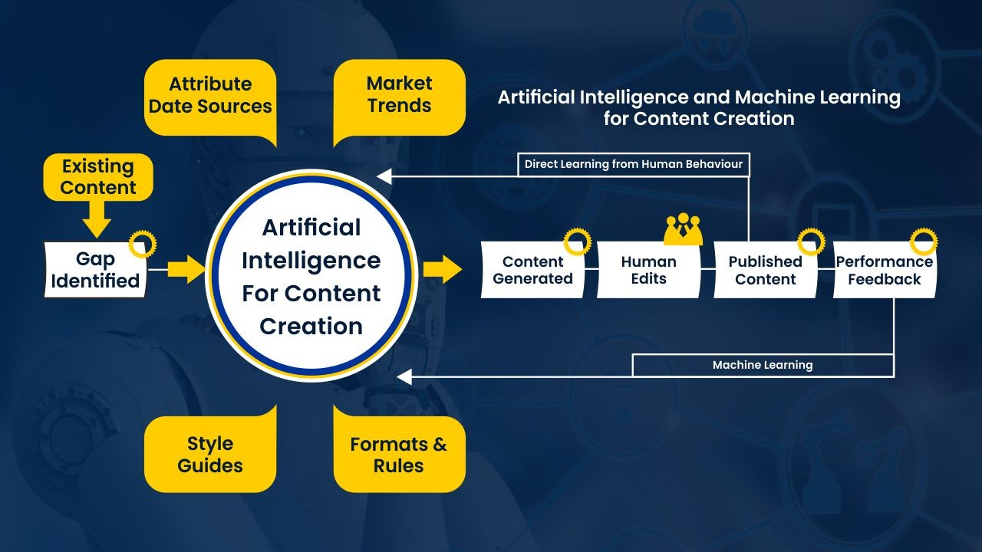
Figure 1. https://www.linkedin.com/pulse/impact-ai-machine-learning-digital-marketing-qutub-bharmal

AI Techniques for Content Modification (e.g GPT-4) or AI Image Generator From Text (DALL-E)
AI can be used to modify existing digital content in various ways, including:
- Translation: AI translation tools can convert text from one language to another, making content more accessible to a wider audience.
- Adaptation: AI can adapt content to different audiences, devices, and environments, ensuring a consistent and personalized experience.
- Content Generation: AI can generate new content, such as blog posts, product descriptions, and even creative writing pieces.
- Image Generator From Text: AI can generate art and create text based masterpieces effortlessly
AI Techniques for Content Refinement and Improvement
AI can be used to refine and improve existing digital content by:
- Grammar and Spelling Correction: AI can identify and correct grammatical errors and typos, ensuring the accuracy and professionalism of the content.
- Style and Tone Adjustment: AI can adjust the style and tone of content to align with specific brand guidelines, target audiences, or communication goals.
- Content Optimization: AI can optimize content for search engines, making it more likely to appear in relevant search results.
- Personalization: AI can personalize content based on user preferences, interests, and demographic data, enhancing user engagement and satisfaction.
AI Techniques for Integrating New Digital Content
AI can be used to integrate new digital content into existing platforms and systems by:
- Content Aggregation: AI can aggregate content from multiple sources, such as blogs, social media, and news websites, creating a comprehensive and up-to-date knowledge base.
- Content Recommendation: AI can recommend relevant and engaging content to users based on their past interactions and preferences.
- Content Personalization: AI can personalize the presentation of content, such as font size, color scheme, and layout, to enhance user experience.
- Content Moderation: AI can moderate content, identifying and removing inappropriate or offensive material, ensuring a safe and welcoming environment.

{Activities}
Students will create a cohesive content package that includes AI-generated text and visuals, simulating a real-world application such as a business presentation or a social media campaign. They'll use AI to draft the text component, perhaps a product description or advertising copy, then generate complementary visuals using an AI tool like DALL-E. The final deliverable will be a presentation that integrates both elements in a format appropriate for the chosen application, demonstrating the student's ability to merge AI-generated content into a unified whole.
{Questions for self-assessment}
- Which AI model is well-known for text generation capabilities?
- GPT-4
  - AutoCAD
  - SolidWorks
  - Blender
- What is a key consideration when using DALL-E for creating visuals?
  - The specificity of the text prompt
  - The color calibration of the monitor
  - The pixel density of the images
  - The storage capacity of the AI system
- Why is ethical reasoning important in AI-generated content?
  - To ensure content adheres to moral and legal standards
  - To make the content more entertaining
  - To ensure the content can go viral
  - To reduce the cost of content production
- In the context of AI-generated content, what is 'integration'?
  - Combining different forms of content for a cohesive presentation
  - Reducing file sizes for storage
  - Translating content into multiple languages
  - Programming the AI to self-replicate
- What does an effective prompt for GPT-3 include?
  - Detailed context and desired output format
  - Ambiguous instructions
  - Minimum character length
  - Maximum keyword density

{Questions for official-assessment}
- What kind of content might a business use AI-generated text and visuals for?
  - Social media campaigns
  - Internal server maintenance logs
  - Database encryption methods
  - Firmware update logs
- What is the aim of a case study analysis in AI ethics?
  - To identify and suggest resolutions to ethical issues
  - To compile statistics on AI failures
  - To find the most cost-effective AI model
  - To design a new AI system from scratch
- Why might a student need to revise AI-generated content?
  - To correct errors and improve clarity
  - Because AI always produces perfect results
  - To translate the content into AI language
  - To make the content less interesting
- In which scenario would DALL-E be the appropriate tool to use?
  - Designing visually compelling graphics for a campaign
  - Creating a spreadsheet for data analysis
  - Generating a 3D model of a new product
  - Writing a whitepaper on blockchain technology
- What is the outcome of a successful AI Content Integration Project?
  - A well-blended presentation of AI-generated text and visuals
  - An unrelated mix of text and graphics
  - A database of customer information
  - An AI-generated script for an upcoming play

