Developing digital content
Artificial Intelligence (AI) Generated Content
{Title}
Operate with new different items of AI in order to create new and original content and information.
{Description}
This unit uses AI-generated elements, automated research, and data analysis to personalize content, adapt narratives, and collaborate with AI models.
{Objectives}
- Identify and understand various AI tools and techniques for content creation.
- Apply AI tools to generate new and original content across different formats.
- Evaluate the effectiveness and limitations of AI-generated content.
- Ethically apply AI in content creation, considering originality, accuracy, and bias.

{Contents}
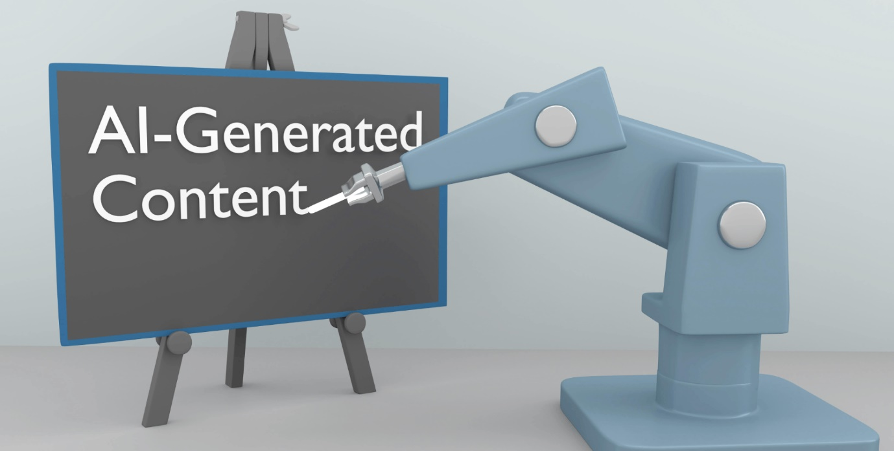
Figure 1. https://www.rizenmetrics.com/ai-generated-content/
AI Tools for Content Creation
A wide range of AI tools and techniques are available for creating new and original content:
- Natural Language Processing (NLP): NLP algorithms can generate text, translate languages, and summarize information, enabling the creation of blog posts, articles, scripts, and even creative writing pieces.
- Generative Adversarial Networks (GANs): GANs can produce realistic and high-quality images, allowing for the creation of illustrations, product mockups, and even artistic pieces.
- Audio Synthesis and Processing: AI algorithms can generate and manipulate audio, enabling the creation of music, sound effects, and even podcasts.
- Video Editing and Compositing: AI can automate tasks in video editing, such as color correction, object removal, and even facial animation.

Creating New and Original Content with AI
AI can be used to create new and original content in a variety of ways:
- Content Idea Generation: AI can generate creative prompts, identify trending topics, and analyze audience preferences to inspire new content ideas.
- Content Personalization: AI can personalize content to individual users based on their preferences, interests, and demographic data.
- Content Adaptation: AI can adapt content to different platforms, devices, and environments, ensuring a consistent and engaging experience.

Evaluating the Effectiveness of AI-Generated Content
While AI-generated content offers significant benefits, it is crucial to evaluate its effectiveness and limitations:
- Accuracy and Reliability: AI algorithms can make mistakes or generate inaccurate or misleading information.
- Originality and Creativity: AI-generated content should not be presented as original human-written work or creative expression.
- Bias and Discrimination: AI algorithms can reflect and amplify existing biases in the data they are trained on.

{Activities}

The student will create a portfolio of visual content by leveraging AI image creation tools. He/She will develop a series of prompts that produce images tailored to a specific theme or branding strategy. This activity challenges them to understand the relationship between textual prompts and visual outputs, enabling them to curate a portfolio that demonstrates both their creative vision and technical skills with AI tools.

{Questions for self-assessment}
- What is the primary goal of fine-tuning input prompts for AI in content generation?
  - To produce more targeted and relevant content
  - To confuse the AI into generating random outputs
  - To reduce the word count of the content
  - To increase the processing time of the AI
- When editing AI-generated text, what aspect is crucial to enhance?
  - The color scheme of the text
  - The speed of content generation
  - The readability and coherence
  - The number of keywords
- What is the outcome of a well-crafted AI-assisted visual portfolio?
  - A portfolio with thematic consistency and visual appeal
  - A collection of uniform images
  - A series of unrelated stock photos
  - Randomly generated clipart
- In the context of AI-generated content, what does 'interactive multimedia presentation' refer to?
  - A presentation combining text, visuals, and interactive elements
  - An audio recording of the content
  - A text-only document
  - A static infographic
- What skill does critically editing AI-generated output test?
  - Critical thinking and editorial judgment
  - Typing speed
  - Graphic design
  - Programming ability

{Questions for official-assessment}
- What is a key benefit of using AI for image generation in a visual portfolio?
  - Creating varied visuals based on complex prompts
  - Bypassing the need for any human-designed elements
  - Generating high-volume text content
  - Replacing traditional photographers
- Why might a student use AI to generate a white paper?
  - To quickly produce a foundational draft on a specific topic
  - To completely automate the research process
  - To translate the paper into multiple languages
  - To ensure that the paper will be published without revisions
- When integrating AI-generated content into a web presentation, what factor is most important?
  - The user engagement and interactivity of the content
  - The number of different fonts used
  - The length of text on each web page
  - The loading speed of the images only
- What is a common use case for GPT-3 in content creation?
  - Generating draft content for further
  - refinement Programming in low-level machine language
  - Calculating complex mathematical equations
  - Composing music for orchestras
- What is an essential aspect to consider when creating AI-generated multimedia content?
  - The narrative flow and how elements complement each other
  - The color of the background only
  - The brand of the computer used
  - The temperature of the room

