Developing digital content
Accessibility incorporation in digital content
{Title}
Modify, refine, improve and integrate accessibility incorporation in digital content
{Description}
Participants dive deeper into the intricacies of creating digitally accessible content while focusing on the advanced aspects of modifying, refining, improving, and seamlessly integrating accessibility features.
{Objectives}
- Enhance your understanding of accessibility principles and guidelines.
- Develop strategies to identify and address accessibility barriers in existing digital content.
- Implement effective techniques to improve the accessibility of digital content.
- Integrate accessibility considerations throughout the content creation and development process.

{Contents}
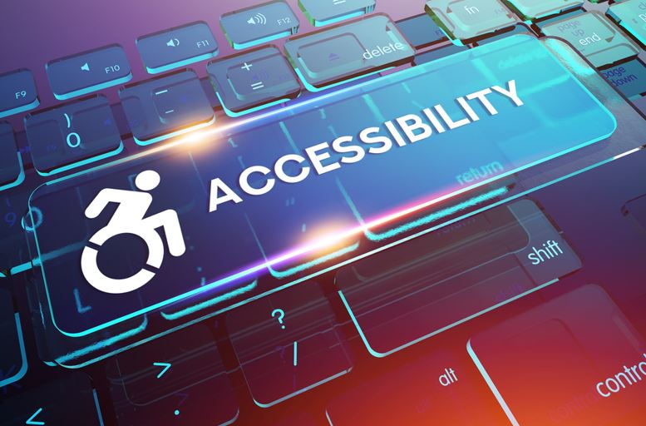
Figure 1. https://www.prdaily.com/10-crucial-considerations-for-making-digital-content-accessible/

In today's digital world, accessibility has become a crucial aspect of ensuring that everyone, regardless of their abilities, can access and utilize digital content effectively. Continuing to modify, refine, improve, and integrate accessibility incorporation in digital content is essential for creating an inclusive and accessible online experience for all.
The first step in improving accessibility is to identify and address existing accessibility barriers in digital content. Besides accessibility barriers we mention in level 3, such as: low colour contrast between text and background, missing alternative text for images and forms that are not designed for keyboard navigation one also needs to consider excessive text, images, or other elements on a page can make it difficult for people with visual impairments to focus and navigate; the clarity of instructions that can also be difficult for people with motor impairments to use.
As already mentioned in level 3 numerous techniques can be implemented to improve the accessibility of digital content. Some key techniques include: Use plain language, avoid jargon, and provide clear instructions and feedback; Use consistent headings, subheadings, and lists to organize your content and make it easy to navigate; Providing alternative text for images; Use high colour contrast: Make sure content is compatible with assistive technologies, i.e. test content with screen readers, keyboard navigation, other assistive technologies to ensure compatibility. Incorporate error handling and descriptive labels in order to make form inputs more accessible. Finally the content should also be tested with participants who have disabilities.
To further optimize digital content for accessibility compliance, consider these steps:
- Establish an accessibility policy: Develop and implement an organization-wide accessibility policy to guide accessibility practices and ensure consistency.
- Train and educate: Provide training and education to employees on accessibility principles, guidelines, and techniques to foster an accessibility-inclusive culture.
- Use accessibility tools and resources: Utilize accessibility tools and resources, such as screen readers, colour contrast checkers, and evaluation tools, to assess and improve accessibility.
There are several tools and resources available to help you evaluate digital content for accessibility compliance. Some popular options include:
- WAVE Evaluation Tool: A free online tool that assesses web pages for accessibility conformance to WCAG guidelines.
- Accessibility Insights: A browser extension for Chrome and Edge that identifies accessibility issues on web pages.
- AXE: An open-source accessibility testing tool that can be used to test websites, web applications, and PDF documents.
{Activities}

1: Accessibility Audit and Remediation
Instructions:
- Select an existing piece of digital content, such as a website, blog post, or social media post.
- Conduct a thorough accessibility audit of the content, using tools like WAVE Evaluation Tool, Accessibility Insights, or AXE.
- Identify and document all accessibility barriers discovered during the audit.
- For each accessibility barrier, research and implement appropriate remediation measures to improve accessibility.
- Retest the content after making the remediation changes to ensure they have effectively addressed the accessibility barriers.
2: Accessibility-Integrated Content Creation
Instructions:
- Select a topic or theme for your digital content, such as a blog post, article, or website page.
- Before creating any content, research and understand the accessibility guidelines and best practices relevant to the chosen format.
- During the content creation process, consciously apply accessibility principles and techniques to ensure the content is perceivable, operable, understandable, and robust.
- Use accessible tools and formats, such as plain text, HTML, and semantic markup, to structure your content effectively.
- Incorporate alternative text for images, clear and concise language, consistent headings, and high color contrast.
- Test the content with assistive technologies, such as screen readers, keyboard navigation, and color contrast checkers, to identify and address any accessibility issues.
- Evaluate the overall accessibility of the content and make necessary refinements to ensure it meets accessibility standards.
{Questions for self-assessment}
- When modifying form inputs to be more accessible, what is a crucial feature to add?
  - Error handling and descriptive labels
  - Pop-up advertisements
  - Auto-capitalization of text
  - High-resolution images
- What kind of testing is important after implementing new accessibility features?
  - Usability testing with participants who have disabilities
  - Colour-blindness testing on animals
  - Load testing under extreme weather conditions
  - Aesthetic testing by a panel of artists
- Why are alternative texts for images important?
  - They describe the image for users who cannot see it
  - They display instead of images when the page loads slowly
  - They make the images appear larger
  - They add decorative elements to the website
- Which can be a necessary step to optimize digital content for accessibility compliance:
- To use accessibility tools and resources
- To improve the hardware structure of the dedicate computer
- To enhance the visual appeal of digital content
- To increase the user engagement of digital content
- Which of the following tools is commonly used for conducting accessibility audits of digital content?
- WAVE Evaluation Tool
- Google Analytics
- Microsoft Powerpoint
- Microsoft Word

{Questions for official-assessment}
- How can interactivity be maintained for users with limited mobility when designing web content?
  - By ensuring all interactive elements are operable with keyboard commands
  - By using motion detection
  - By requiring voice recognition software
  - By making content only accessible through a mobile app

- Why is it important to test accessible digital content with assistive technologies?
- To identify and address potential accessibility issues
- To ensure compatibility with different browsers and devices
- To enhance the overall usability of the content
- To comply with accessibility regulations

- Which of the following is an essential step in integrating accessibility considerations into the content creation process?
- Researching and understanding accessibility guidelines and best practices
- Selecting a visually appealing color scheme for the content
- Choosing a complex and engaging font style for the content
- Using a proprietary content management system

- What is the purpose of providing clear and concise language in accessible digital content?
- To improve readability and comprehension for all users
- To enhance the visual appeal of the content
- To increase user engagement and retention
- To comply with search engine optimization guidelines

- What is the role of high color contrast in accessible digital content?
- To ensure readability and comprehension for users with low vision or color blindness
- To enhance the visual appeal of the content
- To improve the loading speed of the content
- To comply with search engine optimization guidelines

