Developing digital content
Virtual reality, augmented reality and mixed reality
{Title}
Virtual reality, augmented reality and mixed reality – basic knowledge
{Description}
This lesson provides a comprehensive overview of virtual reality, augmented reality, and mixed reality, exploring their concepts, distinctions, applications, and potential impact on various industries and domains.
{Objectives}

- Understand the fundamental concepts of virtual reality (VR), augmented reality (AR), and mixed reality (MR).
- Differentiate between VR, AR, and MR based on their characteristics and applications.
- Identify the key components and hardware involved in VR, AR, and MR systems.
- Discuss the potential applications and benefits of VR, AR, and MR in various industries and domains.

{Contents}
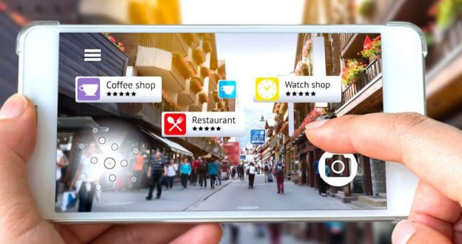
Figure 1. https://www.androiddeveloper.co.in/blog/everything-about-ar-technology-into-mobile-app-development-world/

Virtual Reality (VR): VR immerses users in a completely simulated environment, creating a disconnect from the physical world. Users wear VR headsets to experience a 3D environment generated by computers, often using interactive controllers to navigate and interact with the virtual world.
Augmented Reality (AR): AR overlays digital information onto the real world, enhancing the user's perception of the physical environment. AR apps use smartphones, tablets, or AR glasses to superimpose digital elements onto the real world, providing contextual information and enhancing the user's experience.
Mixed Reality (MR): MR seamlessly blends the physical and virtual worlds, creating a hybrid environment where digital elements interact with the real world. MR systems use advanced technology, such as headsets or handheld devices, to combine the physical world with virtual objects, enabling users to manipulate and interact with both seamlessly.
Differentiating VR, AR, and MR
Feature | Virtual Reality (VR) | Augmented Reality (AR) | Mixed Reality (MR)
Environment | Completely simulated | Real world with virtual overlays | Hybrid of real and virtual worlds
Immersion | High | Low to medium | Medium to high
Interactivity | Limited by hardware | More interactive | Highly interactive
Applications | Gaming, training, entertainment | Education, navigation, product visualization | Design, prototyping, collaboration

Key Components and Hardware: VR, AR, and MR systems rely on various components to deliver immersive and interactive experiences: (1) VR: VR headsets, controllers, tracking systems, and powerful computers are essential components for VR experiences; (2) AR: Smartphones, tablets, AR glasses, cameras, sensors, and software applications are key components for AR experiences; (3) MR: MR headsets, controllers, advanced sensors, and sophisticated software algorithms are required for MR experiences.
Applications and Benefits of VR, AR, and MR: (1) VR: Gaming, training, education, entertainment, therapy, and design are just a few areas where VR is making a significant impact. (2) AR: Navigation, product visualization, maintenance and repair, education, and marketing are among the many applications of AR. (3) MR: Design, prototyping, collaboration, training, education, and entertainment are potential areas where MR can revolutionize user experiences.

{Activities}
Activity 1: Research and compare different types of VR headsets
Instructions:
- Search on the internet and choose 3 different VR headsets to research.
- Compare the headsets in terms of their features, specifications, and price.
- Write a report to share your findings with the class.
Activity 2: Explore the potential applications of MR in different industries
Instructions:
- Choose an industry that you are interested in.
- Research the potential applications of MR in that industry.
- Write a report to share your findings with colleagues.
{Questions for self-assessment}
- What are the three VR headsets you chose to research?
- Oculus Quest 2, Meta Quest Pro, and HTC Vive Pro 2
- PlayStation VR, HTC Vive Cosmos Elite, and Valve Index
- Samsung Gear VR, Google Cardboard, and Oculus Rift
- Apple VR Headset, Sony PlayStation VR2, and Microsoft HoloLens 2
- What are some of the factors to consider when choosing a VR headset?
- Comfort and design
- Your budget
- Your PC or gaming console compatibility
- The type of VR experiences you want to have (gaming, entertainment, education, training)
- What are some of the latest trends in VR headset development?
- Foveated rendering
- Wireless connectivity
- Eye tracking and hand tracking
- Higher-resolution displays
- What is your overall impression of the VR headset market and its future potential?
- VR headsets have the potential to revolutionize the way we interact with the world and experience entertainment.
- VR headsets are still in their early stages of development, and there are many challenges that need to be addressed before they can be widely adopted.
- VR headsets are a niche product that will appeal to a limited audience.
- I am not sure what the future holds for VR headsets.
- What is one of the key challenges that VR headset manufacturers face in terms of increasing the field of view (FOV) of their devices?
- Addressing the potential for motion sickness associated with wider FOVs
- Overcoming hardware limitations in processing power and graphics rendering
- Developing ultra-high-resolution displays that can produce a wider image
- Ensuring compatibility with existing VR content and games
{Questions for official-assessment}
- Which of the following is NOT a common application for VR systems?
  - Video conferencing
  - Education
  - Training
  - Gaming
- Which of the following is NOT a common application for MR systems?
  - Customer service
  - Engineering
  - Military
  - Architecture
- Which of the following is the MOST important factor to consider when choosing a VR headset?
  - Field of view
  - Resolution
  - Price
  - Weight
- How do you think VR headsets can be used to enhance educational experiences and make learning more engaging?
- By providing immersive 3D simulations and virtual environments for hands-on learning
- By enabling remote collaboration and virtual field trips to enhance cultural understanding
- By replacing traditional textbooks with interactive VR learning modules
- By focusing on gamification and incorporating VR elements into educational games
- Which of the following statements is the MOST accurate prediction about the future of VR, AR, and MR systems?
  - VR, AR, and MR systems will be used for a wide range of applications, including gaming, education, healthcare, and manufacturing.
  - VR, AR, and MR systems will become essential tools for businesses and industries.
  - VR, AR, and MR systems will become more affordable and accessible to everyone.
  - VR, AR, and MR systems will eventually replace smartphones and computers.

