Developing digital content
Virtual reality, augmented reality, and mixed reality
{Title}
Modify, refine, and improve Virtual Reality, Augmented Reality and Mixed Reality
{Description}
This lesson explores the iterative process of developing and enhancing Virtual Reality (VR), Augmented Reality (AR), and Mixed Reality (MR) applications, emphasizing user-centered design principles and continuous improvement.
{Objectives}
- Gain a comprehensive understanding of immersion and presence and their impact.
- Develop VR, AR, and MR content using assisted technologies.
- Organize VR, AR, and MR content development as a project

{Contents}

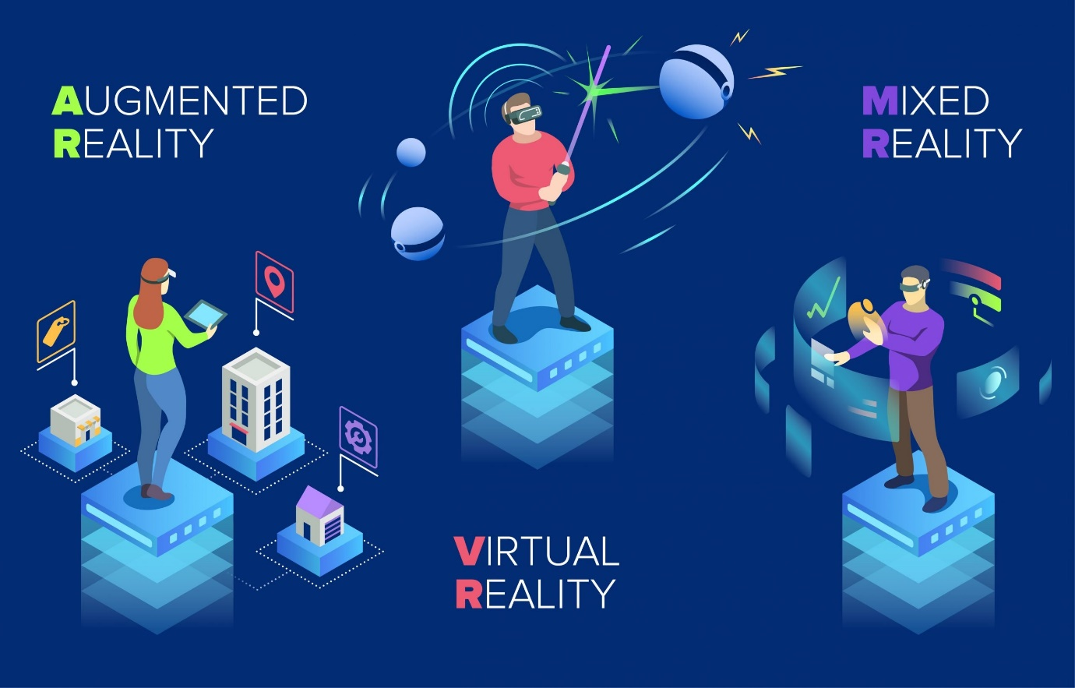
Figure 1 https://www.spheregen.com/augmented-virtual-and-mixed-reality-employee-training/
Modification, refinement, improvement, and integration (MRI) are key concepts in the development of VR, AR, and MR experiences. MRI can be used to improve the quality, usability, and effectiveness of VR, AR, and MR experiences.

Modification refers to making changes to an existing VR, AR, or MR. application. This can be done to improve the application, fix bugs, or add new features. Examples of modification of VR, AR, and MR applications include:
- Adding new features to an existing VR application, such as the ability to interact with virtual objects or to explore different environments.
- Removing features from an existing AR application to improve its performance or to make it more user-friendly.
- Changing the difficulty of an existing MR application to make it more challenging or accessible to a wider range of users.

Refinement refers to making small changes to an existing VR, AR, or MR application to improve its overall quality. This can include things like improving the graphics, making the controls more user-friendly, or fixing minor bugs. Examples of refinement of VR, AR, and MR applications include:
- Improving the graphics quality of an existing VR application.
- Making the controls of an existing AR application more responsive and intuitive.
- Fixing minor bugs in an existing MR application.

Improvement refers to making significant changes to an existing VR, AR, or MR application to make it better in some way. This can include things like adding new features, improving the performance, or making the application more engaging. Examples of improvement of VR, AR, and MR applications include:
- Adding new content to an existing VR application, such as new levels, new characters, or new storylines.
- Improving the performance of an existing AR application to make it smoother and more stable.

{Activities}
To modify, refine, improve, and integrate well-defined items of new content and information to create new and original ones, you can follow these steps:
- Modify an existing VR application to add new features, such as the ability to interact with virtual objects or to explore different environments.
- Refine an existing AR application to improve the tracking accuracy or to make the virtual objects more realistic.

{Questions for self-assessment}

- Which of the following is NOT an example of modifying a VR, AR, or MR experience?
  - Integrating two or more experiences
  - Removing features
  - Changing the difficulty
  - Adding new features
- What is the most important thing to consider when modifying a VR, AR, or MR experience?
  - The user experience
  - The technical requirements
  - The cost of development
  - The target audience
- Which of the following is NOT an example of refining a VR, AR, or MR experience?
  - Adding new content
  - Making the controls more responsive
  - Improving the graphics quality
  - Fixing minor bugs
- What is the most important thing to consider when refining a VR, AR, or MR experience?
  - The user feedback
  - The technical limitations
  - The budget
  - The release schedule
- Which of the following is NOT an example of improving a VR, AR, or MR experience?
  - Removing content
  - Improving the performance
  - Fixing major bugs
  - Adding new levels
{Questions for official-assessment}
- What is the most important thing to consider when improving a VR, AR, or MR experience?
  - The user needs
  - The technical feasibility
  - The cost-benefit analysis
  - The competitive landscape
- Which of the following is NOT an example of integrating VR, AR, and MR experiences?
  - Replacing VR, AR, and MR experiences with traditional experiences
  - Adding AR elements to a VR experience
  - Adding MR elements to an AR experience
  - Combining two or more VR experiences
- What is the difference between modification and refinement in the context of VR, AR, and MR development?
- Modification involves making significant changes to an existing application, while refinement involves making small changes to improve its overall quality.
- Modification involves adding new features to an existing application, while refinement involves removing features to improve its performance.
- Modification involves making changes to the graphics of an existing application, while refinement involves making changes to the controls of an existing application.
- Modification involves fixing bugs in an existing application, while refinement involves adding new content to an existing application.
- Which of the following is NOT a challenge of integrating VR, AR, and MR?
  - Market acceptance challenges
  - Design challenges
  - Cost challenges
  - Technical challenges
- Which of the following is NOT an opportunity of integrating VR, AR, and MR?
  - Reduced costs
  - Improved user experiences
  - Increased efficiency and productivity
  - The timeline

