Developing digital content
Virtual reality, augmented reality and mixed reality
{Title}
Innovative methods in order to develop Virtual Reality (VR), Augmented Reality (AR) and Mixed Reality (MR) applications
{Description}
This lesson explores cutting-edge approaches and techniques for designing and developing immersive and interactive VR, AR, and MR experiences.
{Objectives}
- Explore cutting-edge methodologies and techniques for designing and developing immersive and interactive VR, AR, and MR experiences.
- Understand the underlying principles and applications of advanced technologies such as eye tracking, haptic feedback, and artificial intelligence in VR, AR, and MR development.
- Identify and apply innovative design approaches to create engaging and effective VR, AR, and MR experiences.
- Gain insights into emerging trends and future directions in VR, AR, and MR technology.

{Contents}

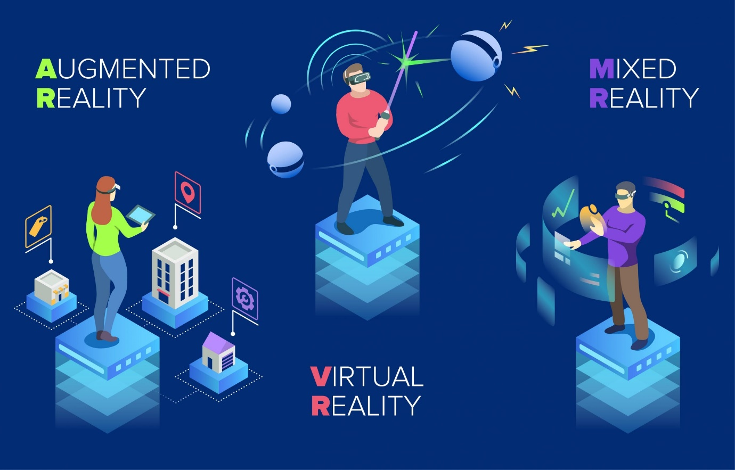
Figure 1 https://www.spheregen.com/augmented-virtual-and-mixed-reality-employee-training/
There are two broad classes of AR apps: marker-based apps and location-based apps. Marker-based apps use predefined markers to trigger the display of AR overlays on top of the image. Location-based apps use GPS, accelerometer, or compass information to display AR objects on top of physical ones.
To choose an AR SDK, the most important criteria to consider are: cost, supported platforms, image recognition and tracking support, Unity support, OpenSceneGraph support, GPS, etc.
When it comes to choosing a development kit, it’s easy to get frustrated by the number of tools available. In order to pick the SDK that best suits your project, you should make sure it supports all the features your app requires. In the following, we detail the main points to consider.
Once you know all the features you could possibly require of an SDK to create your augmented reality app, you can check out the following list of different popular tools that are available on the market. We consider these toolkits to be the most relevant and appropriate based on the set of features they provide and their value for money. Some of them are free:
- Vuforia is a leading portal for augmented reality application development that has a broad set of features. https://youtu.be/jAmU0L_wfV0
- ARToolKit is an open-source tool to create augmented reality applications. Even though it's a free library, it provides a rather rich set of features for tracking. https://www.youtube.com/watch?v=i8l6rdp_a2k&ab_channel=DanielReiling
- Google ARCore: With two million Android active users, Google could not miss the chance to give developers an opportunity to create AR apps on this operating system. That’s how Google ARCore appeared. This toolkit works with Java/OpenGL, Unity, and Unreal. https://youtu.be/NhJydpMkpug
- MAXST has two SDKs available: a 2D SDK for image tracking and a 3D SDK for environment recognition. https://youtu.be/hz5sojXanNw
- Meta Spark is transforming the conventional digital marketing sphere through the strategic use of Augmented Reality, empowering brands and influencers to convey their messages in more innovative and creative ways. https://spark.meta.com/
Immersion and Presence: Immersion is the feeling of being surrounded by a virtual environment. Presence is the feeling of being physically present in a virtual environment. Both immersion and presence are important for creating VR, AR, and MR experiences that are engaging and believable.

{Activities}
- Create a VR experience that showcases a collection of art, such as paintings, sculptures, or photographs (e.g. https://michael-mcanally.medium.com/vr-galleries-nfts-metaverse-70dd573058ce). More details can be found: https://aframe.io/docs/1.5.0/introduction/
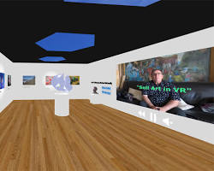
- Create an AR experience that allows users to demo a product before they buy it. For example, an AR furniture app could allow users to see how a piece of furniture would look in their home before they buy it (https://presentigo.com/how-to-create-your-own-3d-ar-augmented-reality-product-catalog-its-easy-and-free/).
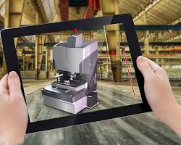
- Create an MR app that provides assembly instructions for products. This could help users to assemble products more easily and correctly (https://astrixinc.in/products/mr-ironstone-l-shaped-gaming-desk-59-inch).
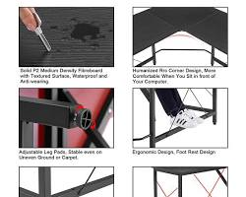﷟HYPERLINK "https://astrixinc.in/products/mr-ironstone-l-shaped-gaming-desk-59-inch"

{Questions for self-assessment}
- Which tool is commonly used for developing Virtual Reality experiences?
  - Unity
  - Microsoft Word
  - Photoshop
  - Excel
- Which of the following best describes Mixed Reality (MR)?
  - Combines elements of both VR and AR
  - Only virtual elements are used
  - Only real-world elements are used
  - Neither virtual nor real elements are used
- What is the primary component for user immersion in VR?
  - Graphics
  - Sound
  - Text
  - Smell
- What ethical aspect is crucial in VR/AR/MR development?
  - User Safety
  - Font Size
  - Color Scheme
  - Marketing Tactics
- Which language is commonly used for VR programming?
  - C#
  - C++
  - C
  - Cobol

{Questions for official-assessment}
- What is the main goal of integrating elements across VR, AR, and MR platforms?
  - Seamless User Experience
  - Increasing Complexity
  - Reducing File Size
  - Enhancing Brightness
- What does VR provide that AR doesn't?
  - Fully immersive environment
  - Real-world elements
  - Increased luminance
  - Easier programming
- What is the key challenge in MR integration?
  - Complexity
  - Brightness
  - Portability
  - File Size
- In AR, what is used to place virtual objects in the real world?
  - Anchor points
  - Magnets
  - Gravity
  - Watermarks
9. Which aspects of the art pieces should be emphasized in the VR experience to create an immersive and engaging experience for users?
- The emotional impact and personal connection evoked by the art pieces
- The historical and cultural context of the art pieces
- The artistic style and technique of the art pieces
- The financial value and investment potential of the art pieces
- What is one of the ethical considerations when creating a VR experience?
  - Data Privacy
  - Light Intensity
  - Screen Resolution
  - Language Preference

