Developing digital content
SEO and digital marketing
{Title}
SEO and digital marketing – basic knowledge
{Description}
This course will present the basic concepts of SEO and digital marketing as well as how to efficiently leverage the newly aquired knowledge.
{Objectives}
- Understand the basic concepts of SEO and digital marketing.
- Learn how to use SEO and digital marketing to improve your online presence and reach your target audience.
- Identify and implement best practices for SEO and digital marketing.
{Contents}
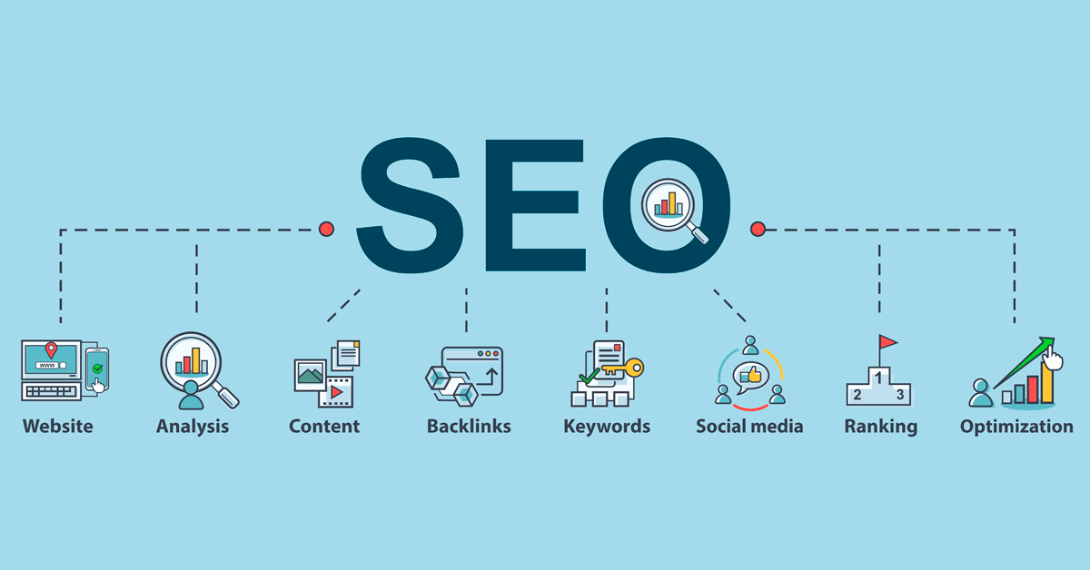
Figure 1. https://medium.com/geekculture/10-ways-to-improve-search-engine-optimization-seo-as-a-developer-a548ef936b22
What is SEO? SEO, or search engine optimization, is the process of improving the visibility and ranking of a website or web page in search engine results pages (SERPs). The higher a website or web page ranks in SERPs, the more likely it is to be seen by potential visitors.
There are many different factors that contribute to a website's ranking in SERPs, including the quality and relevance of its content, the number and quality of backlinks to the website, and the technical aspects of the website, such as its page speed and mobile friendliness. A great number of users are accessing web sites through mobile devices, making mobile-friendliness a very important consideration.
What is digital marketing? Digital marketing is the use of digital technologies to promote products or services to consumers and businesses. Digital marketing can take many different forms, including:
- Content marketing: Creating and distributing valuable, relevant, and consistent content to attract and retain a clearly defined audience and drive profitable customer action.
- Search engine optimization (SEO): Optimizing a website and its content to rank higher in search engine results pages (SERPs). This activity includes both On-Page and Off-Page optimization. Some examples of search engine optimization tools include Google Keyword Planner, Ahrefs, Moz, or Screaming Frog.
- Pay-per-click (PPC) advertising: Creating and managing ads that appear in search engine results pages (SERPs) and on other websites.
- Social media marketing: Creating and distributing content on social media platforms to connect with and engage potential and existing customers.
- Email marketing: Sending promotional messages to subscribers via email.
How SEO and digital marketing work together? SEO and digital marketing can work together to help businesses achieve their online marketing goals. For example, businesses can use SEO to improve the visibility of their website in SERPs, and then use digital marketing channels, such as content marketing and social media marketing, to drive traffic to their website, to reach new markets and customer segments.

{Activities}

1. SEO Audit
Instructions:
- Go to a free SEO audit tool, such as Google Search Console or SEMrush.
- Enter your website's URL and run the audit.
- Review the audit results and identify any areas where your website can be improved for SEO.
Possible actions:
- Fix any technical SEO issues, such as broken links or missing title tags.
- Optimize your website's content for relevant keywords.
- Build backlinks to your website from other high-quality websites.

2. Keyword Research
Instructions:
- Go to a keyword research tool, such as Google Keyword Planner, Ahrefs, Moz, or Screaming Frog.
- Enter a few seed keywords related to your business or industry.
- Review the keyword suggestions and identify relevant keywords with high search volume and low competition.
Possible actions:
- Use the identified keywords in your website content, title tags, and meta descriptions.
- Create content that targets the identified keywords.
- Run paid search engine marketing (SEM) campaigns to target the identified keywords.

{Questions for self-assessment}
- What is the role of Search Engine Optimization (SEO)?
- Improving organic traffic to a webpage/website.
- Optimizing a search engine to faster generate a result page.
- Displaying paid advertising in the top 5 positions of a SERP.
- Reduce the loading time of a page/site when a user accesses it.

- From the perspective of digital marketing, is SEO sufficient?
- No, paid advertising, social media marketing, email marketing and content marketing complements SEO in bringing customers to a website.
- Yes, SEO contains all the tools needed to drive new customers to a webpage.
- No. Along SEO, using invisible keywords and duplicated content are needed for ranking higher in a SERP.
- In most cases, SEO is sufficient, but placing dofollow links in anchor text, that redirects to popular websites improves a website page authority (PA).

- Which of the following represent Search Engine Optimization tools?
- Ahrefs, Moz, and Screaming Frog.
- Google Ads and Facebook Ads.
- AdWords and Google Analytics.
- Google Keyword Planner, SEMrush, and HubSpot.

- How can you identify issues such as broken links, duplicate content, and site speed problems?
- By conducting a comprehensive audit of a website's SEO performance.
- By attracting a large volume of organic traffic to your website.
- By analyzing real-world case studies to understand how SEO strategies are applied in different industries.
- By using emerging technologies like AI, chatbots, Augmented and Virtual Reality.

- Beside SEO, enumerate 2 digital marketing activities?

- Email marketing and PPC advertising.
- Social media marketing and GDPR.
- Influencer marketing and On-Page optimization.
- Mobile marketing and link building.

{Questions for official-assessment}
- Is it important for a site to have a mobile friendly interface?

- Yes, a great number of users are accessing web sites through mobile devices.
- No, smartphone and tablet users only access social media.
- No, there’s no need for a special interface for displaying websites on mobile devices.
- Yes, because only people that use mobile devices will become future customers.

- What is the purpose of expanding your market reach?

- Tapping into new markets and customer segments.
- Achieving higher rankings for target keywords and phrases in SERPs.
- Converting website visitors into customers and subscribers.
- Making data-driven adjustments to your strategies.

- How can you identify issues such as broken links, duplicate content, and site speed problems?

- By conducting a comprehensive audit of a website's SEO performance.
- By attracting a large volume of organic traffic to your website.
- By analyzing real-world case studies to understand how SEO strategies are applied in different industries.
- By using emerging technologies like AI, chatbots, Augmented and Virtual Reality.

- On-Page and Off-Page optimization are part of which digital marketing activity?

- Search Engine Optimization.
- Affiliate marketing.
- PPC advertising.
- Analytics and Data Analysis.

- Why is it important for a website to be displayed in the top positions of a SERP?

- Users are more likely to access the websites in the top positions.
- Ranking higher on a SERP grants higher security to a webpage.
- Web pages displayed in the top 5 positions load faster.
- Website content doesn’t matter when the website is ranked higher.

