Developing digital content
Protection techniques and mechanisms for copyrighting
{Title}
Introduction in copyrighting

{Description}
This unit introduces the topic of copyrighting and explores its fundamental principles and applications in creative works.

{Objectives}
- Develop a clear understanding of copyright principles and their implications.
- Gain knowledge about the rights associated with copyrighted materials.
- Analyze the exceptions to copyright laws, focusing on the concept of Fair Use.
{Contents}

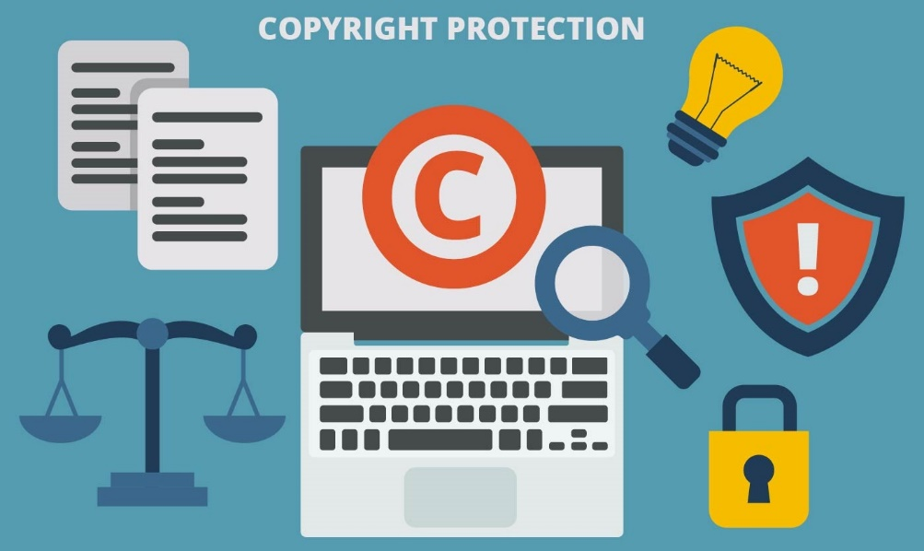
https://www.vecteezy.com/vector-art/146866-copyright-protection-vector

Copyright is the legislative form by which the original work of an owner is protected, meaning that the author is the only one who has the exclusive right to reproduce it. According to this law, a work is considered original if the author created it through independent thinking, without duplication and with a minimum degree of creativity. Unique creations come in the form of poems, musical compositions, paintings, novels, photographs, computer programs, scientific works, films, architectural projects, etc. It should be noted that copyright does not protect the methods, systems, procedures, or ideas themselves, but their expression, so any new product must be noted, written in physical form, or recorded.
Anyone who has an original work of authorship automatically has copyright over it, only that, in order to have power in the legal system, the copyright must be registered voluntarily by the original owner through an established procedure by the respective authorities in that place. This comes in hand when it is necessary to take a legal action in case of violation of the owner's rights.
The creator's exclusive right to the original content is protected by copyright law for a certain period of time, after which it becomes public domain. For example, in the USA, the original owners have this right for their entire life and after their death, another 70 years through legal descendants. Apart from the creator of the work, companies, organizations and other groups can also be copyright owners. The works done by an employee for the purpose of employment are owned by the employer. Because copyright law is not all-encompassing, additional protection for intellectual property is provided by other laws such as patent and trademark law, which may impose additional sanctions.
One party may assign or transfer a copyright, or portions of it (such as reproduction only, excluding moral rights), to another. When a musician records an album, for instance, they often sign a contract with a record label wherein the artist transfers all copyright to the recordings in return for royalties and other benefits. The original copyright holder and inventor gains, or should expect to gain, from production and marketing capacities that are far greater than those of the author. The record business tries to promote and market the creator and their art so it may reach a much wider audience, even if music in the digital era can be freely copied and shared over the Internet.
Certain classifications of intellectual property may only be made accessible under a specified statutory license in certain countries. This is also known as a compulsory license because, under this arrangement, anyone wishing to make copies of a covered work need only file the appropriate notice and pay a fixed fee determined by statute (or by a decision of the agency under statutory guidance) for each copy made, rather than requiring permission from the copyright holder. A lawsuit for violation might be possible for the copier if the correct processes weren't followed. Copyright collectives, collecting societies, and performing rights organizations were established to receive royalties for hundreds, even thousands, of works at once due to the challenge of tracking down every single work. The inclusion of the statutory fee aids in determining the price that collective rights organizations charge per job, even if this market solution circumvents the statutory license, and in driving the general price down.
Not all forms of replication or copying are prohibited under copyright. According to US legal theory, fair use allows limited uses of content protected by copyright without requiring prior consent from the owner of the copyright. One of the copyright restrictions known as "fair use" permits certain restricted uses that would otherwise be deemed infringement as a defense against copyright infringement claims. This serves to strike a balance between the interests of copyright holders and the public demand in greater dissemination and use of innovative creations.

{Activities}
The students will analyze different types of intellectual property (such as blogs, music, literature work etc.) available on the web (resources such as YouTube or Wikipedia may be used) to determine whether it meets the criteria for copyright protection. They will resume factors such as originality, creativity, and fixation (as a short report). This activity can be either done individually or in groups, followed by public discussions regarding the necessity of a copyright registration for the studied works. Can William Shakespeare’s play “Hamlet” be copyrighted? What about the song “Jolene” by Dolly Parton? What about an original and creative cupcake recipe?

{Questions for self-assessment}
- Which of the following content is protected by copyright?
- Original and fixed work.
- Names, titles, slogans, and short phrases.
- Ideas, methods, processes, and concepts.
- All types of content, as long as they’re made through “works made for hire”.

- What is the purpose of copyright law?
- To grant exclusive rights to reproduce original works.
- To control the distribution of copyrighted material.
- To protect methods, systems, and ideas.
- To restrict the creation of new products.

- What represents an original work?
- A work created by a human author, by themselves, without copying, and that has a minimal degree of creativity.
- A captured work, either by the author itself, or under an authority designated by the author.
- A work of art, a photo, a movie, a piece of music, a book, or a computer program.
- Content with variations of typographic ornamentation, lettering and coloring, compared to other existing content.

- Under which circumstances a content creator doesn’t need permission of the copyright owner to use copyrighted material?
- For “fair use”.
- For “works made for hire”.
- By citing the source.
- By modifying the typographic ornamentation, lettering, and coloring.

- What must be done for copyright to have power in the legal system?
- The work must be registered voluntarily by the original owner.
- The work must be duplicated and distributed.
- The work must be reproduced by multiple individuals.
- The work must be publicly disclosed.
{Questions for official-assessment}
- How long is the creator's exclusive right to original content protected by copyright law in the USA?
- For the creator's entire life and an additional 70 years after their death.
- 20 years after the creation of the work.
- 50 years after the creator's death.
- Indefinitely.

- Who owns the copyright of a work?
- The content creator.
- The government.
- The employer, only if the work was created outside the scope of employment.
- No one, all works are automatically labeled as “public domain”.

- What additional protection for intellectual property is provided by laws other than copyright?
- Patent and trademark laws.
- Real estate laws.
- Works created before copyright existed.
- Employment laws.

- What is the purpose of a statutory license?
- Allow anyone to make copies of covered works by filing a notice and paying a fixed fee.
- Restrict access to copyrighted material.
- Eliminate the need for copyright registration.
- Grant exclusive rights to copyrighted material.

- What role do copyright collectives and performing rights organizations play?
- They receive royalties for multiple works and distribute them to copyright holders.
- They track down copyright violators.
- They provide legal representation for copyright disputes.
- They enforce copyright laws.

