Developing digital content
Protection techniques and mechanisms for copyrighting
{Title}
How to copyright material and Protection techniques
{Description}
This intermediate-level course describes the process of how to obtain a copyright registration and several techniques to protect said property.

{Objectives}
- Identify and understand the types of works that qualify for copyright protection.
- Learn the process of obtaining a copyright for original works.
- Explore and apply various techniques to protect copyrighted materials effectively.

{Contents}
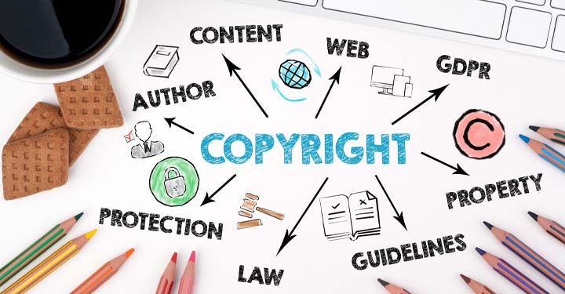
https://www.vecteezy.com/vector-art/146866-copyright-protection-vector

Copyright is a kind of intellectual property which secures unique creations produced by individuals. Unlike a trademark, which safeguards the use of a distinctive design, term, or phrase to distinguish the owner’s products and indicate their source, a copyright prohibits the reproduction, performance, or distribution of these works without the consent of the copyright owner. To get copyright protection for an output, it is necessary for the work to be physically recorded or captured in a manner that allows it to be seen, reproduced, or conveyed for a significant duration, such as by being written down.
Copyright is automatically grated to the author once the original work is recorded. However, to be able to legally enforce the exclusive rights of copyright, one must register the asset. Usually, the registration process consists of a submission in the form of an application paper, in a traditional, physical format or an online questionnaire, to the respective authority in their country, pay a required fee, and offer copies of the piece of work that is being registered. One essential detail about this process is time. In most cases, by registering a copyright before any infringement might occur, or, at the very least, within two to three months after the date of publication, the author can rest assured that he will be legally entitled to receive legal expenses and statutory damages in the event of being sued for copyright infringement. This saves the inconvenience of having to demonstrate the loss of original work and money, or the unfair gain of the infringer.
If someone discovers that their assets have been taken without notice or approval, it is in their best interest to promptly notify the unauthorised party or organisation of the copyright infringement and to immediately consult with a lawyer who specialises in intellectual property regarding the next steps to take. It is also highly advisable to maintain documented evidence as much as possible to substantiate the claim, should it be required in the future. Some methods of protecting copyrighted materials are presented below:
- Digital Object Identifier (DOI) – It is an identifier for digital copyright works, so the location of that product or even some information may change after some time, but its DOI won’t.
- Watermarks – In the digital space, watermarks incorporate copyright information onto the work itself. Mostly, it is created in such a manner to go unnoticed in everyday usage in favour of a better proof in case of unauthorised usage, but it can also be a little visible, like watermarks imprinted on papers.
- Conditional Access – The digital work owners may arrange Access in several ways. Conditional access can refer to the examination of the content files, the user’s identity, or the rights of the person that wishes to access a copyrighted work (for example: reding, editing content, executing programs, etc.).
- Product Encryption – Software and multimedia content are routinely encrypted to prevent unauthorised usage. A DRM (digital rights management) software exists which can send a notice to the national institution that manages copyright aspects, make a request for a fee, decrypt the data, and allocate the client a password or a key to allow them to Access the content after they download the content.
- Labelling – Adding warnings to a copyrighted product such as messages like “For non-commercial purposes only” can also help in bringing attention to the ownership status. Even if the product is digital or not, it is recommended to add a written notice in which the terms of usage and restrictions are clearly mentioned.
- International Regulations – Cultural and legal variations affect copyright protection in international markets, so an effective approach requires understanding and adapting skills. Some cultures may respect more joint efforts or even consider imitation flattering. Language and translation issues may hinder application of copyright protection as well.
{Activities}
Each student will have to come up with an original idea or choose an existing one for a digital painting on a desired theme or a science fiction book. For the chosen artwork, they will have to complete the specific registration form (visual or literary) based on the model issued here by the US Government. After this, students will have to prepare a list of protection mechanisms designed for their specific product. After all the student’s works are submitted and presented, group discussions can be organized for a better understanding of the copyrighting process and protection implications.
{Questions for self-assessment}
1. What type of intellectual property is copyright?
- A type of intellectual property that secures unique creations produced by individuals.
- A kind of trademark.
- A form of intangible asset.
- A type of patent.
2. How does copyright differ from a trademark?
- Copyright prohibits reproduction, performance, or distribution of works without consent.
- Copyright safeguards phrases for product distinction.
- Copyright indicates the source of the owner's products.
- Copyright protects distinctive designs.
3. What is necessary for a work to receive copyright protection?
- It must be physically recorded or captured.
- It must be registered with the copyright office.
- It must be created by a famous author.
- It must be publicly disclosed.
4. What is the importance of registering a copyright?
- Enables the author to legally enforce exclusive rights.
- Allows for immediate legal action.
- Ensures automatic protection.
- Provides evidence of ownership.
5. In the event of copyright infringement, what is advisable to do?
- Consult with a lawyer specializing in intellectual property.
- Take immediate legal action without notification .
- Ignore the infringement and move on.
- Notify the authorities but avoid consulting a lawyer.
{Questions for official-assessment}
6. What is recommended regarding evidence in cases of copyright infringement?
- Maintaining documented evidence as much as possible.
- Relying solely on digital timestamps.
- Oral statements from witnesses.
- Minimal documentation to avoid confusion.
7. What is a Digital Object Identifier (DOI) used for?
- Providing a permanent identifier for digital copyright works .
- Encrypting digital content.
- Adding watermarks to digital works.
- Determining international copyright laws.
8. What is copyright infringement?
- Anyone who uses someone's work without permission.
- A copy of someone's work.
- A picture of someone's work.
- Anyone who uses someone's work, but with permission.
9. What does conditional access refer to?
- Limiting access to digital works based on conditions.
- Distributing copyrighted works without restrictions.
- Removing access restrictions from digital works.
- Providing unconditional access to copyrighted works.
10. Why is understanding international regulations important for copyright protection?
- To adapt copyright protection strategies to cultural and legal variations.
- To prevent any international distribution of copyrighted works.
- To ensure that copyrighted works are free for international usage.
- To limit copyright protection to domestic markets.

