Developing digital content
Protection techniques and mechanisms for copyrighting
{Title}
Ethical aspects of copyrighting and strategy tailoring
{Description}
This unit dives deeper into the topic of copyrighting, by presenting ethical considerations in copyrighting and presenting strategies based on the type of business and targeted markets.
{Objectives}
- Examine the ethical and social implications of copyright protection.
- Develop and implement comprehensive strategies for managing copyright.

{Contents}
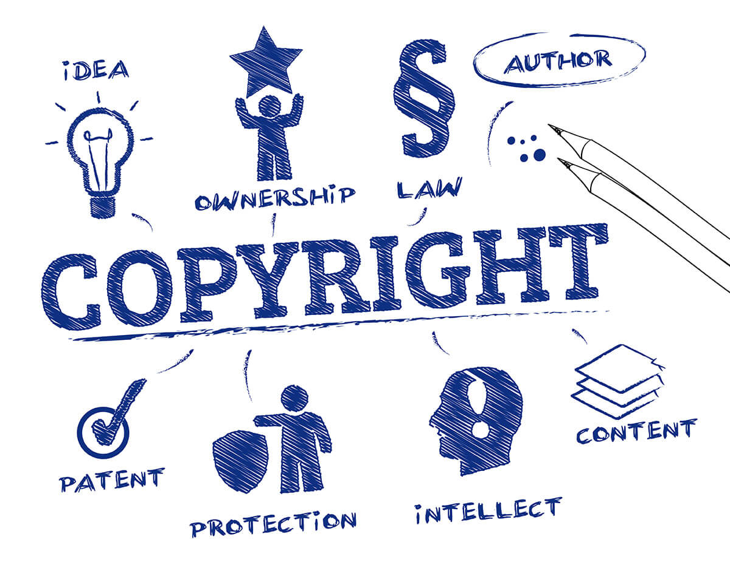
Figure 1. https://blog.ipleaders.in/unpublished-works-copyright/
Copyright ethics are centred on striking a balance between upholding artists' rights and promoting creativity, innovation, and information access. Recognising an author's right to control and profit from their work is fundamental to copyright ethics. This includes the right to be compensated for their contributions and to profit monetarily from their creative endeavours.
As an example, the United States Copyright Act of 1976 (Fair Use in Copyright, 2001) states that there are four things to consider when figuring out whether a certain activity qualifies as "fair use." The following is a list of these factors:
• Nature of the copyright-protected work.
• Goal and character of the usage, including whether it is for profit-making or charitable educational reasons. For instance, it is more acceptable to copy from works that are essentially factual than it is from more creative ones.
• The amount and significant usage of the section with respect to the whole work that is covered by copyright. For instance, 10% or three minutes of motion media, 10% or 1000 words of text, five photos taken by an artist or photographer, or 10% or fifteen photos from a group project may all be included in instructional multimedia projects.
• How the usage affects the copyright-protected work's value or prospective market. (Part 107).
In the 1991 publishing houses case in New York, Basic Books Inc. vs. Kinko's Graphics Corporation, the first one declared that Kinko's shop was accused of copying book passages and creating course "packets" for college students. The plaintiffs said that copies of their copyrighted works were sold for profit and that they were exploited without authorization or payment of the necessary fees. Although Kinko's contended that their usage qualified as "fair use," the courts found that this was not the case since the copyright-protected content was used for profit in a commercial setting.
On the other hand, in international markets, companies must have a thorough intellectual property (IP) strategy. In addition to copyright protection, this approach needs to include additional IP types, including patents and trademarks. Different works need different levels of copyright protection. For effectively allocating resources and concentrating protection efforts, it is essential to identify the main assets for copyright protection. Establishing specific goals for the IP strategy, such as safeguarding important works that are protected by copyright, avoiding infringement, and using IP assets to achieve economic success. Defining clear objectives helps in directing resource allocation and decision-making, while examining the commercial environment in the intended markets will reveal clues regarding regional rivalry, the market's need for copyrighted works, any difficulties, and cultural concerns.
Copyright rules and issues vary throughout sectors. For instance, although artistic businesses could place more importance on visual or audio works, software firms would need to concentrate on code protection and licensing. Ensuring that copyright protection measures are incorporated into all agreements and contracts that a company enters, whether it is done through partnerships, joint ventures, or cooperation with local businesses in foreign markets, will only enhance the security of copyright protection. Consistent communication with customs authorities is required to apprise them of copyrighted works, as well as any potential hazards or patterns of infringement.

{Activities}
Students can engage in a group debate on the fair use of copyrighted material in a hypothetical situation. For example, they could create a multimedia presentation using copyrighted texts, videos, and images. They would discuss the fairness of their use in accordance with the US Copyright Act of 1976. Students could be divided into stakeholder groups representing the educational institution, students using the material, and creators, each presenting their own argument on the ethical and legal permissibility of the use.
{Questions for self-assessment}
1. What is the primary focus of copyright ethics?
- Upholding artists' rights and promoting creativity, innovation, and information access.
- Restricting fair use provisions.
- Maximizing profit for copyright holders.
- Limiting access to information.
2. What is fundamental to copyright ethics?
- Recognizing an author's right to control and profit from their work
- Ignoring copyright laws.
- Limiting fair use provisions.
- Prioritizing profit over creativity.
3. According to the United States Copyright Act of 1976, which of the following is NOT one of the factors to consider when determining fair use?
- How the usage affects the copyright-protected work's value or prospective market.
- Goal and character of the usage.
- Nature of the copyright-protected work.
- Time period since publication.
4. If you create a piece of work at school, who usually owns the copyright?
- You
- The school
- You and the school
- The government
5. If you paint a mural on a classroom wall as an assignment for your art class, who owns the copyright?
- You do because you are the "author" of the work.
- The school because it owns the wall.
- Your parents because you are too young to own a copyright.
- Your art teacher because she assigned the art project.
{Questions for official-assessment}
6. In the Basic Books Inc. vs. Kinko's Graphics Corporation case, what was the primary reason the courts ruled against Kinko's?
- Kinko's used copyrighted content for profit in a commercial setting.
- Kinko's failed to provide evidence of fair use.
- Kinko's did not profit from the use of copyrighted material.
- Kinko's did not exploit copyrighted material.
7. In international markets, what does an effective intellectual property (IP) strategy need to include?
- Patents and trademarks in addition to copyright protection.
- Trademarks only.
- Copyright and trademark infringement strategies.
- Copyright protection only.
8. What helps in directing resource allocation and decision-making in an IP strategy?
- Defining clear objectives.
- Avoiding cultural concerns.
- Ignoring regional rivalry.
- Focusing solely on economic success.
9. How do copyright rules and issues vary throughout sectors?
- Different sectors prioritize different types of copyright protection.
- Software firms don't require copyright protection.
- Only artistic businesses place importance on visual or audio works.
- They don't vary; copyright rules are uniform across all sectors.
10. Why is it important to incorporate copyright protection measures into agreements and contracts?
- Enhance the security of copyright protection.
- Restrict access to copyrighted works.
- Ignore fair use provisions.
- Increase profit for copyright holders.

