Developing digital content
Licences
{Title}
Licence – definition and types
{Description}
This lesson presents the definition of a licence and some details regarding different types of licensing agreements.
{Objectives}
- Understand what a licence is, as well as the parties involved and their roles.
- Learn the main types of licences.
- Discover the conditions stipulated in such a contract.
{Contents}
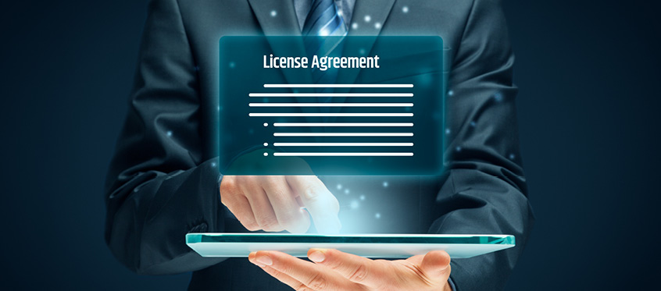
Link: https://tech-yg.com/software-license-how-to-prevent-future-hassles/
Licensing is an important aspect of developing, modifying, and distributing digital content. Hereafter we will first explain what licences are, what different types of licences are there, and provide insights into business considerations.
The official permission or permit to do, use, or own something, as well as the document of that permission or permit, is known as a licence. It provides clear guidelines, rules, and stipulations that cover the use of the digital content. A party that wishes to possess or simply use an intellectual property (IP), the licensee, usually gets the permission to do so from the owner of said property, the licensor, if they agree to pay a certain amount of money or to return some different benefit to the owner. Normally, a licence agreement contains the following elements: detailed content about the material that will be licenced, the purpose under which the IP will be used by the licensee, rights and obligations of both licensor and licensee (for example, the licensor should have full ownership over derived products made using their patented IP), duration of the licence, the compensation that should be paid to the licensor which can be a one-time only payment or ongoing (this type of payment that is made while the licensee uses the assets of the other party is referred as royalties) and last but not least, the termination clause that specifies in detail the conditions under which any party can annul the licensing agreement withing a given notice with a time-frame of about 30 days.
When it comes to businesses, licencing agreements allows them to leverage their IP without much effort, having others handle their products, all while receiving a steady stream of revenue. An important detail that must not be missed is the impact of the licensees over the company’s reputation and quality of their brand. Clear standards and monitoring methods have to be implemented from the very beginning, otherwise unfortunate choices can lead to negative feedback from the clients, reputation damage and finally loss of income.
Nowadays, there are a number of different types of licence agreements, all of them with distinct set of rules. Here we present the most common types:
- Copyright licensing – This type of agreement acts as a legal backer in the case of exclusive ownership over creative works. These kinds of products usually include artistic and educational works such as paintings, movies, songs and even characters such as Tom & Jerry or Iron Man.
- Patent licensing – Patent licences come in the form of written arrangement between the possessor of the patent and some other person or society in which the first grants the other party to use their patent. Practically, this kind of licence allows patent owners to share their creation with an organization that will handle the mass-production and distribution of it, while they continue to receive payment through royalties until the determined end of the contract.
- Trademark licensing – Trademark agreements allows licensees to use the IP of the owner’s product, such as logos, slogans, or brand. These are mostly used for products with commercial purposes, for example: clothes, phone accessories or toys.
- Exclusive licence – This exclusive contract between the licensor and the licensee stipulates that the second will receive exclusive rights over the intellectual property in case, with the possibility of limiting it in terms of product type or geographical location, but this exclusivity may come at a much higher price.
- Non-exclusive licence – As the name implies, this licence can be distributed to more than one licensee by the owner and has a lower price than the exclusive one. An advantage of this licence agreement is that the owner can maximize his income from his product, be it material or not.
- Open licence – This one is the most permissive of all, as the creator, whether it is a person or a company, grants the rights to anyone who wishes to use a certain product, with zero or limited restrictions, like citing the original author.
- Software licence – A software licence is a legal document that defines how software products can be used and/or distributed. For example, in USA, software in any form is protected by copyright law, unless free-use is granted by the owner or the software was created by the US Government.

{Activities}

Access different types of licence agreements, for example the Google-Android agreement and the Open Source Software licenses of Volkswagen Group.
Students will have to explore two different types of licence agreements and compare them, from the type of licence to the terms and conditions of each contract. They can choose other agreements than the ones linked above, as long as this aspect will be firstly discussed with the coordinator of the course. They should focus their attention on the type of licence, who are the licensors/licensees, products subjected to the contracts and their nature, rights and obligations of each party involved, termination clauses, etc.

{Questions for self-assessment}
- What is the primary purpose of licensing in the context of digital content?
- Provide legal permission to use digital content.
- Generate revenue for content creators.
- Restrict access to digital content.
- Regulate the distribution of digital content.

- What is a licensee in the context of licensing agreements?
- The party granted permission to use the intellectual property.
- The creator of the digital content.
- The entity responsible for monitoring copyright infringement.
- The legal document outlining the terms of use.

- If you gain access to the source code of a software product, are you free to use it any way you want?
- No, because the licence agreement usually contains stipulations on this scenario.
- No, because the product/content already exists on the market and therefore the code cannot provide you any market advantage.
- Yes, because if you gain access to the code it means that it was not a sensitive information.
- Yes, because it is company’s responsibility to protect their data and there are no legal consequences for using this information.

- Which type of licensing agreement is used for exclusive ownership over creative works?
- Copyright licensing.
- Exclusive licence.
- Patent licensing.
- Trademark licensing.

- What does a termination clause in a licensing agreement specify?
- The conditions for ending the licensing agreement.
- The obligations of both licensor and licensee.
- The compensation paid to the licensor.
- The duration of the license.
{Questions for official-assessment}
- How do licensing agreements benefit businesses?
- Enabling them to leverage their IP for revenue.
- Limiting their intellectual property rights .
- Increasing their reputation and brand quality.
- Reducing the need for licensing agreements.

- What is an important consideration regarding licensees' impact on a company's reputation?
- Clear standards and monitoring methods must be implemented.
- Negative feedback from clients is unavoidable.
- Reputation damage is reversible.
- Licensees have no impact on a company's reputation.

- What is the primary purpose of patent licensing?
- Share patented creations for mass production and distribution.
- Maximize income from products through non-exclusive agreements.
- Grant exclusive rights over creative works.
- Allow licensees to use brand logos and slogans.

- What is a licence?
- The official permission or permit to do, use, or own something, as well as the document of that permission or permit.
- A digital content vendor.
- A service provided by the search engine.
- Trade secret information.

- Why is it important for users to be aware of licence agreements and respect them?
- To avoid legal consequences, in addition to respecting intellectual property rights.
- They might gain free access to additional digital content if they respect the licence agreement.
- Respecting the agreements provides you a competitive edge.
- None of the above, licence agreements are not relevant.

