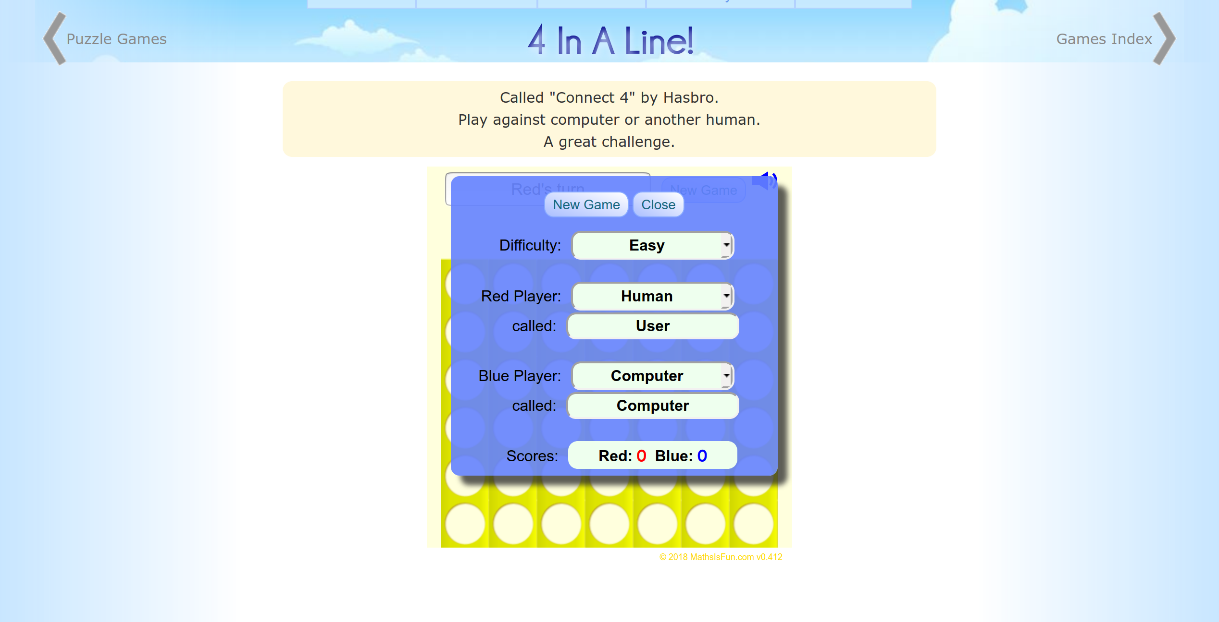
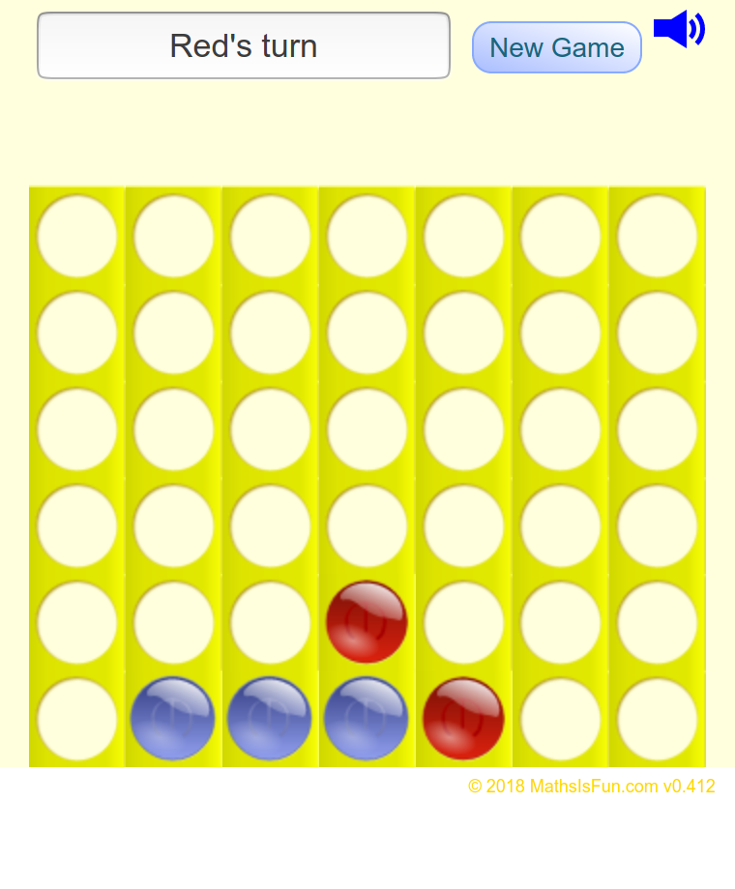
https://www.mathsisfun.com/games/connect4.html
Minimal noise & clutter (rule 2 fulfilled)
Navigation buttons, easy to tell where user is on the page
Graphics and design are basic, but sufficient enough to play a game of connect 4 without any problems.
Information presented to user in a clear way
https://papergames.io/en/connect4
Multiplayer oriented, easy to find a game for a new user
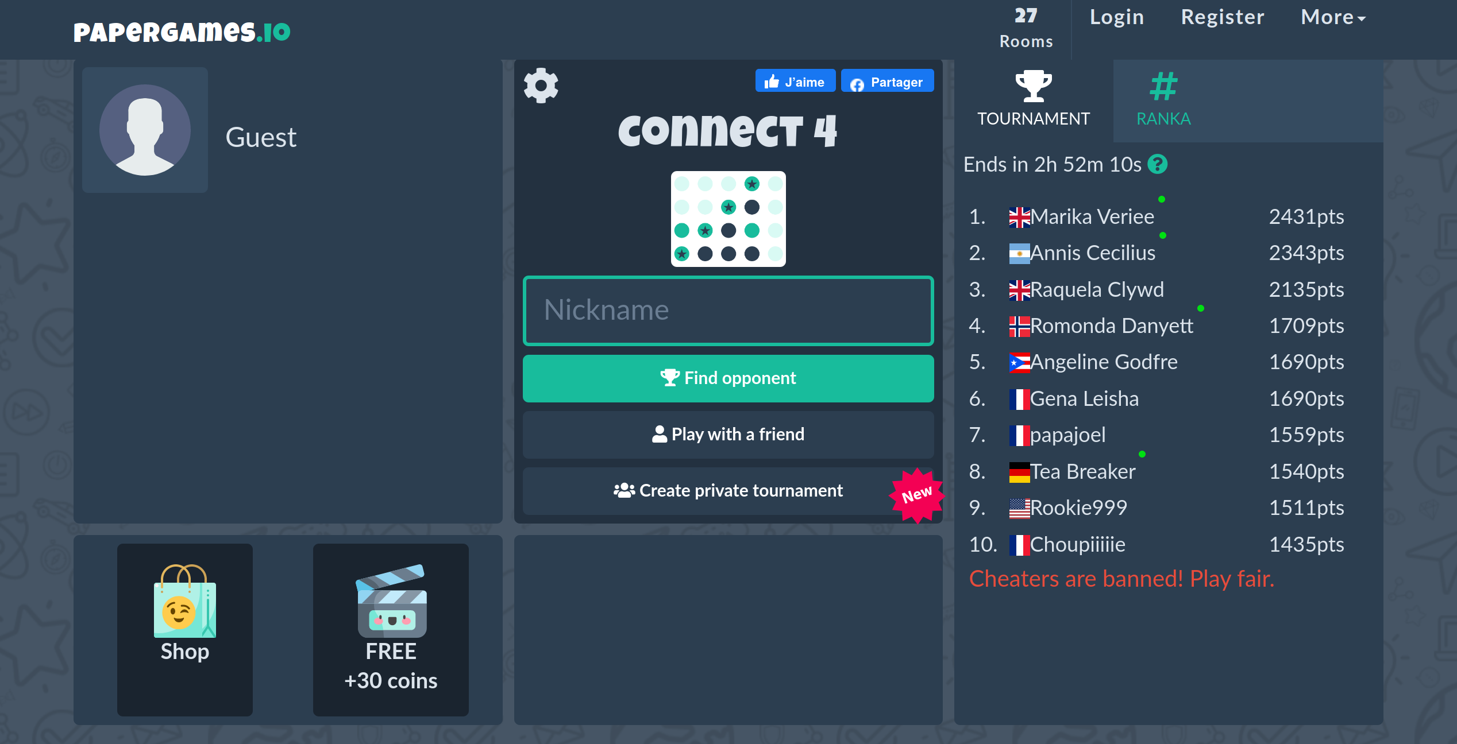
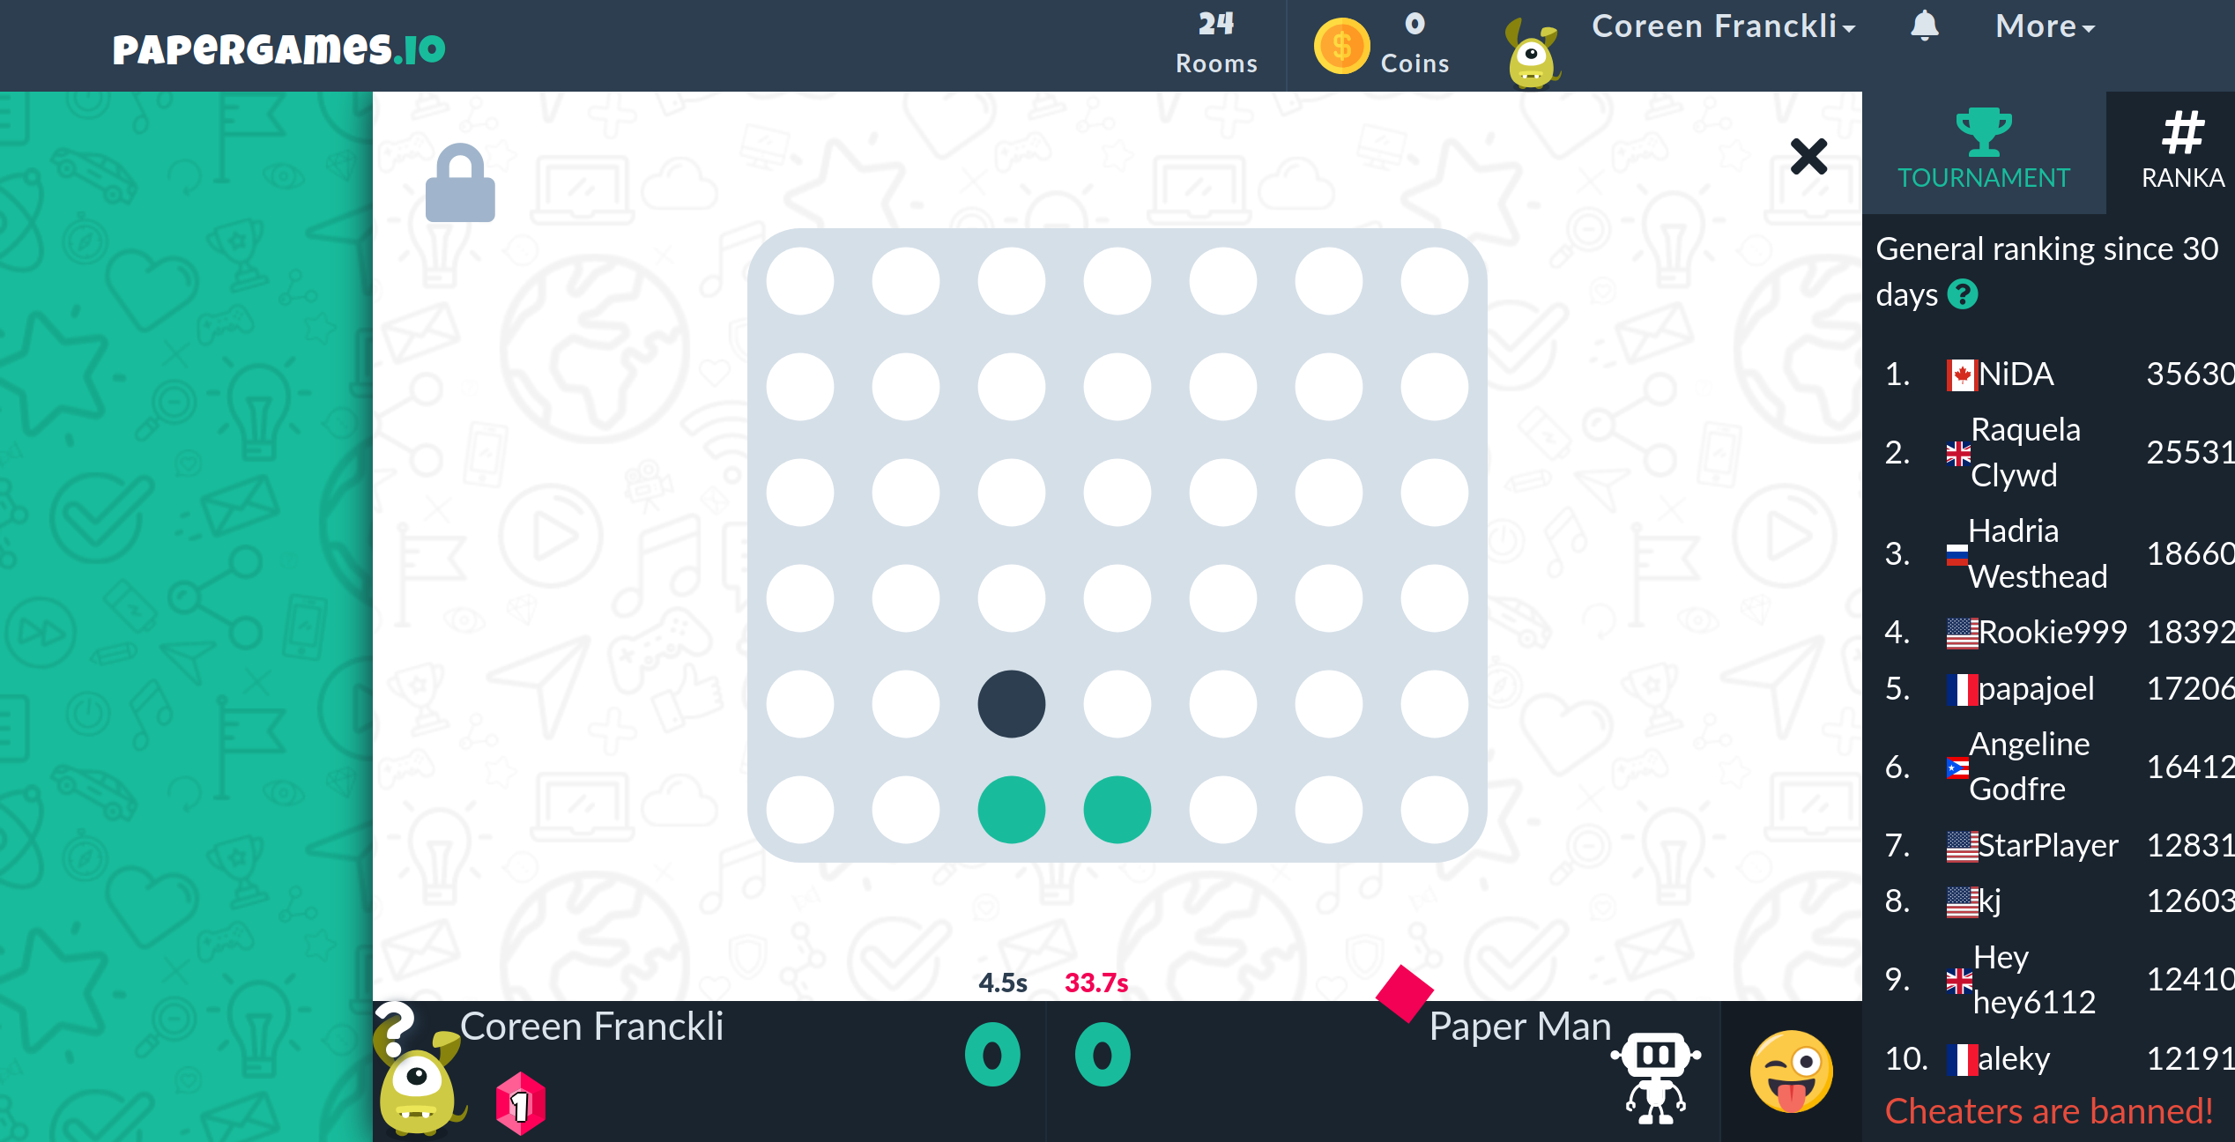
Modern and aesthetically pleasing design
Layout is clear – not many distractions
Great focus on the game itself
https://www.girlsgogames.com/game/connect-4-classic
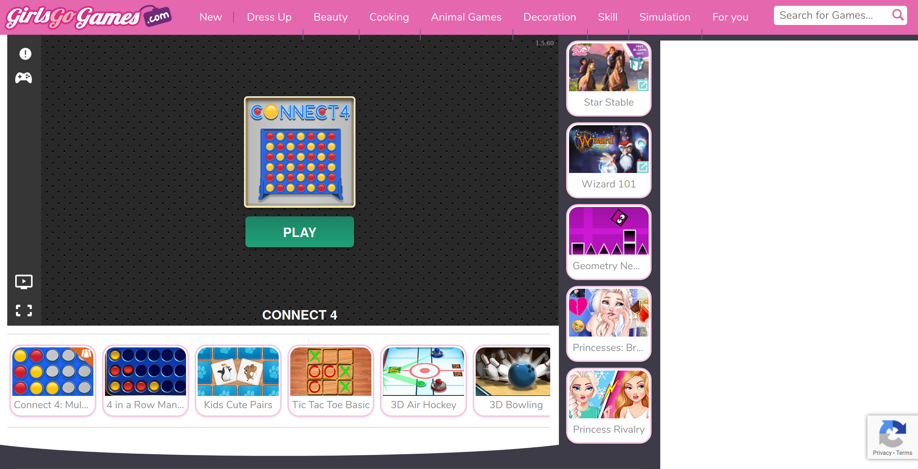
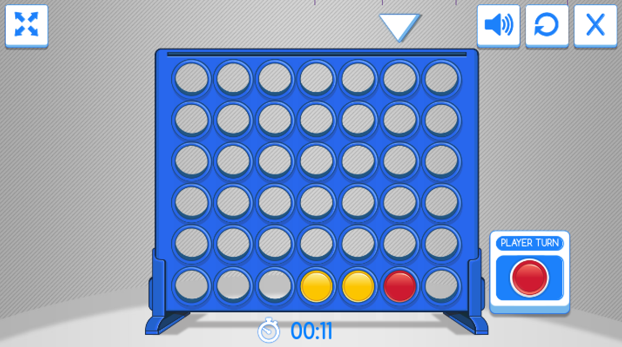
Page design can be distracting. Also there is no clear indication on where the user is on the page (trunk test violated)
However, the flash game is well designed. The user can go fullscreen to avoid those distractions on the page itself.
Useful information is presented, which player it is to move and current gametime.

