User Requirements Specifications

Fontys University of Applied Sciences
Department of ICT

Semester 2 Media Bazaar Project
S2-S-CB-05, Group 4

Made by:
Nitu Ana, Onea Bianca, Cetinic Franulovic Ante, Barbaro Vid

Project mentor:
Sivaramakrishnan Karthika

February, 2021.

Contents
Agreements with client 2
Functional requirements 2
Use cases 2
GUI 2

Agreements with client

In the meeting with the client, we have made agreements to present a demo of our teams’ software solution after 6 weeks.
Concerning the technical part of our software solution the client requested to keep in mind usability, meaning that the application needs to be minimalist, simple to use, but serve all of its purposes at the same time. Media Bazaar currently has 50 employees and is planning to expend soon to about 100 employees, so the software solution needs to be scalable in size.
Since the company is a start-up, we want to create a well-organized environment for both the admins and managers and employees. We understood the different departments within the company and their needs and accessibility to certain features: CEO(Admin), Employees Managers, Inventory Managers, Warehouse Employees and Sales employees.
Priorities of the client are the usability and user friendliness of the application including structured information. The main features of the app should be systems to manage employees and the inventory, with the employee managing being made the priority over the inventory managing system.

Functional requirements

Functional Requirements

Functional requirement No. | Functional requirement description | Priority
FR 1 | Keeping track of attendance | Must
FR 2 | Keep track of inventory | Must
FR 3 | View a list of employees | Must
FR 4 | Manually assign shifts to employees | Must
FR 5 | Website for employees to log in and view their shifts and personal information | Must
FR 6 | Keep data on employees(Wage, name, address) | Must
FR 7 | Hire and fire employees | Must
FR 8 | App to view statistics about employees, stock | Should
FR 9 | Promoting and demoting employees | Should
FR 10 | Automatically assign shifts to employees | Could
FR 11 | Divide employees per department | Could
FR 12 | Select an employee and view his information | Could

Use cases

Use Case Name | Login
Use case Description | A user to the Software System login with their unique credentials in order to access the system and functionalities.
Actors | Admin, Managers, Employees
Pre-Condition | System must be open on the login page, the user needs to know their unique credentials.
Post-Condition | After a successful login, the user receives a message box with an appropriate message.

Main Scenarios | Serial Nr. | Steps
Stakeholders (Actors/Users) | 1. | Enter username, password and id.
 | 2. | Validate username, password and id.
 | 3. | Verify which type of the user is, according to the 5 departments. Allow access to the system.
Extensions | 1a. | Empty textbox.  System shows a message box with an appropriate message.
 | 1b. | Invalid username or id.  System shows a message box with an appropriate message.
 | 2a. | Invalid password.  System shows a message box with an appropriate message.
 | 3a. | Invalid Password for 3 times.  Application is blocked and only the admin can unblock it.

Use Case Name | Modify Announcement/News (Add, Update, Remove)
Use Case Description | On the home page, certain users of the Software System can add, update, remove an announcement. This particular announcement can be visible in the list box by all the users of the software.
Actors | Admins, Employees Managers, Inventory Managers
Pre-Condition | The users must be successfully logged in and on the home page.
Post-Condition | After successfully making modifications to the News list box, the user can instantly view all the changes.

Main Scenarios  ADD ANNOUNCENEMT | Serial Nr. | Steps
Stakeholders (Actors/Users) | 1. | Login as a user that has access to the features.
 | 2. | Press the button “Add”. A different form will open.
 | 3. | Add the text of the announcement in the specified text box and press the button “Add”.
 | 4. | When the user is finished with posting new announcements, he/she can press the button “Done” and the form will close.
Extensions | 1a. | The user is not allowed to access the features and he/she doesn’t have the specified buttons/ text boxes.
 | 3a. | The text box is empty.  System shows a message box with an appropriate message.
 | 4a. | If there is still text in the text box when pressing the button “Done”, the system will show a message box asking the user if he/she wants to post that announcement.

Main Scenarios  UPDATE ANNOUNCENEMT | Serial Nr. | Steps
Stakeholders (Actors/Users) | 1. | Login as a user that has access to the features.
 | 2. | The user selects the announcement that needs to be updated.
 | 3. | The user makes the changes to the announcement in the text box.
 | 4. | The user presses the button “Update” in order to post the updated news.
Extensions | 1a. | The user is not allowed to access the features and he/she doesn’t have the specified buttons/ text boxes.
 | 2a. | The user didn’t select an announcement.  System shows a message box with an appropriate message.

Main Scenarios  REMOVE ANNOUNCENEMT | Serial Nr. | Steps
Stakeholders (Actors/Users) | 1. | Login as a user that has access to the features.
 | 2. | The user selects the announcement that needs to be removed.
 | 3. | The user presses the button “Remove” in order to remove the selected news.
Extensions | 1a. | The user is not allowed to access the features and he/she doesn’t have the specified buttons/ text boxes.
 | 2a. | The user didn’t select an announcement.  System shows a message box with an appropriate message.

Use Case Name
Use Case Description
Actors
Pre-Condition
Post-Condition

GUI

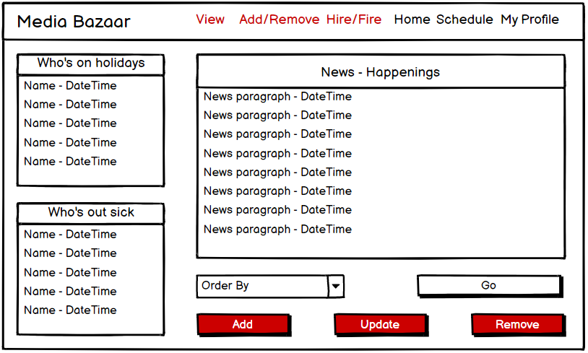
Home page: - all 3 listboxes are scrollable
- The 2 listboxes on the left should update when the date representing the end of that employees holiday comes and that employee should be removed from that listbox
- Only managers and the CEO can see the 3 red buttons on this page and they are the only ones that can add a happening or update or remove that happening. When they press the “Add” button a new form pops up that needs to be filled in with information like title of the happening and description before being able to publish it. The remove button should remove the selected item in the listbox.
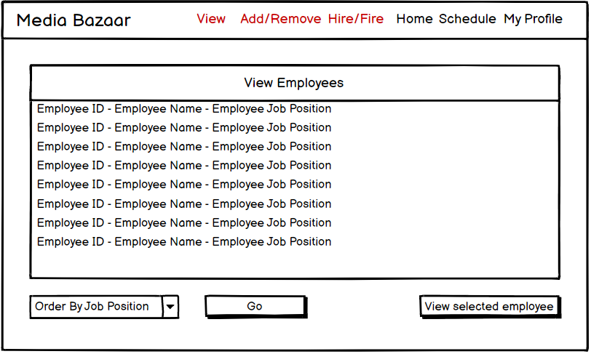
View employees page:
- Listbox is scrollable
- This page is only accessible by the CEO and employee manager
- The listbox gets information from the employee database
- The combobox orders the employees by the chosen department
- The view button can be used after clicking on an employee in the listbox. A new form pops up with all the information about that employee
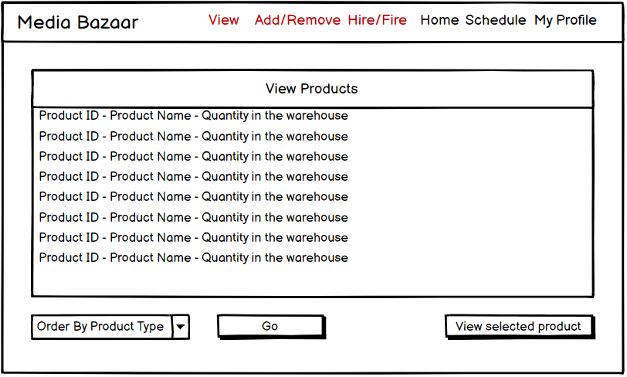
View Products page: - Only viewable by CEO and inventory manager
- The page is very similar to the view employee page with all functions doing the same just for products, so ordering is by product department and viewing a selected product opens a new form with information about that product
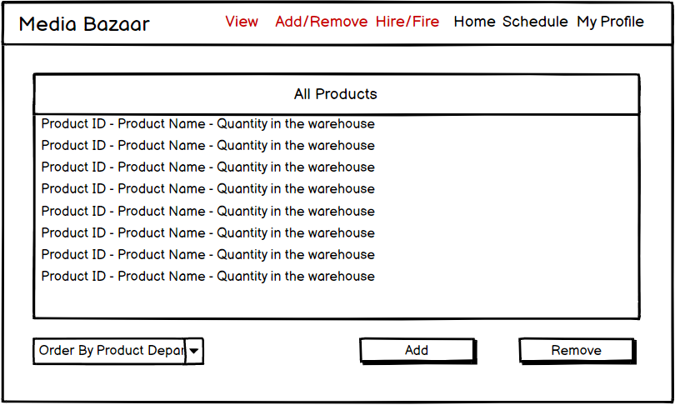
Add/Remove Products page: - The page is accessible only by the inventory manager
- The combobox orders items in the listbox by department
- The add button opens up a new form that has details like Name, Distributor, ID is self incrementing
- The remove button removes a selected item from the listbox
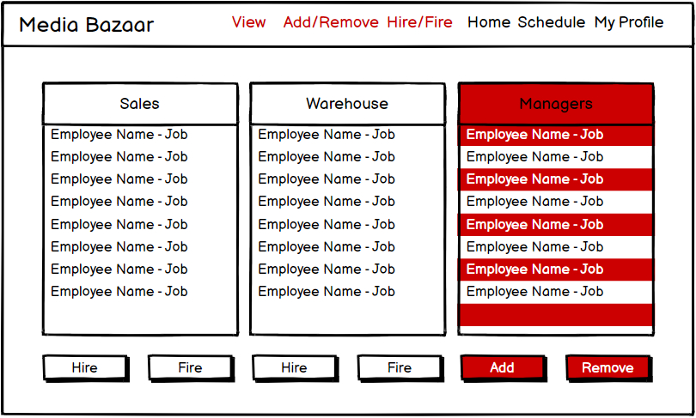
Hire/Fire Employees page: - This page is accessible by CEO and employee manager
- The hire buttons open up a new form with details that need to be filled in with name, job, birthdate… and that info then gets stored in the employee database
- The managers can also be hired and fired but only by the CEO
- The fire buttons work on a select-click-execute basis, fired employees get removed from the database
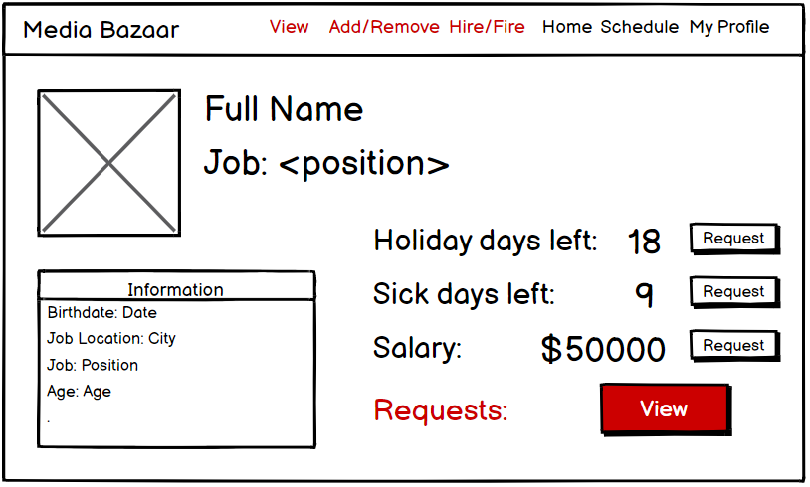
My Profile page:
- Information on the left can either be a listbox or a collection of labels(not yet decided)
- The buttons that request holidays or sick days open a new form that sends a request to the employee manager
- If the request is approved the number of holiday/sick days decreases
- Requests if something that employee manager sees and if he clicks on it a new form opens with a listbox of requests and he can either approve or deny those requests

