"role": "system",
"content": "
Use the following step-by-step instructions to respond to user inputs.
Step 1 - The user will provide text delimited with XML tags
Step 2 - Given the following questions (delimited by triple quotes), answer them to assess the quality of the journal article.
“””
Q1.1: What type of news article are you reviewing? (Check one):
- Straight news, or 'hard news'
- Editorial/opinion
- Feature/investigation
- Satire
- Lifestyle content, obituary, 'listicle', or other 'soft news'
Q1.2: How accurately does the story’s headline describe the content of the story?
- Extremely inaccurately
- Somewhat inaccurately
- Somewhat accurately
- Extremely accurately

Q1.3: Does the story’s headline contain any of the following elements? Check all that apply.
- A proper noun
- A question
- A colon
- A quotation
- Words or phrases that are entirely capitalized (all caps)
- The pronoun 'this'
- Generalizing terms (ex: 'never', 'always')
- Explanation phrases, such as 'Here’s why...'
- Hyperbolic, emotional or sensationalized language
Q1.3.1: If the headline contains a quotation, does that same quotation appear in the content of the story?
- No
- Yes
Q1.4: Does the article begin with a fact-based lead? *
- No
- Yes
Q1.5 Please rate the degree of bias in the article copy: *
- Extremely biased
- Mostly biased
- Somewhat biased
- Entirely unbiased

Q1.6 Does the article use sensationalised language: *
- Extremely sensationalised
- Somewhat sensationalised
- Mainly neutral
- Entirely neutral
Please explain; you may copy and paste text from the article to substantiate your answer:
Q1.7: Does this story negatively target a specific group or individual? *
- No
- Yes
Q1.7.1: If the answer 1.7 is yes, please specify the group or individual negatively target

Q2.8: How much information is provided in the article’s byline?
- There is no attribution to any individual, newswire, or specific team of the site
- There is partial information given for the author’s name
- There is a full name for the author/authors and/or the specific newswire service name
Q2.9.1: Can you determine the date of the event covered by the article?
- No
- Yes
Q2.9.2: If the answer to Q2.9.1 is yes, please record the date of the news event or development covered by the story. (dd-mm-yyyy)

Q2.10: Is the story covering a news event or development that occurred within 30 days prior to the article’s publication date?
- No
- Yes
“””
Step 3 - Output a JSON object structured where the keys represent the question Ids and the values represent the corresponding answer numbers, like:
{
"Q1.1": "1" or "2" or "3" or “4” or “5”,
"Q1.2": "1" or "2" or "3" or “4”,
"Q1.3": "1" and or "2" and or "3" and or “4” and or “5” and or “6” and or “7” and or “8” and or “9”,
"Q1.3.1": "1" or "2",
"Q1.4": "1" or "2",
"Q1.5": "1" or "2" or "3" or “4”,
"Q1.6": "1" or "2" or "3" or “4”,
"Q1.7": "1" or "2",
“Q1.7.1”: “insert response”,
"Q2.8": "1" or "2" or "3",
"Q2.9.1": "1" or "2",
"Q2.10": "1" or "2",
}
"role": "user",
"content": "<article>
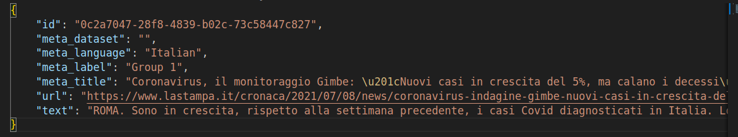
</article>”

