Fonti Proxmox-Portal

1 Lista delle fonti 3
2 Prompt AI 3

Lista delle fonti

- https://pve.proxmox.com/wiki/Proxmox_VE_API
- https://lore.proxmox.com/pve-devel/316d54c09c624013ab5d6501710e2fcce9580370.camel%40groupe-cyllene.com/
- https://forum.proxmox.com/threads/nodes-node-lxc-vm_id-interfaces-not-available.143901/
- https://github.com/proxmoxer/proxmoxer
- https://proxmoxer.github.io/docs/2.0/basic_usage/
- https://docs.python.org/3/library/ipaddress.html
- https://stackoverflow.com/questions/24196932/how-can-i-get-the-ip-address-from-a-nic-network-interface-controller-in-python
- chatgpt.com
- https://docs.python.org/3/library/secrets.html
- https://stackoverflow.com/questions/3854692/generate-password-in-python
- https://docs.python.org/3/library/socket.html
- https://precli.readthedocs.io/0.7.10/rules/python/stdlib/socket-no-timeout/
- https://docs.paramiko.org/en/stable/api/client.html
- https://docs.paramiko.org/en/stable/api/channel.html
- https://docs.paramiko.org/en/stable/api/client.html
- https://man7.org/linux/man-pages/man8/chpasswd.8.html
- https://docs.python.org/3/library/shlex.html
- https://man7.org/linux/man-pages/man8/sudo.8.html

Prompt AI
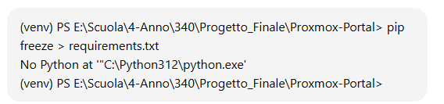

Spiegazione Errore Python

Mancante apertura del file auth.log
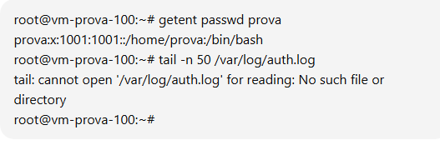

Da continuare

