The impact of social and weather drivers on the historical electricity demand in Europe
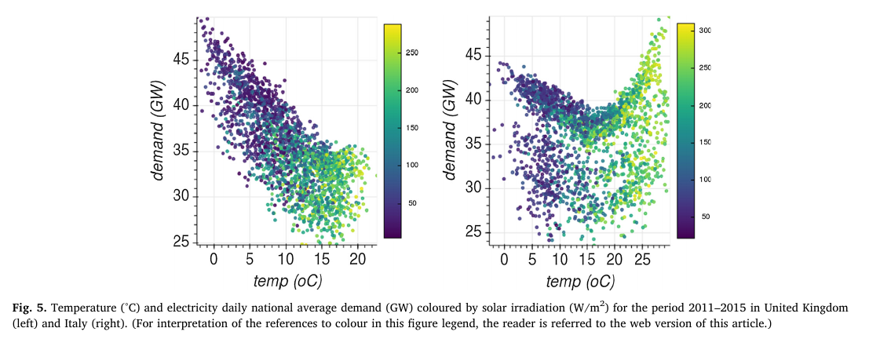
wind speed and solar irradiation alone did not show a strong relationship with demand, indicated by a Spearman correlation coefficient of 0.53 and −0.64, respectively (Suppl. Fig. S11). The relationship between temperature and demand, however, has a different trend for each European state, with southern countries showing a parabola-like curve and northern ones generally displaying a monotonic inversely proportional trend (Fig. 5).

The increasing impact of weather on electricity supply and demand

Relationships between meteorological variables and monthly electricity demand

The main purpose of this study is to analyse the effect of the meteorological variability on the monthly electricity demand in Italy. Temperature, wind speed, relative humidity and cloud cover are considered

Temperature turns out to be the most important variable. According to the month considered, a specific combination of the weather related variables can give the lowest Mean Absolute Percentage Error (MAPE) but differences are usually small. Good results for the summer months are obtained using Heat Index to calculate the Cooling Degree-Days; the cloud cover has a major influence from February to April.

More recently, the deregulation of the electricity markets and the evidence of the ongoing climate changes [1] have promoted an increased scientific interest in the study of the relationships between energy consumption and weather/climate [2–4]. In the

Previous studies have shown that air temperature is the most significant climatic variable affecting electricity demand [2], whereas other variables like humidity and wind speed may be used as correcting terms for the influence of temperature [19].

The relationship between electricity demand and temperature in the European countries is non-linear with a more pronounced non-linear pattern in the warm countries [20]. An evident U-shaped relation has been found in the warmer areas, as also confirmed by other studies regarding Greece [14,21] and Spain [15,19,22].

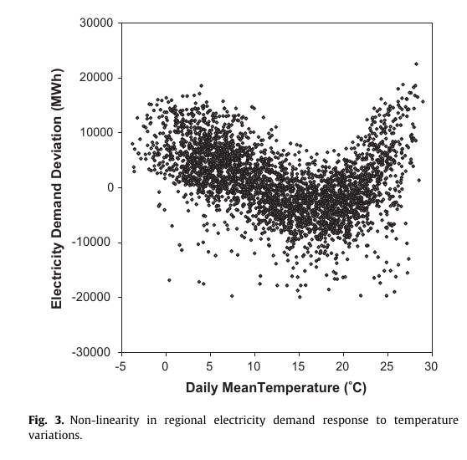
The non-linear dependence of the electricity demand on temperature has been dealt with using the Cooling and Heating Degree Month variables; the possible ef-

Modelling the non-linear response of Spanish electricity demand to temperature variations

Energy requirements, and specifically a country’s demand for electricity, are strongly linked to climatological factors, which explain in large measure their intra-annual variability. Temperature stands out among the meteorological factors that affect electricity

The principal studies indicate that the relationship between electricity demand and temperature is clearly non-linear. This non-linearity refers to the fact that both increases and decreases of temperature, linked to the passing of certain bthresholdQ temperatures, increase the demand for electricity. According to Henley and Peirson (1997), this response is caused by the differences between the ambient or outdoor temperature and the comfort or indoor temperature. When the differential between outdoor and indoor temperatures increases, the starting-up of the corresponding heating or cooling equipment immediately raises the demand for energy. Naturally, the curve of the response of demand to temperatures depends especially on the climate characteristics of the geographical area to which the demand data refer, which condition the type of equipment installed, and the conditions under which it will start to operate. Thus, in especially hot areas, there will be hardly any response to cold, and conversely in relatively cold or temperate regions, there will be little or no response to heat.1 Also, the notion of indoor temperature is not a

Factors affecting electricity demand in Athens, Greece and London, UK: A comparative assessment

More recently, the deregulation of the electricity markets and the evidence of the ongoing climate changes [1] have promoted an increased scientific interest in the study of the relationships between energy consumption and weather/climate [2–4]. In the

Temperature has been found to play the most important role in controlling the electricity load demand, especially for Athens. For both cities electricity demand peaks in winter but for Athens a second significant peak is apparent in the summer, not present in London. Thermal comfort

Several economic activities are affected by weather fluctuations. One of the most sensitive is the electricity market, since power demand is closely linked to air temperature. The sensitivity of energy demand to weather stems from the fact that that produced electricity must be instantly consumed. Various studies have investigated the influence of ambient air temperature, most times represented by heating and cooling degree-days, on electrical energy consumption [1–10]. However, temperature is not the only variable considered in the literature. Other primitive independent variables, such as relative humidity, clearness index, cloudiness, rainfall, solar radiation and wind speed [11–15], and derived variables including latent enthalpy-days,

Time series analysis of daily electricity demand data reviles a ‘‘U’’ shape relation between outdoor temperature and electricity demand [3,5,10,11,15,25,26,28,32,33]. This non-linearity refers to the fact that both increases and decreases of temperature, linked to exceeding certain ‘‘threshold’’ temperatures, increase the demand for electricity. According to Henley and Peirson [2], this response is

