Summer temperature in the eastern part of southern South America: its variability in the twentieth century and a teleconnection with Oceania

Mo and Paegle (2001) found that tropical convection, dominated by the Madden-Julian Oscillation (MJO), modulates the intraseasonal Pacific-South American modes 1 and 2 (PSA1 and PSA2) for both summer and winter during 1949–2000, in both the interannual and intraseasonal bands. These modes are connected to rainfall anomalies over northeastern Brazil, the South Atlantic Convergence Zone (SACZ), and the subtropical plains. Dı́az and Aceituno (2003)

Intraseasonal teleconnections leading to heat waves in central Chile

Specifically, we explore the relationship between warm events in CCh and (a) the Madden-Julian Oscillation (MJO) as a tropical source of variability, and (b) an extra-tropical index (ETI), representative of the internal dynamics of the Southern Hemipshere mid-latitudes, presented as an original contribution from this study following a novel approach. Both signals, and apparently their constructive superposition, seem to contribute to the organization of the large-scale circulation anomalies leading ultimately to heat waves in CCh.
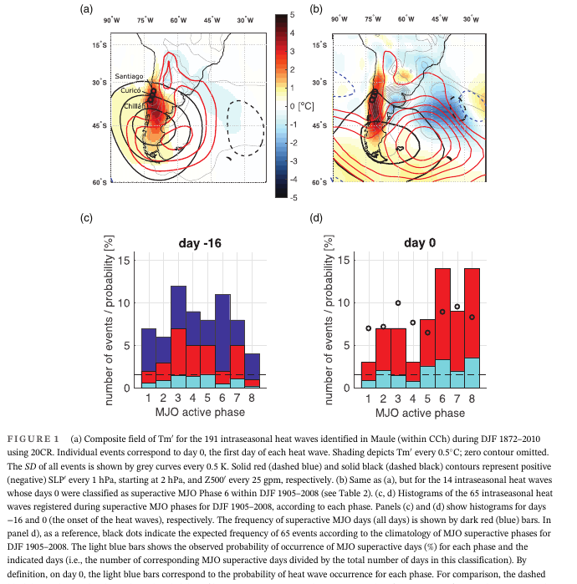

The development of one MJO cycle can be divided into eight phases, numbered from 1 to 8, according to the widely-used Wheeler and Hendon Real-time Multivariate MJO (RMM) index (Wheeler and Hendon, 2004). An MJO phase is said to be active when the intensity of its RMM index surpasses a given threshold, typically 1 unit. Alvarez et al. (2015) described the MJO-induced seasonal signals in temperature and precipitation over South America for 1979–2012, with-out focusing on extreme events. In southeastern Patagonia, heat waves tend to cluster within active MJO Phase 8 (Jacques-Coper et al., 2015). This result definitely contrib-

For the historical period (DJF 1872–2010), we use daily 2 m mean temperature (Tm), sea level pressure (SLP), and geopotential height at 500 hPa (Z500) from the 20th century reanalysis version 2 (20CR), with a 2# × 2# horizontal resolution (Compo et al., 2011). This data set has been successfully used in previous own studies focusing on teleconnections of extreme events in southern South America (Jacques-Coper et al., 2015,

2016). As in those publications, we follow the methodology proposed by Cerne and Vera (2011), analysing synoptic-to-intraseasonal variability anomalies, that is, those values resulting after extracting from each variable its annual cycle and the corresponding DJF seasonal departure from the reference climatology (1961–1990), i.e., the interannual variability, hence effectively removing possible long-term trends The corresponding anoma-lies are denoted by a prime (e.g., Tm0). As a starting

tical significance. Specifically, heat waves that show a superactive MJO on their day 0 tend to occur with higher frequency on Phases 6 and 8 (Figure 1d). As reported in previous own work (Jacques-Coper et al., 2015), superactive MJO Phase 8 induces a warm anomaly centred in Eastern Patagonia and hence the signal in CCh results as a northwestward extension of it. Moreover, heat wave events peaking during MJO Phase 8 might follow as a consequence of tropical forcing persisting from MJO Phase 6. Hence, research priority is put on MJO Phase

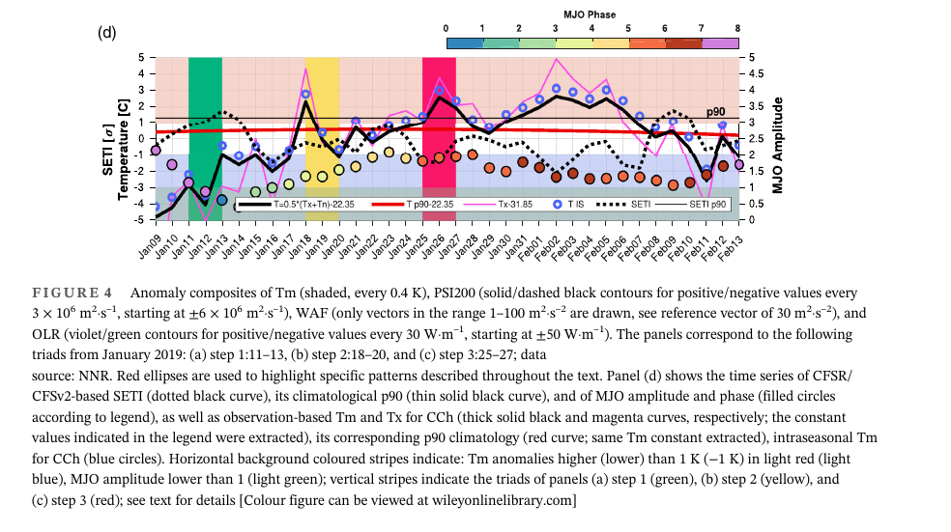

Joint Diagnostic of the Surface Air Temperature in Southern South America and the Madden–Julian Oscillation

It was found that the different phases of the MJO show a consistent signal on winter temperature variability and precipitation in southeastern South America.

Series of daily maximum and minimum temperatures at 53 stations provided by the National Weather Service of Argentina and the Claris Project were selected. These

Influence of the Madden Julian Oscillation on precipitation and surface air temperature in South America

chances of enhanced rainfall are observed in southeastern South America (SESA) region mainly during RMM phases 3 and 4, accompanied by cold anomalies in the extratropics, while enhanced rainfall in the South Atlantic Convergence Zone (SACZ) region is observed in phases 8 and 1.

an anticyclonic anomaly over southern South America. In September–November, enhanced rainfall and upper-level divergence are observed in the SACZ region during phases 7 and 8. These signals are generated primarily through the propagation of Rossby wave energy generated in the region of anomalous heating associated with the MJO.

Daily values of 250-hPa geopotential heights, 0.21-sigma level velocity potential, and surface air temperature were taken from the National Center for Environmental Prediction-National Center for Atmospheric Research (NCEP-NCAR) reanalysis dataset (Kalnay et al. 1996), from December 1979 to November 2012. These datasets are on a 2.5° × 2.5° grid. Daily precipitation on a 1° × 1° grid is from the dataset developed by Liebmann and Allured (2005), within the period December 1979 to November 2011.

convection, during all seasons in phases 8 and 1 convecion is maximum in the western hemisphere and Africa, phases 2 and 3 correspond to a maximum over the Indian Ocean, phases 4 and 5 peak over the Maritime Continent, and phases 6 and 7 over the western Pacific (Wheeler and Hendon 2004). It has been shown that statistical prediction of the RMM index has useful skill out to 2 weeks by using

All calculations were done separately for the 3-month seasons December–February (DJF), March–May (MAM), June–August (JJA) and September–November (SON). Daily anomalies of temperature, geopotential height and velocity potential were calculated at every grid point by subtracting the long-term average for that day so as to remove the seasonal cycle.

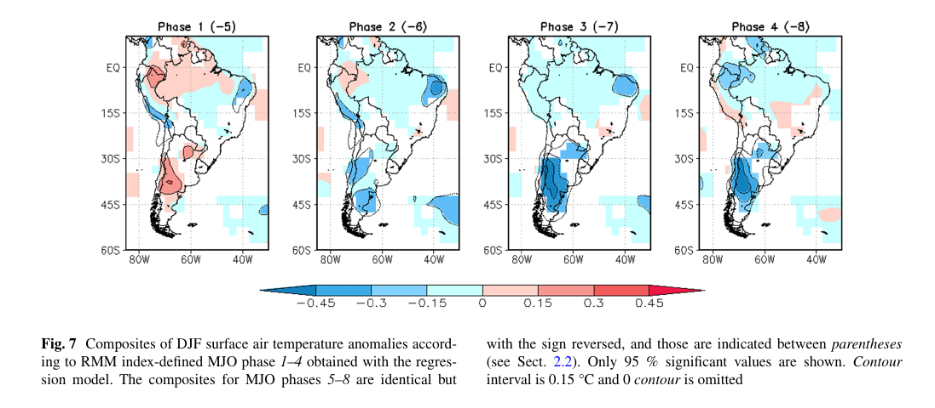
Intraseasonal modulation of spring-strong wind events associated with convection in northeastern Argentina

Moreover, the MJO strongly modulates heavy precipitation events over SACZ and SESA during summer, as well as sur- face temperature and associated circulation anomalies (Hirata and Grimm, 2016). MJO influence on regional climate in South America was also detected in spring as well as in the other seasons, although with large seasonal variations (Alvarez et al., 2016).

Hourly 10-m wind data and hourly Present Weather data from nine surface stations of the National Weather Service min NEA (Figure 1) are used to detect CSSWE. The data used

Influence of Madden–Julian Oscillation on extreme rainfall events in Spring in southern Uruguay

We used observational and reanalysis data. The reanalysis data are geopotential at 200 and 1,000 hPa and winds at 200 and 850 hPa, taken from reanalysis NCEP/ DOE (Kanamitsu, 2000) with a horizontal resolution of 2.5# × 2.5# in September–October–November during the
period 1980–2013. We also used the all-season real-time multivariate MJO index (RMM) (Wheeler and Hendon, 2004) taken from the Australian Bureau of Meteorology BOM (n.d.).

The observational data consists of daily accumulated rainfall registered in 15 gauge stations distributed in southern Uruguay during September–October–November (SON) 1980–2013. It was facilitated by the National Weather Service (INU) and the National Institute of Agricultural Investigation (INI). The region was defined as an area of similar rainfall characteristics in Ungerovich and Barreiro (2019). It was delimited considering 47 pluviometric stations available along the country. These stations were subjected to various clustering analysis to reduce the high-dimensionality of the dataset (i.e., from 47 to 4).

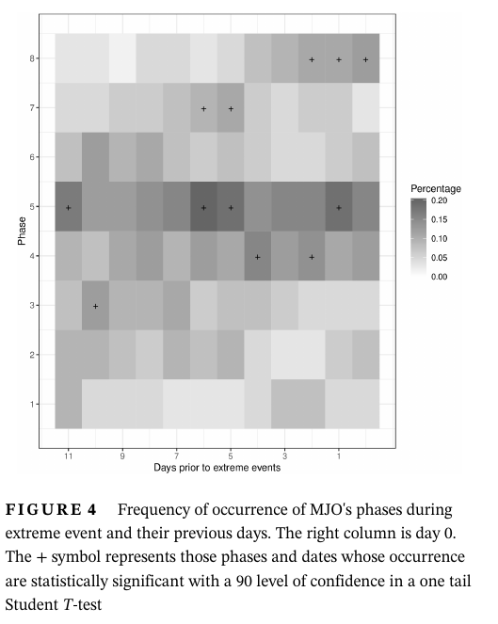
Evidence for a modulation of the intraseasonal summer temperature in Eastern Patagonia by the Madden-Julian Oscillation

Our results show that the summer SAT variability in Patagonia is highly driven by the intraseasonal activity (~80%), especially by that associated with the MJO. The active MJO phases modulate the spatial mean intraseasonal temperature signal in Eastern Patagonia with ~1.5°C of amplitude. In most of the region, the warmest (coldest) conditions are found during active phase 8 (4). These opposite states of the

The intraseasonal variability range has been reported to exhibit a notorious impact in temperature (especially in minimum temperature) in southeastern South America during winter [Naumann and Vargas, 2012]. For this region and season, Naumann and Vargas [2010] showed consistent covariability of temperature and precipitation with the MJO. The MJO is the dominant mode of intraseasonal variability of the tropical coupled ocean-atmosphere system. It consists of a planetary-scale eastward propagating pattern of atmospheric circulation and deep convection, associated with anomalies in various variables in both tropical and subtropical regions [Zhang, 2005]. The modulation of regional weather and climate systems by the MJO, especially in subtropical latitudes, has been extensively studied, regarding both precipitation [e.g., Sperber, 2003; Donald et al., 2006; Kanamori et al., 2013; Matthews et al., 2013] and temperature [e.g., Maloney and Kiehl, 2002; Oliver, 2014; Salby and Hendon, 1994; Zhou et al., 2011].

Large-scale impacts associated with this mode have also been described for climates of higher latitudes, both in the Northern Hemisphere [Vecchi and Bond, 2004; Cassou, 2008] and in the Southern Hemisphere, in particular, South America [e.g., Moore et al., 2010; Naumann and Vargas, 2010; Barrett et al., 2011; Juliá et al., 2012].

Recently, Alvarez et al. [2015] described the seasonal variations of the MJO influence on both rainfall and surface temperature anomalies in South America based solely on reanalysis and restricted to 1979–2012. In particular, that study shows a significant MJO signal on positive (negative) temperature anomalies in southern South America during MJO phases 7–8 (3–4) during summer. However, that study did not

A special novelty of this paper is that it comprises the analysis of long daily instrumental records, together with the Twentieth Century Reanalysis (20CR) and a century long reconstruction of the MJO. The said observational time series have not been assimilated in the reanalysis used here and thus constitute an independent data set to perform our research and compare our results. Due to its temporal coverage, the

With the aim of facilitating the intercomparison of results, the intraseasonal anomalies of each variable are defined in this paper after Cerne and Vera [2011], as the result of subtracting from the daily values their corresponding climatological daily means (a term which accounts for the annual cycle) and the seasonal departures of each particular year from the climatology (i.e., the DJF mean of each year minus the long-term seasonal mean). That is, the intraseasonal anomaly of a given variable for day d and year y is calculated as

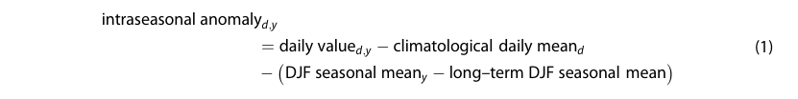
It is important to remark that the above definition of the intraseasonal scale does not remove high-frequency synoptic signals from the data. However, spectral analysis of SAT′ from each instrumental record (not shown) revealed that all of them exhibit a considerable amount of spectral power in the frequency band comprised between 30 and 90 days. Moreover, 11 out of the 16 time series (~69%) included in this study exhibit their spectral peak at periods longer than 30 days.

