The Global Influence of the Madden–Julian Oscillation on Extreme Temperature Events*

The results show that the frequency of extreme events is significantly modulated (i.e., increased by a factor of more than 2) by the MJO with a time lag over some areas in the extratropics as well as in the tropics. In the extratropics, the modulation of the frequency of the extreme events is roughly associated with midlatitude wave responses to tropical forcing and anomalous lower-level circulation due to the MJO.

The Madden–Julian oscillation (MJO) is the dominant mode of intraseasonal variability in the tropics (Madden and Julian 1994; Zhang 2005), and it influences weather and climate over not only the tropics but also the extra- tropics (e.g., Matthews et al. 2004). Previous studies have

Previous studies have examined various regional influences of the MJO on, for instance, precipitation over East Asia (Jeong et al. 2008), the intraseasonal fluctuations of the Australian summer monsoon (Hendon and Liebmann 1990), precipitation in Australia (Wheeler et al. 2009), winter surface temperature in Canada and North America (Lin and Brunet 2009; Schreck et al. 2013; Zhou et al. 2012), winter precipitation in Canada (Lin et al. 2010), the South American summer rainfall and circulation (Paegle et al. 2000; Carvalho et al. 2004), and precipitation in Africa (Pohl and Camberlin 2006; Alaka and Maloney 2012).

Moreover, the MJO may induce the occurrence of extreme weather events, which can have large societal and economic impacts. Jones et al. (2011) demonstrated a relationship between the MJO and extreme precipitation over the United States and Hong and Li (2009) investigated the extreme cold anomaly over Southeast Asia in February 2008. The main purpose of this paper is to discuss the global influence of the MJO on the extreme warm and cold conditions.

The MJO has been thought to have a potential predictability up to one month(Waliser et al. 2003; Reichler and Roads 2005; Ding et al. 2010) and to be a source of forecast predictability in the extratropics (Jones et al. 2004; Ferranti et al. 1990). Therefore, reliable forecasts of extreme weather events derived from the MJO signals would potentially be useful for disaster mitigation and risk management in various societal and economic

The Japanese 55-year Reanalysis (JRA-55) dataset (Ebita et al. 2011; Kobayashi et al. 2015) and the National Oceanic and Atmospheric Administration (NOAA) outgoing longwave radiation (OLR) data (Liebmann and Smith 1996) were used on a 2.58 grid for the period from 1981 to 2010.

This result suggests that the MJO contributes to the predictability of extreme events.

Impacts of the Madden–Julian Oscillation on Storm-Track Activity, Surface Air Temperature, and Precipitation over North America

The results highlight regions over which the MJO has significant impacts on surface weather on intraseasonal time scales. A north–south shift of storm-track activity associated with the MJO is found over North America. The shift is consistent with the MJO-related surface air temperature anomaly over the eastern United States. In many regions over the western, central, and southeastern United States, the MJO- related precipitation signal is also consistent with nearby storm-track activity. An MJO-related north–south shift of precipitation is also found near the west coast of North America, with the precipitation over California being consistent with the MJO-related storm-track activity over the eastern Pacific. MJO-related temperature

The Madden–Julian oscillation (MJO), characterized by large-scale eastward-propagating tropical convection, is the dominant mode of intraseasonal tropical variability (Madden and Julian 1971, 1972, 1994). One commonly used index for defining the phase and amplitude of the MJO is the real-time multivariate MJO (RMM) index (Wheeler and Hendon 2004). It separates the MJO as eight different phases depending on the location of MJO convection and associated circulation fields: a positive convective anomaly that develops over the Indian Ocean (phase 1); strengthens and propagates eastward during boreal winter, reaching the eastern Indian Ocean (phases 2–3); the Maritime Continent (phases 4–5); and the western Pacific (phases 6–7). Subsequently this anomaly continues to propagate east-ward but weakens, reaching east of the date line by phase 8. The accompanying negative convective anomaly, moves from the Indian Ocean (phase 5), across the eastern Indian Ocean (phases 6–7) and the Maritime Continent (phases 8–1), to the western Pacific (phases 2–3), and reaches east of the date line by phase 4. Many studies (e.g., Hoskins and Karoly 1981; Sardeshmukh and Hoskins 1988; Jin and Hoskins 1995) have shown that tropical diabatic heating source could excite stationary Rossby waves that propagate into the extratropics and significantly modulate the midlatitude circulation. Therefore, the eastward-moving convection associated with the MJO can act as diabatic heating source and modify the extratropical circulation (e.g., Matthews et al. 2004; Seo and Son 2012; Riddle et al. 2013). Pre-

Various indices have been defined to track the MJO. In this study, we make use of the RMM index, which is a commonly used MJO index. The RMM index is developed based on multivariate empirical orthogonal function (EOF) analysis of combined fields of OLR and 850- and 200-hPa zonal wind anomalies. The first two leading normalized principal components are usually referred to as RMM1 and RMM2. The MJO eight phase life cycle can be defined based on the sign and amplitude of RMM1 and RMM2, and the life cycle is characterized by the eastward propagation of tropical convection from the Indian Ocean toward the Western Hemisphere during boreal winter. In this study, ‘‘strong’’ MJO days are defined as the days when RMM index amplitude is greater than 1 [(RMM12 1 RMM2 2 ) 1/2 $ 1]. Only strong MJO days will be used to make the composites. Note that Guo et al. (2017) found that storm-

we will focus on the extended boreal winters (November–April) from 1979 to 2016. The 6-hourly mean sea level pressure (MSLP),

Prediction of the Madden–Julian Oscillation: A Review

There has been an accelerating interest in forecasting the weather and climate within the subseasonal time range. The Madden–Julian oscillation (MJO), an organized envelope of tropical convection, is recognized as one of the leading sources of subseasonal predictability. This review synthesizes the latest progress regarding the MJO predictability and prediction. During the past decade, the MJO prediction skill in dynamical prediction systems has exceeded the skill of empirical predictions.

The subseasonal forecast is particularly important since many management decisions, including those related to water, food, and hazard considerations, fall into this range. Skillful predictions of

The Madden–Julian oscillation (MJO; Madden and Julian 1971, 1972) is recognized as one of the leading sources of subseasonal predictability (e.g., Waliser 2011; Zhang et al. 2013). The MJO is an organized envelope of tropical convection with a life cycle of about 40–50 days, fitting neatly within the subseasonal time scale (30–90 days). It is characterized by a vast zonal scale (wavenumber 1–3) and a dominant eastward propagation over the tropical Indo-Pacific basin, particularly during the boreal winter season. The MJO-associated convection and circulation anomalies affect global weather and climate, acting as a primary source of subseasonal predictability for the global weather and climate system (e.g., Zhang 2005, 2013; Brunet et al. 2010; National Research Council 2010; Lau and Waliser 2011; Zhang et al. 2013; National Academies of Sciences, Engineering, and Medicine 2016). Real-time MJO forecasts are now produced routinely by many centers, a big difference since the community’s first attempts at cobbling together (experimental) operational MJO forecasts (Waliser et al. 2006). For example, NOAA/CPC1 produces a weekly update of MJO status and forecast, in addition to the dynamical model MJO forecasts every day.

Madden–Julian Oscillation Impacts on Australian Temperatures and Extremes

The MJO has significant impacts on Australian temperatures and winds in all parts of the country at various times

The state of the MJO is depicted using the real-time multi- variate MJO index pair, RMM1 and RMM2, from Wheeler and Hendon (2004). Calculated for each calendar day from 1 June 1974 to the present,5 these indices capture the eastward-propagating large-scale structure of the MJO in zonal wind and convection along the equator, providing a measure of the strength and phase of the MJO. The RMM indices are the principal components of the leading pair of eigenvectors derived from a combined empirical orthogonal function analysis of equatorially averaged outgoing longwave radiation (OLR) and zonal wind at 200 and 850 hPa. Importantly, they are filtering

RMM1 and RMM2 may equivalently be expressed as a daily amplitude ( RMM12 1 RMM22) and phase [tan21 (RMM2/RMM1)], which facilitates the construction of MJO composites in this study. We use the same eight phases as defined by Wheeler and Hendon (2004), with the MJO deemed to be in its active cycle when the RMM index amplitude is equal to or greater than one, and in a weak or inactive state when the RMM index amplitude is less than one. The MJO life cycle is depicted by active convection moving over the Indian Ocean in phases 2 and 3, over the Maritime Continent (directly north of Australia) in phases 4 and 5, and over the western and central Pacific Ocean in phases 6 and 7, with suppressed convection occurring a half cycle out of phase (e.g., over the Maritime Continent in phases 8 and 1). We use data spanning from 1 June 1974 to 31 May 2022 in this work to assess the MJO’s impacts over a complete 48-yr dataset.

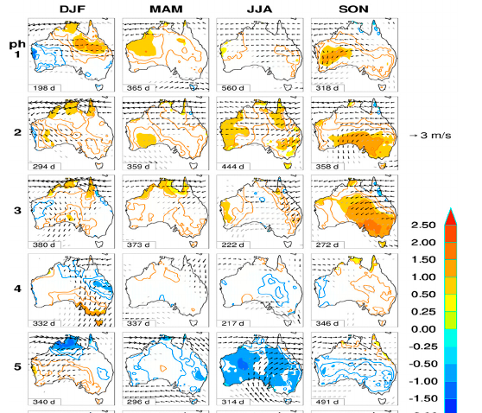
Near-global impact of the Madden-Julian Oscillation on rainfall

has a return interval of 30 to 80 days that might partly fill this gap. Our near-global analysis demonstrates that the MJO is a significant phenomenon that can influence daily rainfall patterns, even at higher latitudes, via teleconnections with broadscale mean sea level pressure (MSLP) patterns. These weather states provide a mechanistic basis for an MJO-based forecasting capacity that bridges the weather-climate divide. Knowledge of these tropical and extra-tropical MJO- associated weather states can significantly improve the tactical management of climate-sensitive systems such as agriculture. Citation: Donald, A., H. Meinke, B. Power, A. de H.

Evidence suggests that the MJO is responsible for much of the observed intraseasonal climate
variance not only in the tropics, but also in higher latitudes [Bond and Vecchi, 2003, Chen and Murakami, 1988; Barlow et al., 2006].

For this analysis, we used daily phase data for a period 1 June 1974 to 27 April 2004

Predictability of the Madden–Julian Oscillation index: seasonality and dependence on MJO phase

In a recent review, Waliser (2012) suggested that the predictability time scale of the MJO is at least 2 to 3 weeks. Recent model-based studies have estimated the time scale to be 20–24 days using a mixed ensemble of statistical and dynamical models (Kang and Kim 2010), 20–45 days using ensembles of dynamical models (with longer predictability estimates from multi- model means rather than single ensemble members; Neena et al. (2014)), and 32 days using ensembles of modern
climate forecast systems (Kim et al. 2014)

The predictability of the MJO is generally longer than the predictability limit attributed to weather
(1–2 weeks) and thus provides potential predictability on time scales that bridge the gap between weather and climate.

The Influence of the Madden–Julian Oscillation on Precipitation in Oregon and Washington*

Intraseasonal teleconnections leading to heat waves in central Chile

This study focuses on precursors of summer (December–February, DJF) warm events, particularly heat waves, in central Chile

We confirm these results for recent decades (DJF 1981–2020) using temperature observations and further data sets, namely the NCEP-NCAR Reanalysis (NNR) and the Climate Forecast System

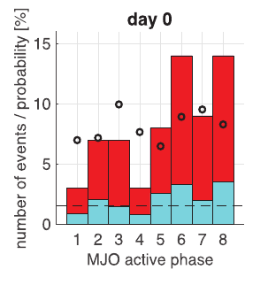
Wheeler and Hendon Real-time Multivariate MJO (RMM) index (Wheeler and Hendon, 2004). An MJO phase is said to be active when the intensity of its RMM index surpasses a given threshold, typically 1 unit. Alvarez et al. (2015) described the MJO-induced seasonal signals in temperature and precipitation over South America for 1979–2012, without focusing on extreme events. In southeastern Patagonia, heat waves tend to cluster within active MJO Phase 8 (Jacques-Coper et al., 2015). This result definitely contributes towards a better predictability of these events, considering a skilful MJO forecast capability. The MJO predictability limit is considered to lie in the range of 12–36 days (Lim et al., 2018).

. As in those publications, we follow the methodology proposed by Cerne and Vera (2011), analysing synoptic-to-intraseasonal variability anomalies, that is, those values resulting after extracting from each variable its annual cycle and the corresponding DJF seasonal departure from the reference climatology (1961–1990), i.e., the interannual variability, hence effectively removing possible long-term trends

we found that Phases 6 and 8 were the most populated ones.

The active MJO Phase 6 (but not 8) induces negative cloud fraction anomalies and hence more solar radiation over CCh (Barrett et al., 2012).

Intraseasonal and low frequency processes contributing to the December 2013 heat wave in Southern South America

.During the first period of the heat wave, the RMM MJO phase was 4 and 5, despite not showing a coherent displacement of the convective anomalies to the east (not shown).

Joint Diagnostic of the Surface Air Temperature in Southern South America and the Madden–Julian Oscillation

It was found that the different phases of the MJO show a consistent signal on winter temperature variability and precipitation in southeastern South America.

For the minimum temperature, for example, warm anomalies are observed over the entire northern region of the domain for phases 5 and 6 ESTO ES CONSISTENTE PARA URUG Y ARG. For phases 2 and 3, the inverse pattern of behavior is observed, with cold anomalies in nearly the entire region, except southeastern Brazil. It is worth noting that

A coherent pattern of behavior also exists in what is observed for the maximum temperature (Fig. 1) and precipitation (Naumann 2010), principally in the north- eastern portion of the region. In phases 3 and 5, negative maximum temperature anomalies (positive precipitation anomalies) were observed in the east-central portion of the region, while positive (negative) anomalies exist in Patagonia and the central Andes. Phases 1, 4, and 7 are characterized by the opposite behaviorESTO NO, with a deficit in precipitation in southeastern Brazil and northeastern Argentina. Excesses also stand out in phase 1 in Patagonia and the central mountain range.

Influence of the Madden Julian Oscillation on precipitation and surface air temperature in South America

During December–February when the South American monsoon system is active, chances of enhanced rainfall are observed in southeastern South America (SESA) region mainly during RMM phases 3 and 4, accompanied by cold anomalies in the extratropics, while enhanced rainfall in the South Atlantic Convergence Zone (SACZ) region is observed in phases 8 and 1. The SESA (SACZ) signal is characterized by upper-level convergence (divergence) over tropical South America and a cyclonic (anticyclonic) anomaly near the southern tip of the continent. Impacts during March–May are similar, but attenuated in the extratropics. Conversely, in June–November, reduced rainfall and cold anomalies are observed near the coast of the SACZ region during phases 4 and 5, favored by upper-level convergence over tropical South America and an anticyclonic anomaly over southern South America. In September–November, enhanced rainfall and upper-level divergence are observed in the SACZ region during phases 7 and 8. These signals are generated primarily through the propagation of Rossby wave energy generated in the region of anomalous heating associated with the MJO.

The MJO influence in South America has been identified in both austral summer precipitation (e.g., Liebmann et al. 2004; Jones et al. 2004; De Souza and Ambrizzi 2006) and in the occurrence of extreme wet and dry events (e.g., Muza et al. 2009). A large modulation of precipitation by the MJO in the area of the SACZ has been found (e.g., Paegle et al. 2000; Carvalho et al. 2004). Furthermore, large IS variability has also been recorded in surface air temperature anomalies in southern South America (e.g., Cerne and Vera 2011), which seems to be at least partially influenced by MJO activity (Naumann and Vargas 2010).

Daily values of 250-hPa geopotential heights, 0.21-sigma level velocity potential, and surface air temperature were taken from the National Center for Environmental Prediction-National Center for Atmospheric Research (NCEP-NCAR) reanalysis dataset (Kalnay et al. 1996), from December 1979 to November 2012. These datasets are on a 2.5° × 2.5° grid. Daily precipitation on a 1° × 1° grid is from the dataset developed by Liebmann and Allured (2005), within the period December 1979 to November 2011.

All calculations were done separately for the 3-month seasons December–February (DJF), March–May (MAM), June–August (JJA) and September–November (SON). Daily anomalies of temperature, geopotential height and velocity potential were calculated at every grid point by subtracting the long-term average for that day so as to remove the seasonal cycle. Following Zhou et al. (2011), composites of temperature, geopotential height and velocity potential anomalies were generated for each MJO phase through regression modeling. The advantage of the regression-based approach is that it fits the regression model to observations from

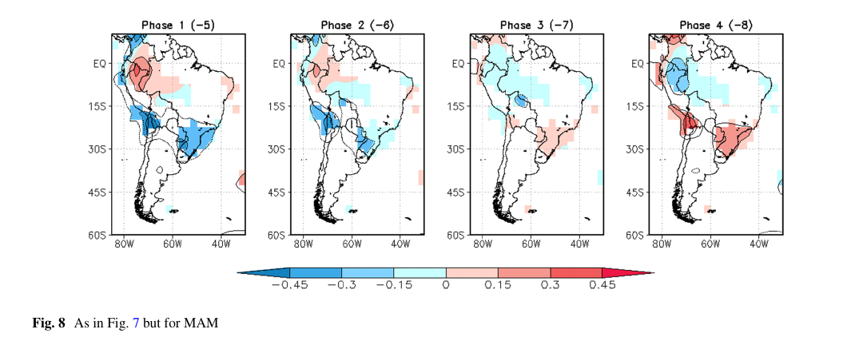
no hay mucha señal, la forma de la respuesta demanda-temp dificulkta la interpretacion
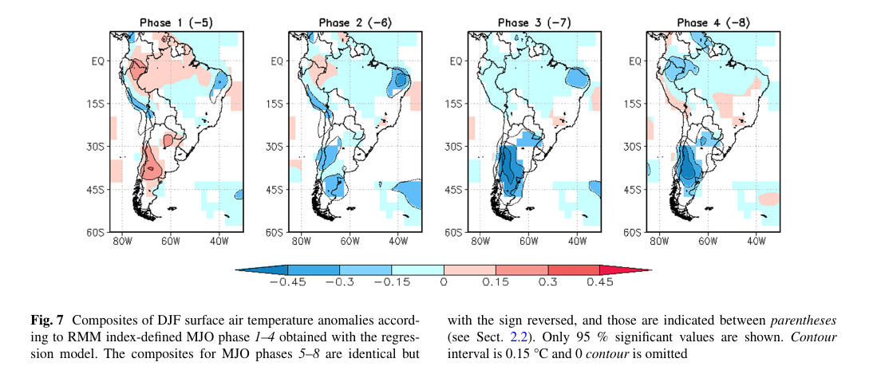
consistente – menos demanda en fases 3 4 5
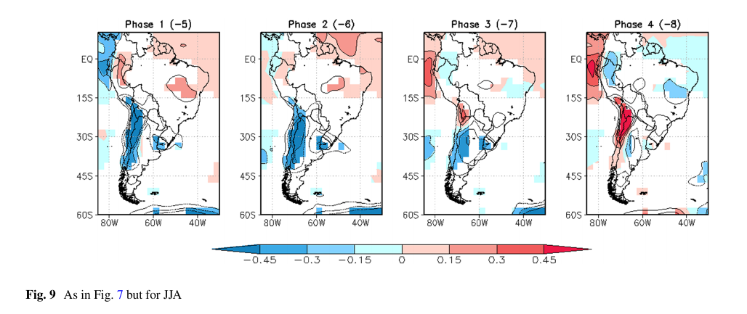
consistente fase 6 (menos demanda). No consistente fase 7 (mas demanda)
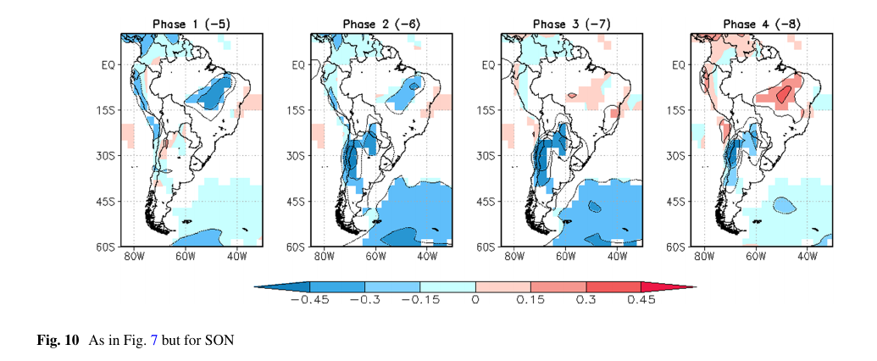
no hay mucha señal, la forma de la respuesta demanda-temp dificulkta la interpretacion

DJF fase 3 4 5 menos radiacion y mas lluvia ebn uruguay
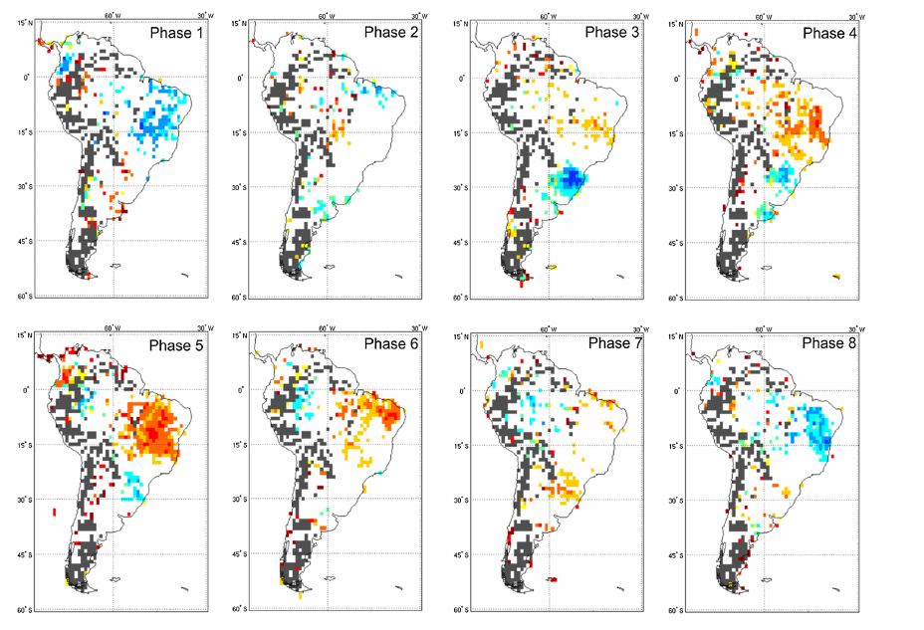
MAM 4 5 6 menos radiacion y mas lluvia ebn uruguay
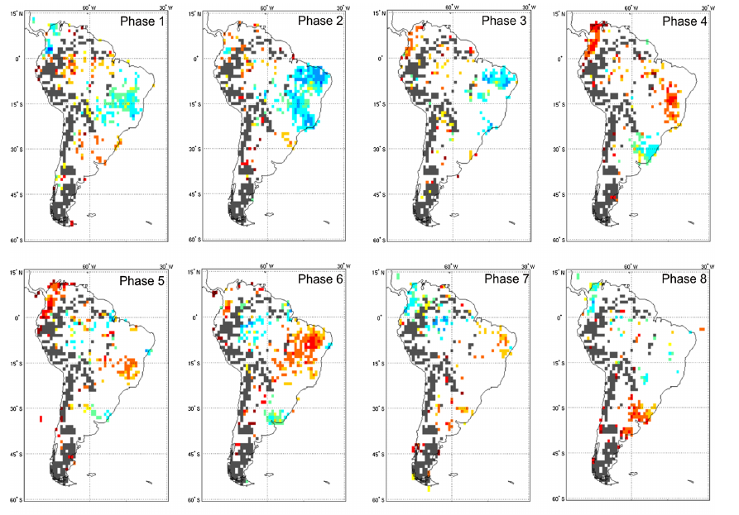

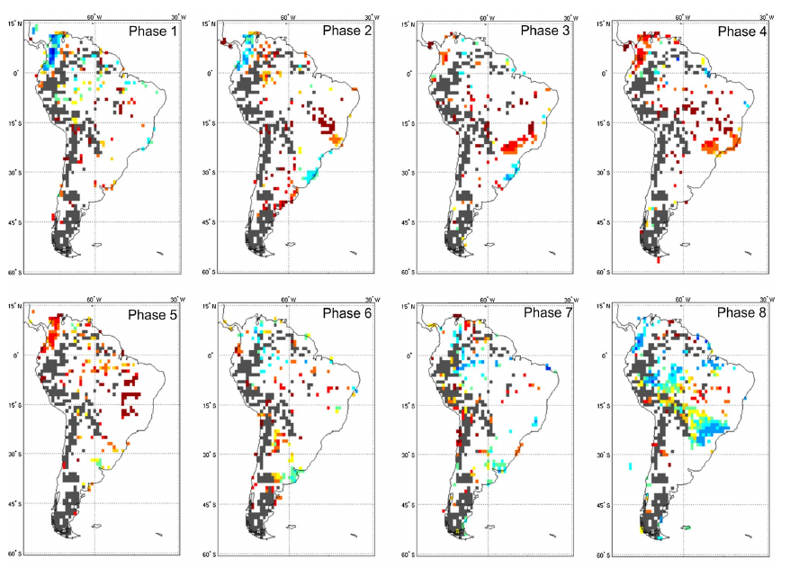
JJA

OND poca señal
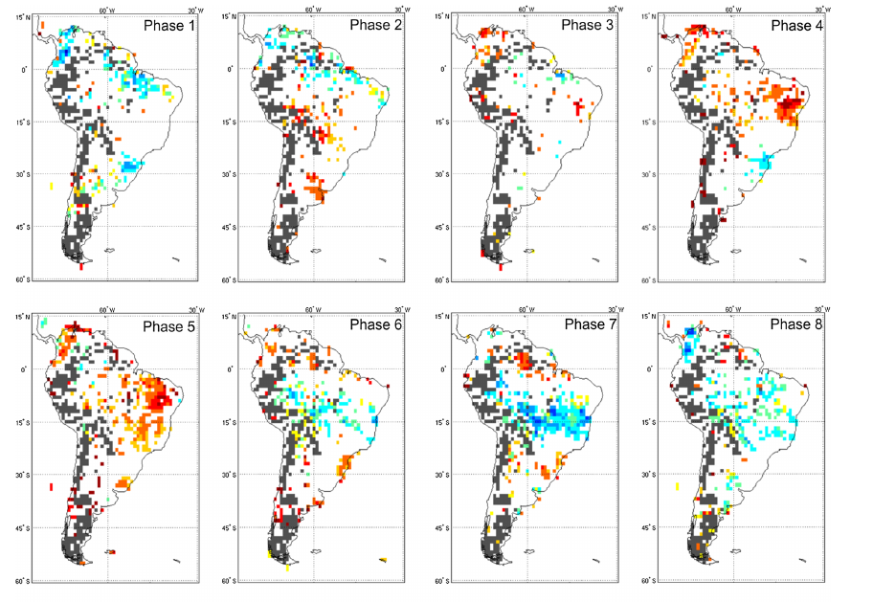
Madden–Julian Oscillation (MJO) Modulation of Atmospheric Circulation and Chilean Winter Precipitation

were created using the Real-Time Multivariate MJO index, which divides the MJO into eight longitudinally based phases. Precipitation was found to vary across MJO phases, with positive precipitation anomalies in central and south-central Chile (308–458S) for MJO phases 8, 1, and 2 FASE 8 + LLUVIA - RADIACION, and negative anomalies in phases 3–7. Circulation was also found to vary across phase, in good agreement with precipitation: low geopotential height and negative omega (corresponding to upward vertical motion) anomalies were found over and upstream of Chile during the rainier phases, and the anomalies reversed during the drier phases.

Because the MJO has some predictability (Jones et al. 2000; Kang and Kim 2010), intraseasonal forecasts of regional precipitation are now possible, especially once relationships between the MJO and relevant forcings are documented. Carrasco (2006) began this work for Chile,
NCEP 1980 - 2010

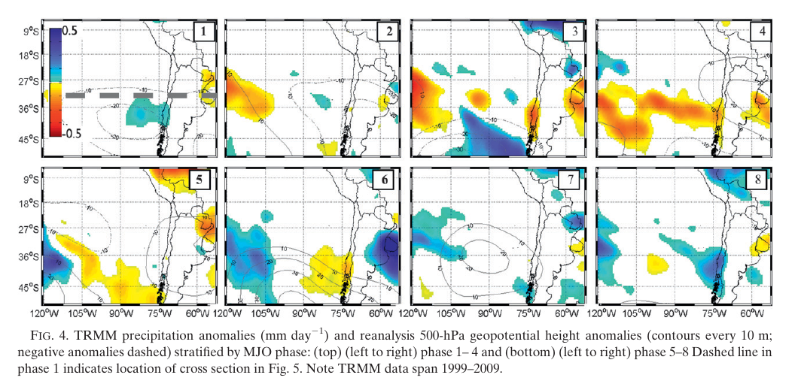
CONSISTENTE. 3 4 5 MS RADIACION. 8 MENOS

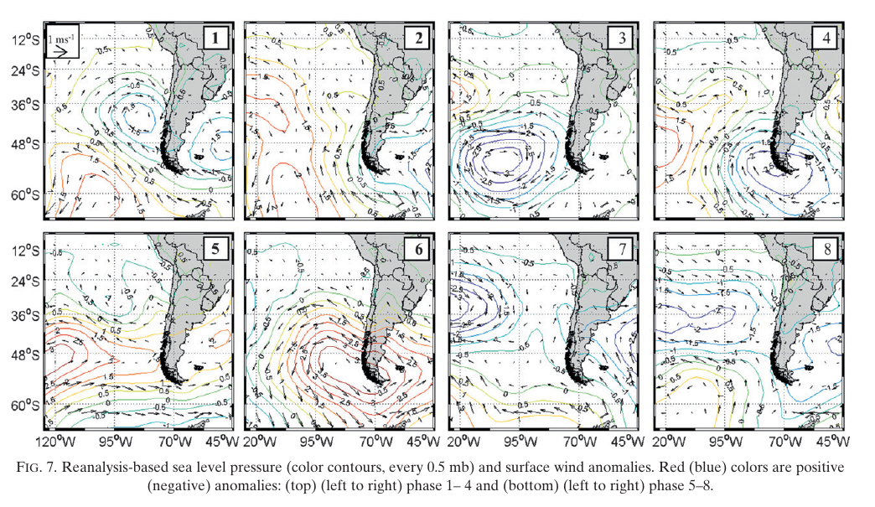
Assessing the Influence of the MJO on Strong Precipitation Events in Subtropical, Semi-Arid North-Central Chile (308S)

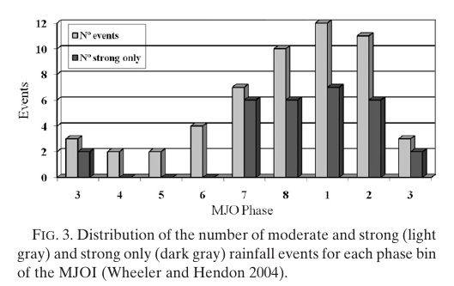
CONSISTENTE
Specifically, an active MJOI in phase 7, 8, 1, or 2 is associated with intense precipitation events often characterized by a broad, slow-moving cyclone consistent with a large-scale teleconnection pattern. No strong events have happened during an MJOI in phase 4, 5, or 6.

Evidence for a modulation of the intraseasonal summer temperature in Eastern Patagonia by the Madden-Julian Oscillation

We describe the relationship between the intraseasonal component of surface air temperature
(SAT) variability in Eastern Patagonia and the Madden-Julian Oscillation (MJO) during austral summer based on ~50 years of daily instrumental records, the Twentieth Century Reanalysis, and a century-long MJO

In most of the region, the warmest (coldest) conditions are found during active phase 8 (4). COMPATIBLE

The intraseasonal variability range has been reported to exhibit a notorious impact in temperature (especially in minimum temperature) in southeastern South America during winter [Naumann and Vargas, 2012]. For this region and season, Naumann and Vargas [2010] showed consistent covariability of temperature and precipitation with the MJO.

The modulation of regional weather and climate systems by the MJO, especially in subtropical latitudes, has been extensively studied, regarding both precipitation [e.g., Sperber, 2003; Donald et al., 2006; Kanamori et al., 2013; Matthews et al., 2013] and temperature [e.g., Maloney and Kiehl, 2002; Oliver, 2014; Salby and Hendon, 1994; Zhou et al., 2011]. Large-scale impacts associated with this mode have also been described for climates of higher latitudes, both in the Northern Hemisphere [Vecchi and Bond, 2004; Cassou, 2008] and in the Southern Hemisphere, in particular, South America [e.g., Moore et al., 2010; Naumann and Vargas, 2010; Barrett et al., 2011; Juliá et al., 2012].

Hence, to the best knowledge of the authors, no previous study has explicitly analyzed the relationship between intraseasonal temperature in Eastern Patagonia and the MJO during summer,

With the aim of facilitating the intercomparison of results, the intraseasonal anomalies of each variable are defined in this paper after Cerne and Vera [2011], as the result of subtracting from the daily values their corresponding climatological daily means (a term which accounts for the annual cycle) and the seasonal departures of each particular year from the climatology (i.e., the DJF mean of each year minus the long-term seasonal mean). That is, the intraseasonal anomaly of a given variable for day d and year y is calculated as
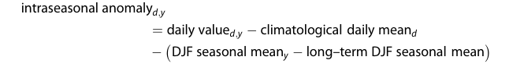

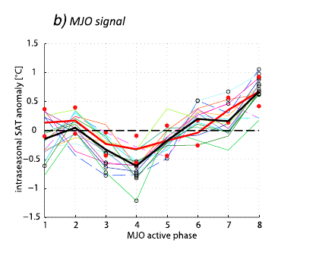
The consistency of the present results suggests that there may be an enhanced predictability of summer intraseasonal SAT in Eastern Patagonia, subject to a skillful MJO forecasting capability, which is estimated to be up to 15–17 days [Seo et al., 2009].

The Modulation of the Subtropical and Extratropical Atmosphere in the Pacific Basin in Response to the Madden–Julian Oscillation

Influence of Madden–Julian Oscillation on extreme rainfall events in Spring in southern Uruguay

Uruguay, the goal of this study is to address the influence of MJO on extreme rainfall events during austral Spring in this region.
NCEP 1980-2013

fases 4 y 5 mas lluviosas NO VERIFICA UN EFECTO EN LKA DEMANDA

Long-term patterns of European PV output using 30 years of validated hourly reanalysis and satellite data

With MERRA, the direct irradiance (i.e., the discrete “beam” from the sun) and the diffuse irradiance (scattered in the atmosphere through clouds, aerosols, etc) are estimated using ground-level global irradiance (SWGDN) and top-of-atmosphere irradiance (SWTDN) variables, as described below.

The BRL model requires a clearness index, which is estimated by the fraction of ground irradiance to top of atmosphere irradiance from the MERRA data.

Diffuse fraction estimation using the BRL model and relationship of predictors under Chilean, Costa Rican and Australian climatic conditions

Clearness index is the quotient between the measured Global Horizontal Irradiance and the corresponding extraterrestrial irradiance (Io):

citar a Modelling of diffuse solar fraction with multiple predictors

