Intraseasonal and low frequency processes contributing to the December 2013 heat wave in Southern South America

This extreme event resulted in the longest consecutive period of heat wave conditions between 1979 and 2014. This event was the result of the combined activity of short intraseasonal (10–30 days), long intraseasonal (30–90 days) and larger (more than 90 days) time scales. Accounting for the lower frequency, dry soil moisture anomalies were observed in Argentina during autumn, winter and spring of 2013

Moreover, the summer dipole pattern presents two main bands of temporal variability with periods between 10–30 days (hereafter, Short Intraseasonal Band, SIB), and 30– 90 days (hereafter, Long Intraseasonal Band, LIB), each band influenced by different large scale forcings (Gonzalez and Vera 2014; Vera et al. 2018). The LIB is related to an eastward traveling wavenumber-1 structure in OLR and circulation anomalies in the tropics, similar to that associated to the Madden and Julian Oscillation (MJO, e.g., Madden and Julian 1994). The LIB is also related to a quasistationary teleconnection pattern extended along the South Pacific Ocean linking Australia with South America (Vera et al. 2018). The SIB is associated with Rossby-like wave- trains extended along the south Pacific and influencing South trains extended along the south Pacific and influencing South America too, although it does not seem to be associated with the activity of propagating tropical convection. There are

Madden–Julian Oscillation (MJO) Modulation of Atmospheric Circulation and Chilean Winter Precipitation

were created using the Real-Time Multivariate MJO index, which divides the MJO into eight longitudinally based phases. Precipitation was found to vary across MJO phases, with positive precipitation anomalies in central and south-central Chile (308–458S) for MJO phases 8, 1, and 2, and negative anomalies in phases 3–7. Circulation was also found to vary across phase, in good agreement with precipitation: low geopotential height and negative omega (corresponding to upward vertical motion) anomalies were found over and upstream of Chile during the rainier phases, and the anomalies reversed during the drier phases. Surface pressure and middle- and upper-tropospheric geopotential height anomalies showed a classic equivalent barotropic wave train, indicating a teleconnection response to deep convective activity in the Maritime Continent in agreement with numerous earlier observational, modeling, and theoretical studies.

to circumnavigate the tropics (Krishnamurti et al. 1985). Low-latitude thermal forcing, such as that produced by convection that occurs over the Maritime Continent during certain phases of the MJO, generates wave trains whose long wavelengths propagate poleward and eastward (Hoskins and Karoly 1981). It is this teleconnection to the Southern Hemisphere that is critical to explaining the link between intraseasonal precipitation variability in Chile and the MJO. A detailed review of the MJO, in-

Because the MJO has some predictability (Jones et al. 2000; Kang and Kim 2010), intraseasonal forecasts of regional precipitation are now possible, especially once relationships between the MJO and relevant forcings are documented. Carrasco (2006) began this work for Chile,

Active MJO for this study was defined as one where the root sum of the two squared principal components, RMM1 and RMM2, was greater than one. It is interesting

After quantifying the MJO phase using the RMM index, atmospheric circulation and precipitation were examined using data from the National Centers for Environmental Prediction (NCEP)–Department of Energy (DOE) re- analysis 2 (Kalnay et al. 1996), the NCEP Global Summary of the Day (GSOD) precipitation database, the TRMM daily rain summary (dataset 3B42; Kummerow et al. 1998), and the NCEP Integrated Radiosonde Archive (IGRA). Winter [May–August (MJJA)] GSOD precipi-

Once the various datasets were selected, we then created composites of daily values for each variable, one composite for each of the eight phases of the MJO. Because the majority of precipitation in central Chile between 258 and 458S falls in winter months, the daily composites consist of data from MJJA. Standardized precipitation (‘‘normalized’’) anomalies were calculated at each station by finding the mean for each MJO phase, subtracting the mean for the entire winter season, and dividing the resulting anomaly by the station standard deviation s (Junker et al. 2008).

Assessing the Influence of the MJO on Strong Precipitation Events in Subtropical, Semi-Arid North-Central Chile (308S)

index (MJOI) based on the actual precipitation events and 2) examining the likelihood of precipitation based on a favorable MJOI. About 80% of the strong precipitation events at the coast in La Serena are related to an active MJO near the central equatorial Pacific. These events are often typified by broad, slow moving synoptic

1979 to 2009. Meteorological data were obtained from the National Centers for Environmental Prediction’s Climate Forecast System Reanalysis (CFSR) (Saha et al. 2010). This reanalysis is available at a maximum resolution of 0.38 every 6 h from 1979 until the present. The phase (1–8) and amplitude (intensity) of the MJO come from a MJOI defined by Wheeler and Hendon (2004; http://www.cawcr.
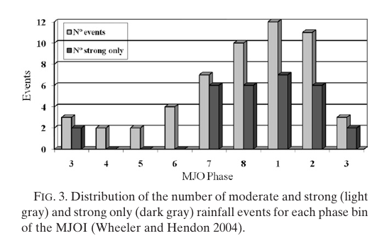
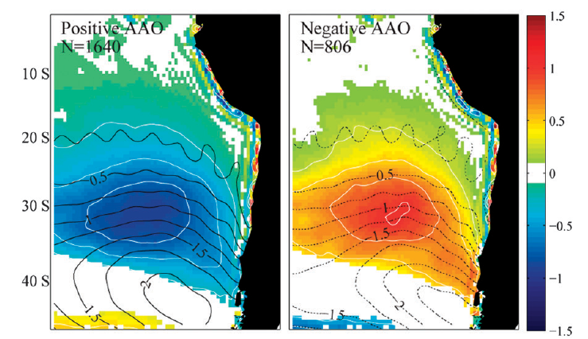
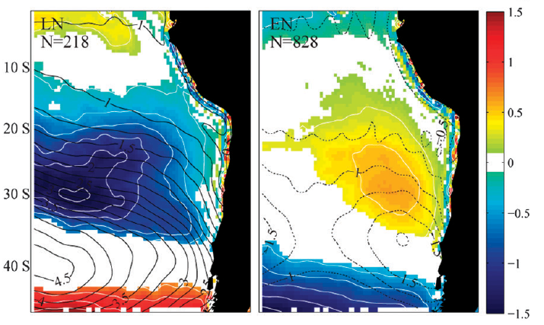
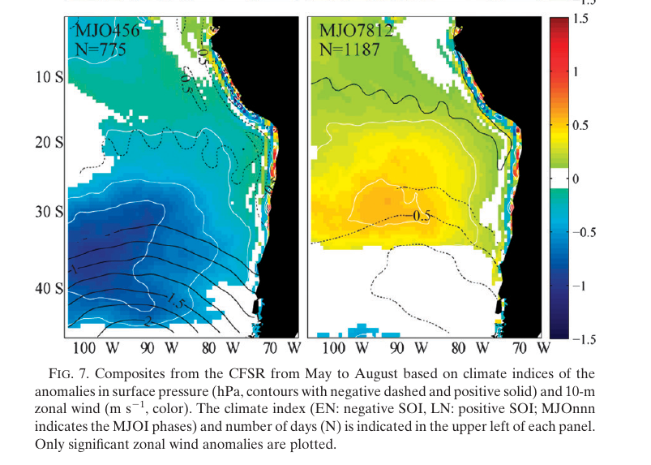
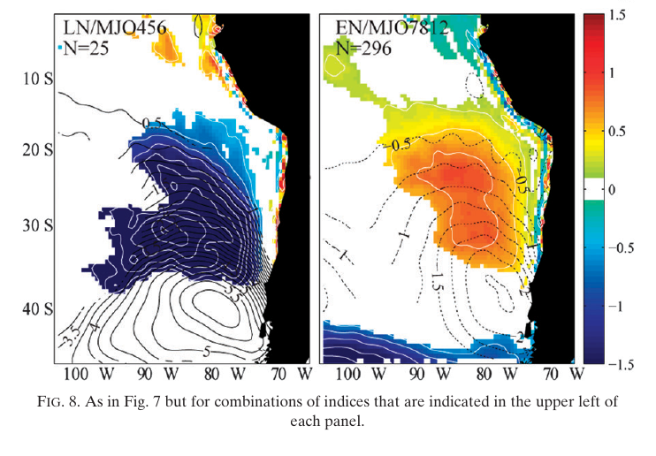
The Modulation of the Subtropical and Extratropical Atmosphere in the Pacific Basin in Response to the Madden–Julian Oscillation

. Its impacts are, however, not limited to tropical latitudes. Forcing by the MJO, in the form of latent heat release associated with tropical convection, can have a profound impact on the subtropical and extratropical flow in both hemispheres: numerous studies have identified a significant

The primary source of data for this study is the 40-yr European Centre for Medium-Range Weather Forecasts (ECMWF) Re-Analysis data (ERA-40; Uppala

DESCRIPCIÓN PRELIMINAR DE LA VELOCIDAD Y DIRECCIÓN DEL VIENTO MEDIO MENSUAL EN TRELEW

