Seasonal forecasts of wind power generation

The energy sector is highly dependent on climate variability for electricity generation, maintenance activities and demand. In recent years, a few climate services have appeared that provide tailored information for the energy sector. In particular, seasonal climate predictions of wind speed have proven

The energy sector is heavily impacted by atmospheric variability: energy demand and supply are conditioned by atmospheric conditions at several time scales ranging from small-scale turbulence through day-ahead weather or seasonal anomalies and up to climate change impacts [14,43]. Renewable generation from hydro, solar and wind power installations is specially sensitive to seasonal or multiannual climate oscillations and long-term trends [28,48]. Recent improvements in the field of climate prediction make it now possible to inform in advance of anomalous conditions for the months to come (i.e. seasonal prediction) [12,31]. Anticipating the future variability of energy sources beyond the first two weeks allows to take calculated, precautionary actions with potential cost savings. To foster the usage of those predictions, in 2015 the World Meteorological Organization (WMO) included energy as one of the priority areas in the Global Framework for Climate Service (GFCS) [23,52]. The GFCS set the basis for understanding user needs in terms of climate knowledge and building applications that trans- form climate model outputs to fulfill those specific user needs. Since then a few climate services have appeared that provide specific information for assisting decision making in the energy sector [6].

In RESILIENCE the value of seasonal forecasts of wind speed issued one to three months ahead was explored according to the needs of various stakeholders in the sector: wind farm owners, operation and maintenance (O&M) teams, energy traders and transmission system operators (TSO).

While forecasts of wind power generation at lead times from minutes and hours to a few days ahead have been produced with very advanced methodologies (e.g. dynamical downscaling, machine learning or statistical downscaling [17]), a number of difficulties make the provision of generation forecasts at seasonal timescales challenging. Climate models have more complexity than weather models as they simulate and couple the different components of the climate system (atmosphere/hydrosphere/cryosphere/land surface/biosphere) and therefore demand enormous amounts of computational resources. This limits the effective temporal and spatial scales of the climate predictions that are currently available. Besides, climate predictions are affected by different sources of uncertainty than weather forecasts. Therefore some advanced methodologies that have been used with weather forecasts cannot be directly employed with climate model outputs.

[6] C. Buontempo, European climate services, in: A. Troccoli (Ed.), Weather & Climate Services for the Energy Industry, Springer International Publishing, Cham, 2018, pp. 27e40.
[12] F.J. Doblas-Reyes, J. García-Serrano, F. Lienert, A.P. Biescas, L.R.L. Rodrigues, Seasonal climate predictability and forecasting: status and prospects, Wiley Interdiscip. Rev. Clim. Change 4 (4) (2013) 245e268.
[13] C. Draxl, A. Clifton, B.-M. Hodge, J. McCaa, The wind integration national dataset (wind) toolkit, Appl. Energy 151 (2015) 355e366.
[14] L. Dubus, S. Muralidharan, A. Troccoli, What does the energy industry require from meteorology? in: A. Troccoli (Ed.), Weather & Climate Services for the Energy Industry Springer International Publishing, 2018, pp. 41E63.
[23] C. Hewitt, S. Mason, D. Walland, The global framework for climate services,
Nat. Clim. Change 2 (2012) 831 (EP e).
[31] A. Mariotti, P.M. Ruti, M. Rixen, Progress in subseasonal to seasonal prediction through a joint weather and climate community effort, npj Clim. Atmos. Sci. 1 (1) (2018).
[43] I. Staffell, S. Pfenninger, The increasing impact of weather on electricity supply and demand, Energy 145 (2018) 65e78.
[48] A. Troccoli, K. Muller, P. Coppin, R. Davy, C. Russell, A.L. Hirsch, Long-term wind speed trends over Australia, J. Clim. 25 (1) (2012) 170e183.
[52] WMO, Energy Exemplar to the User Interface Platform of the Global Frame-
work for Climate Services, 2017.

Scoping the potential usefulness of seasonal climate forecasts for solar power management

As with all the renewable energy sources, for an effective management of solar power, it is essential to have reliable and accurate information about weather/climate conditions that affect the production of electricity. Operations in the solar energy industry are normally based on daily (or intra-daily) forecasts. Nevertheless, information about the incoming months can be relevant to support and inform operational and maintenance activities.

The fluctuations of the electricity produced by the majority of renewable energy sources (RES) is closely related to weather and climate variability. Sources like solar and wind power, which together accounted for approximately 12% of the European electricity generation in 2016 [1], are inherently non-dispatchable and influenced by the availability of solar radiation and wind, respec-

This strong link between power generation and meteorology implies that an increase in energy produced by RES requires actions by the electric utilities and grid operators to prevent drawbacks and faults due to less favourable weather conditions.

Solar power is affected by the availability of solar radiation making the power supply particularly vulnerable to clouds and, more generally, to the occurrence of low-pressure systems. Furthermore, the efficiency of photovoltaic panels is directly

Forecasting the expected production of solar power for the next hours/days is normally necessary for the scheduling of non-renewable power plants and for decision-making processes within the energy market. However, there are also decisions that are made at longer timescales (e.g. 2e3 months ahead) and influenced by weather/climate such as in relation to system adequacy analysis, hedging, asset management and risk assessment [5]. A tool that could help to predict the climate information at long time-scales is the climate forecast generated by an Earth system model.

[1] Eurostat. http://ec.europa.eu/eurostat/web/energy/data/shares, 2017. (Accessed 21 July 2017).
[5] D.S. Kirschen, G. Strbac, Fundamentals of Power System Economics, John
Wiley & Sons, 2004.

Seasonal climate forecasts for medium-term electricity demand forecasting

Air temperature is an effective predictor for electricity demand, especially during hot periods where the need of electric air conditioning can be high. This paper presents for the first time an assessment of the use of seasonal climate forecasts of temperature for medium-term electricity demand prediction. The

Given the necessity of ensuring the balance between electricity production and demand, an accurate estimation of future weather state could improve the efficiency and reliability of energy management at local and national scales. In fact, weather is a crucial element both for the generation and demand of electricity [25,16] The relationship between temperature and demand is well-known and it has been already investigated in many works focused on Europe. Valor et al. [28] and Pardo et al. [24] first recog-

Sub-seasonal forecasts of demand and wind power and solar power generation for 28 European countries

Electricity systems are becoming increasingly exposed to weather. The need for high-quality meteorological forecasts for managing risk across all timescales has therefore never been greater. This paper seeks

A key feature of current large-scale power systems is that the demand for electricity must be met by electricity generation on a near-instantaneous basis. Historically, this has been achieved by scheduling a combination of coal, gas and nuclear power stations to meet a forecast demand, which is strongly dependent on temperature (Bessec and Fouquau, 2008). The growing use of wind and solar photovoltaic (PV) generation, however, leads to new challenges. The generation output from these weather-dependent sources is determined by meteorological conditions and thus cannot be controlled to the same extent as the generation from traditional power plants. Both demand and renewable generation potential therefore contain strongly weather-sensitive components. Given the necessity of ensuring the balance between electricity production and demand, an accurate estimation of future weather can improve the efficiency and reliability of energy management at local and national scales and provide a more realistic estimate of future energy prices.

Skil-ful forecasts of country-aggregated demand and renewable generation are believed to provide valuable contextual information to a variety of energy system stakeholders: from individual traders, power plant operators and owners to na- tional transmission system operators (White et al., 2017; Soret et al., 2019). Although the use of short-range weather forecasts is now common in the energy sector and there has been a substantial amount of academic literature on the topic (Bossavy et al., 2013; Füss et al., 2015; Drew et al., 2017; Cannon et al., 2017; Browell et al., 2018; Stanger et al., 2019), there has been comparatively little attention paid to the use of sub-seasonal to seasonal (S2S) forecasts by energy users for decision-making. This is possibly consistent with the perceived difficulty of extracting predictable signals from extended-range forecasts (Soares and Dessai, 2016). However, recent advances in forecasting have begun to result in skilful longer-range predictions for European demand (De Felice et al., 2015; Clark et al., 2017; Thornton et al., 2019; Dorrington et al., 2020), wind power generation (Lynch et al., 2014; Beerli et al., 2017; Soret et al., 2019; Torralba et al., 2017; Lledó et al., 2019; Bett et al., 2019; Lee et al., 2019), solar power generation (Bett et al., 2019) and hydropower generation (Arnal et al., 2018), which can con-

Wind review power of the forecastingda state of the art

Predicting Daily Mean Wind Speed in Europe Weeks ahead from MJO Status

The Madden–Julian oscillation (MJO), a prominent feature of the tropical atmospheric circulation at subseasonal time scales, is known to modulate atmospheric variability in the Euro-Atlantic region. However, current subseasonal prediction systems fail to accurately reproduce the physical processes involved in these teleconnection mechanisms. This paper explores the observed impact of strong MJO events on surface wind speed over Europe. It is found that some MJO phases are accompanied by strong wind anomalies in Europe. After showing that this teleconnective mechanism is not present in the predictions of the ECMWF monthly forecasting system, a methodology to reconstruct forecasts of daily mean wind speed in the continent weeks

The Madden–Julian oscillation (MJO) is the dominant mode of atmospheric variability at subseasonal time scales in the tropics. It consists of an enhanced

Extratropical circulation is specially affected through excitation of tropospheric Rossby waves but also through the stratosphere (Barnes et al.

can benefit from this approach is the wind energy sector. While power producing companies, traders and grido perators use weather forecasts up to 10 days ahead routinely for its daily operations, forecasts of daily mean wind speed weeks ahead could be useful for many of them (Soret et al. 2019).
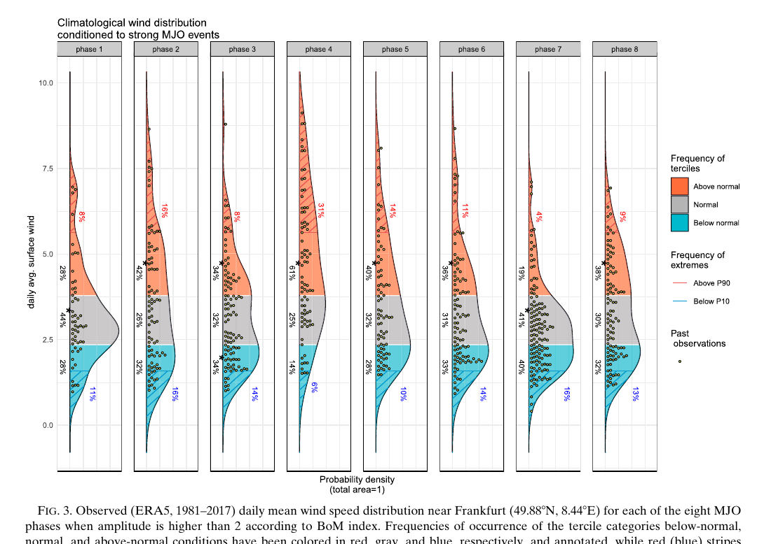
An analysis of simultaneous wind speeds over Europe during strong MJO episodes using reanalyses has revealed that large wind anomalies do exist. Their location and strength are a function of the MJO phase, although there are considerable variations among individual events. For instance,

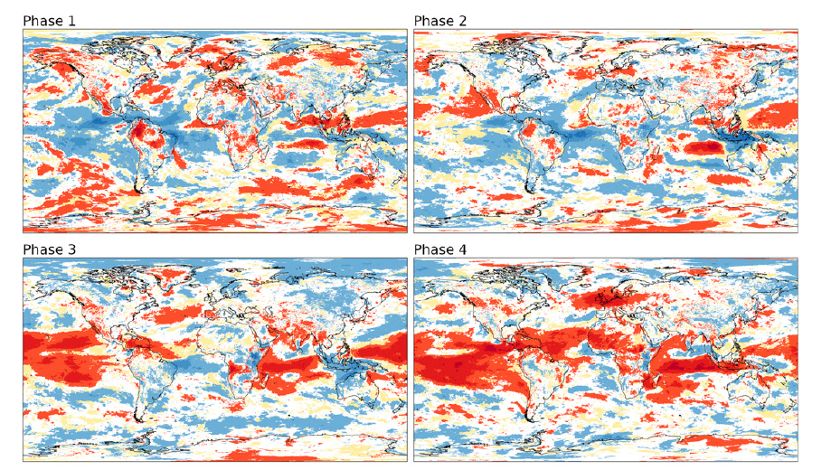
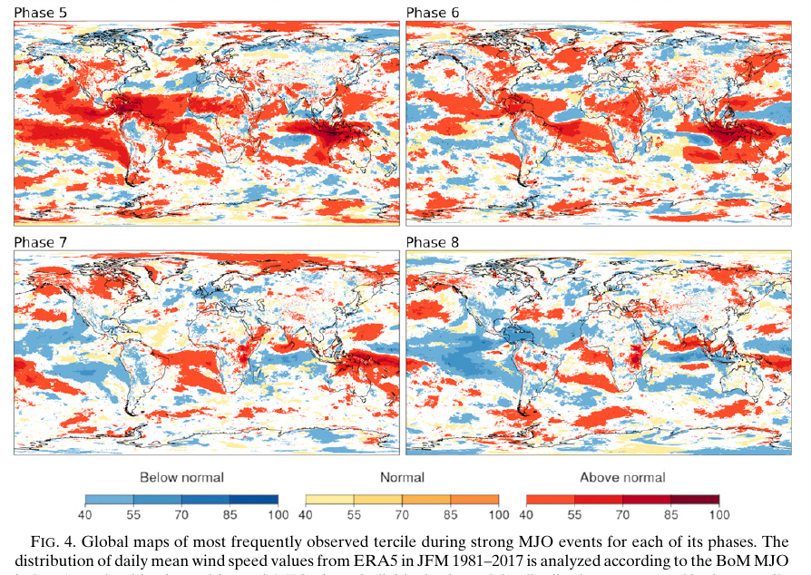
ES BASTANTE CONSISTENTE

Short-term forecasting of electricity demand for the residential sector using weather and social variables

Short-term electricity demand forecasting plays a significant role in power system planning, including economic scheduling of generating capacity, scheduling of fuel purchases, and power system management (Thatcher, 2007; Shrivastava and Misra, 2008; Kavaklioglu et al., 2009; Mao et al., 2009; Wang et al., 2009; Azadeh et al., 2011; Apadula et al., 2012; Wang, 2012). It is especially obvious that accurate electricity forecasting has great importance to the residential sector, a major contributor to the peak loads in most electricity systems. Overestimating electricity demands misleads planners and wastes resources with expensive expansion plans. Such overestimation also increases operating costs since electricity, unlike other energy sources, cannot be stored on a large scale (Keyno et al., 2009; Qiu, 2013). But underestimation of electricity demands will result in failures and shortages (Kavaklioglu et al., 2009).

Sub-seasonal to seasonal climate predictions for wind energy forecasting

Both renewable energy supply and electricity demand are strongly influenced by meteorological conditions and their evolution over time in terms of climate variability and climate change. However, knowledge of power output and demand forecasting beyond a few days remains poor. Current methodologies assume that long-term resource availability is constant, ignoring the fact that future wind resources could be significantly different from the past wind energy conditions. Such uncertainties create risks that affect investment in wind energy projects at the operational stage where energy yields affect cash flow and the balance of the grid. Here we assess whether sub-seasonal to seasonal climate predictions (S2S) can skilfully predict wind speed in Europe.

Understanding and quantifying climatic conditions from several weeks to months can improve the decision making of renewable energy generation and electricity demand (Figure 1). Climate predictions including both sub-seasonal (up to one month) and seasonal predictions (forthcoming months) have witnessed considerable improvements in the last decade demonstrating that probabilistic forecasting can inform better decision making for some forecast windows and regions [1]. However,

4. Conclusions
Recent advances in global climate models, which simulate the physics of the whole climate system, demonstrate that probabilistic forecasting approaches can produce improved information upon retrospective climatology at certain spatial and temporal scales. Hence, energy decision makers now have a new set of tools to strengthen their decision making. Sub-seasonal to seasonal climate predictions (S2S) could be an important planning tool for energy traders, producers, plant operators, plant investors that can lead to better and timely management climate variability related risks.

The future of forecasting for renewable energy

Forecasting for wind and solar renewable energy is becoming more important as the amount of energy generated from these sources increases. Forecast skill is improving, but so too is the way forecasts are being used.

Forecasting for renewable energy is under substantial focus as the penetration of renewable energy from wind and solar increases, with an overwhelming consensus on its importance for the economic and reliable integration of their energy production into existing power networks. While other forms of renewable energy sources may also involve some forecasting tasks

The non-linear link between electricity consumption and temperature in Europe: A threshold panel approach☆

Our results confirm the nonlinearity of the link between electricity consumption and temperature found in more limited geographical areas in previous studies. By distinguishing between North and South countries, we also find that this non-linear pattern is more pronounced in the warm countries.

non-linear pattern of the relationship between electricity consumption and temperature. In winter, the expected link between electricity demand and temperature is negative since an increase in temperature diminishes the need for energy resources used for heating purposes. This negative response is referred to as the heating effect in the related literature. In contrast, in summer, a temperature increase may raise the demand for electricity. An increase in temperature leads to a higher use of air conditioners and other cooling devices. This is the so-called cooling effect. Taking this non-linearity into account requires a specific treatment.

