# **Tampon hiding, stains scrubbing and unrealistic advertising. Why is menstruation still taboo in 2021?**

Menstruation has always been seen as a sign of women’s fertility. Although every woman experience it monthly during whole decades, many still feel embarrassed when they are menstruating. How did we become used to not talking about it? Or even worse, to trying to hide it? It is therefore best time to stop feeling ashamed of this biological function and to stop the stigma that still annoys us.

What did they teach us?

Menstruation became after many years taboo in almost every field. Even names, such as “period”, “the time of the month” or “my days”, have been invented to hide the meaning of disgrace. Menstruation was in old days associated with impurity, dirt and fear of losing virginity. And as our ancestors, teachers and sometimes even relatives taught us, that is the worst sin that may ever happen to a woman. Or at least before marriage…

**“After lesson we got instructions not to talk about it with boys”**

**I remember how awkward it was in school**

First, they separated us from boys saying they will learn about something “boyish” instead. Woman, who came to talk to us about sex education, started with whispering as if it was something prohibited. The atmosphere in the class was serious and tense. After lesson we got instructions not to talk about it with boys. Maybe if we would openly talk about menstruation from childhood, men wouldn’t be that scared and anxious about it in adulthood.

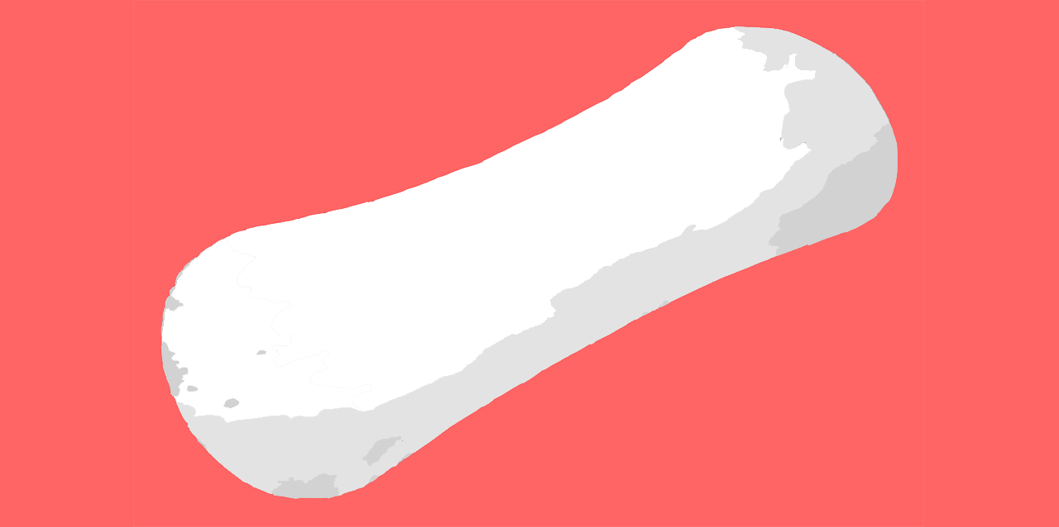

## **Let’s be honest girls, which of us doesn‘t have a story when it didn’t turn out well?**

Oh, that shame when you wore your new white jeans and suddenly you had to wrap your hoodie around. And that moment when you had to ask your friend “for a help” in front of the whole class? What about endless washing of blood stains when none of the detergents in your bathroom works? You already washed it twice, it’s not gonna work on the third time! And how we’re all trying not to “swoosh” while opening the covers on the toilet.