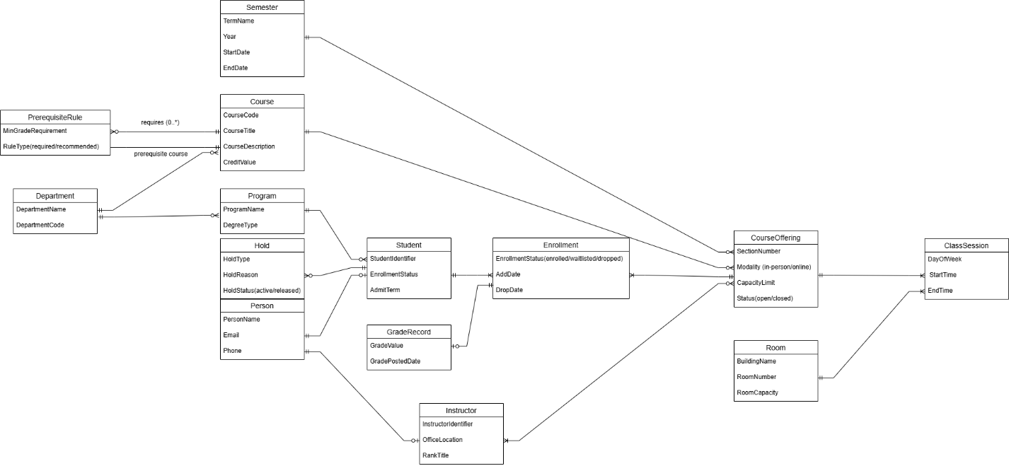

Relationship: Course – PrerequisiteRule – Course (Prerequisite)
Description
The prerequisite relationship between courses is modeled using a recursive relationship through the associative entity PrerequisiteRule. The Course entity participates in this relationship in two different roles: the main course and the prerequisite course.
A Course may have zero or many prerequisite rules, since not all courses require prerequisites (e.g., introductory courses). Each PrerequisiteRule must reference exactly one prerequisite Course, because a prerequisite rule cannot exist without specifying a prerequisite course.

Cardinality and Participation
- Course → PrerequisiteRule:
  - Cardinality: 0..* (optional many)
  - Explanation: A course may have no prerequisites or multiple prerequisite rules.
- PrerequisiteRule → Course (Prerequisite Course):
  - Cardinality: 1 (mandatory one)
  - Explanation: Each prerequisite rule must be associated with exactly one prerequisite course.

Design Rationale
The prerequisite course is not modeled as a separate entity. Instead, it is represented as the same Course entity playing a different role in a recursive relationship. This design avoids redundancy and correctly reflects the conceptual nature of course prerequisites. The use of PrerequisiteRule as an associative entity allows the model to support additional business rules, such as minimum grade requirements or different prerequisite conditions, while remaining at a conceptual level.

