Profile

A dedicated and passionate English teacher with a Master's degree in English Literature from Federal Urdu University. Offering six years of experience in teaching at various schools. Committed to fostering a positive learning environment and helping students develop strong language and communication skills.

Skill Highlights

|  |  |
| --- | --- |
| * Excellent Customer Service * Strong decision maker * Complex problem solver | * Multitasking * Innovative * Service-focused |

Experience

**Teacher** – 02/2015 – 02/2019

**Al-Baka Islamic School**, Karachi

Experience in designing and developing curriculum materials and lesson plans aligned with educational standards and learning objectives.

**Customer Service Officer** - 05/2019 – 05/2020

**Ilma University**, Karachi

* Act as a primary point of contact for clients, addressing their inquiries, concerns, and requests promptly and professionally.
* Provide excellent customer service by actively listening to clients, understanding their needs, and offering appropriate solutions or guidance.

**Teacher** – 06/2020 – Present

**Fazaia Intermediate College**, Karachi

Classroom management to create a positive and structured learning environment, ensuring student discipline and participation.

Education

Masters of Arts: **English Literature** - 2020

**Federal Urdu University**, ISB

Certifications

Microsoft Office (certificate): **MS Word, MS Excel**.

Language: **English language course.**

Rabia Shabbir

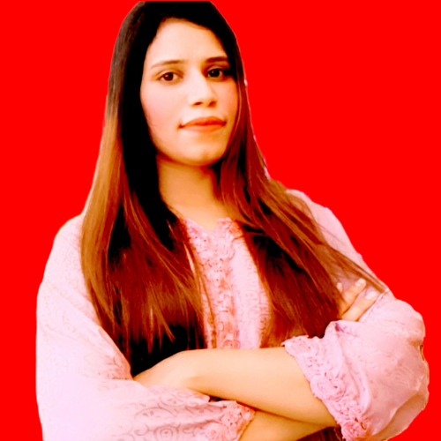

Contact

**Address:**

Aman orchid tower flat no 721,7th floor korangi, crossing, Karachi

**Phone:**

+92 346 0136 506

**Email:**

[rabiashabbir1996@gmail.com](mailto:christoper.m@gmail.com)

**LinkedIn:**

linkedin.com/christopher.morgan

Languages

Urdu

English

Sindhi

Hobbies

* Writing
* Sketching
* Photography
* Design