**Need a Scrapy Spider script (without Selenium):**

Open below url/site

<https://ecerts.ssc.nsw.gov.au/eproperty/P1/eTrack/eTrackApplicationSearch.aspx?Group=DA&ResultsFunction=SSC.P1.ETR.RESULT.DA&r=SSC.P1.WEBGUEST&f=SSC.P1.ETR.SEARCH.DA>

**Home page:** Screen will be

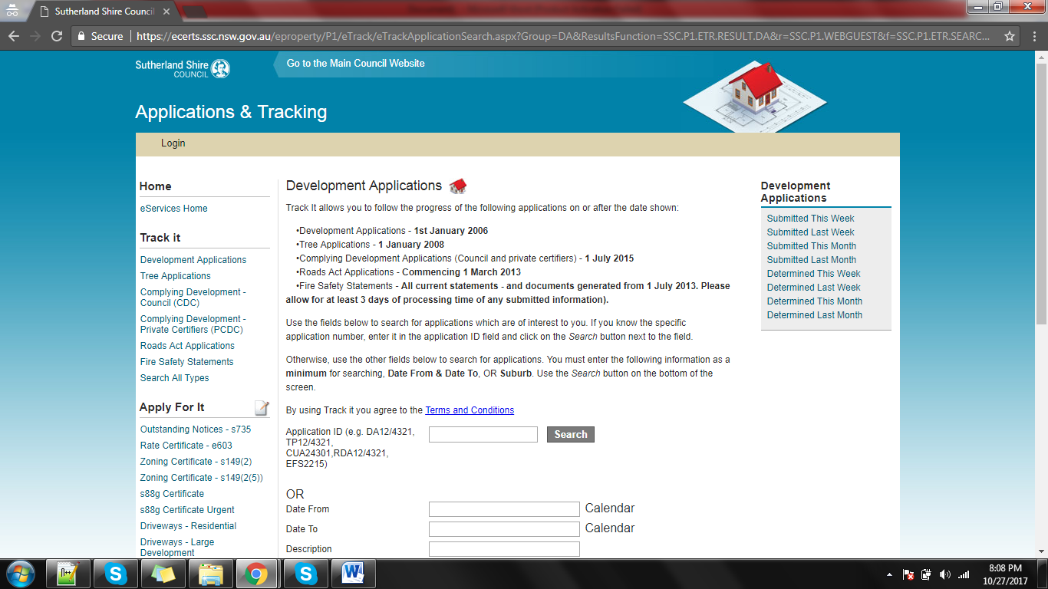

**Fill below two date fields**

Date From: 01/01/2017

Date To: 02/02/2017

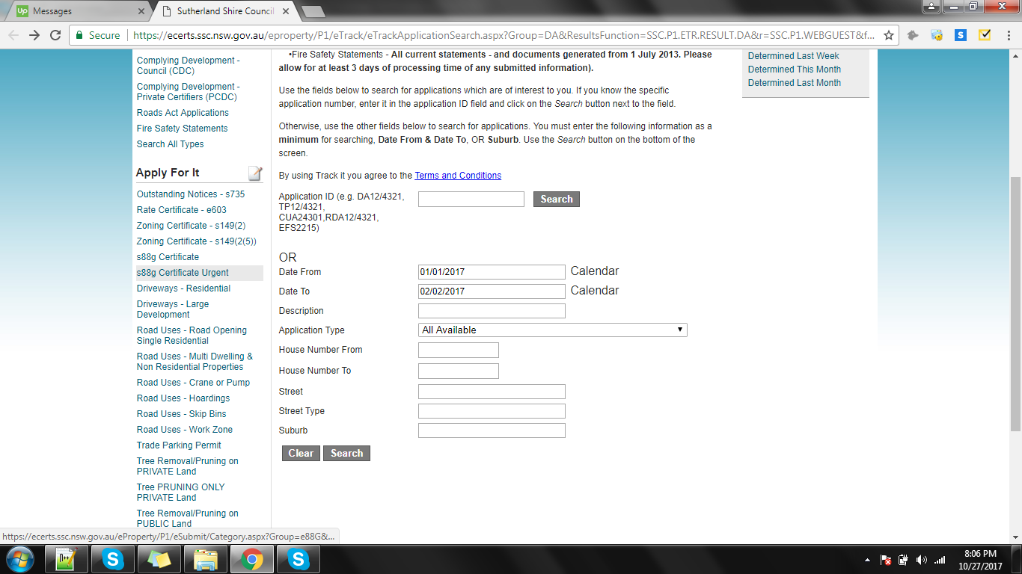

Click on ‘Search’, it bring list of below records.

Records page:

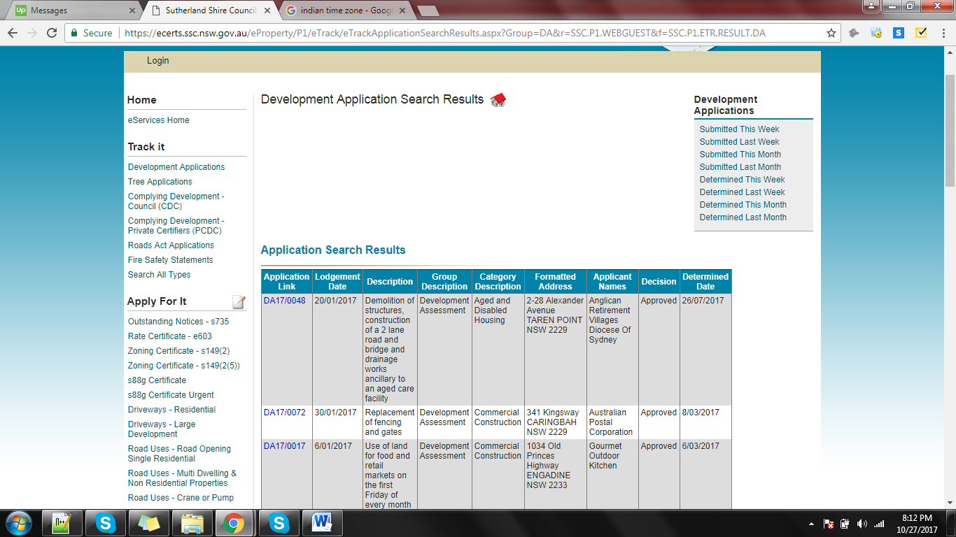

See links under ‘[**Application Link**](javascript:__doPostBack('ctl00$Content$cusResultsGrid$repWebGrid$ctl00$grdWebGridTabularView','Sort$RamId'))’ column, click on each record link,

I clicked on ‘DA17/0048’ link, it redirect to below ‘Application Details’ page.

**Note:** each link required Javascript clicks, also pagers also required Javascript clicks.

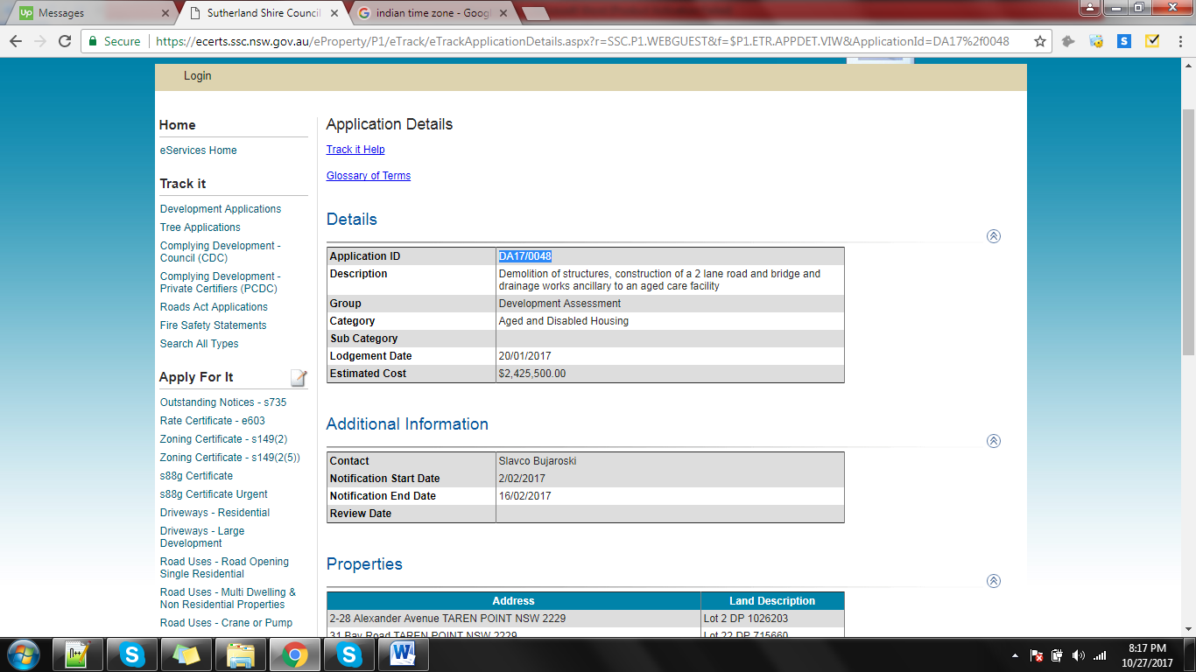

This page all data need to save in JSON file.