Worksheet — Friction on an Incline Simulation
Use with Simulation - Friction on an incline.html · goes with the Forces investigation (friction on a ramp)
Biljana Taneska · Physics teacher · btaneska@vis.ac.at

Name: ______________________________ Class: ________ Date: ______________
How to use this worksheet  Scan the QR code or open biba0112.github.io/physics-sims/03-friction-incline in a browser (offline: Simulation - Friction on an incline.html). ▲ Tilt raises the ramp until the block slips; ▶ Release lets the block go at the angle in the box. The Tasks tab has the same three parts as this sheet; write your explanations here.  Part 1 before the lab (≈ 15 min) · Part 2 during the lab (≈ 10 min) · Part 3 homework (≈ 30 min).  Use g = 9.81 N kg⁻¹. Sliding uses Newton's 2nd law (Blocks 3–4). |   Scan to open

Part 1 — Pre-lab: predict, then test
Question | My prediction (before) | What the simulation showed | Physics explanation
1. The ramp tilts and the block stays at rest. What happens to the friction force?
2. What happens to the normal force as the ramp tilts?
3. You double the block's mass. What happens to the slip angle?
4. Which surfaces give the smallest slip angle: rubber, wood/bench, ice or sandpaper?
5. After it slips (ramp angle fixed), does the block slide at constant speed, speed up or stop?

6. Draw the free-body diagram of the block at rest on a 20° ramp. Show the weight components mg sin θ and mg cos θ as dashed arrows.
Free-body diagram

7. Show that the block slips when tan θ = μ_{s}. Then calculate the slip angle for wood on the bench (μ_{s} = 0.41).
Working

θ_{slip} = __________ ° Sim check: __________ °

Part 2 — During the lab: Forces investigation
Investigation block (0.150 kg) on the wooden board. Fill in the sim values and your group's values.
Quantity | Simulation | Our measurement / calculation
slip angle θ_{slip} / °
μ_{s} = tan θ_{slip}
largest static friction at 20°, μ_{s}mg cos 20° / N
friction acting at 10°, mg sin 10° / N
acceleration at 60°, a / m s⁻² |  | 7.8 (given)
μ_{d} = (g sin θ − a)/(g cos θ)

8. Give one reason why your measured slip angle differs from the simulation's.
______________________________________________________________________________________
______________________________________________________________________________________
9. At 10° the friction is much smaller than μ_{s}F_{N}. Explain why.
______________________________________________________________________________________
______________________________________________________________________________________

Part 3 — Homework: find μ_{d} from a graph
Wood on bench, m = 0.500 kg. Release the block at each angle and record a.
θ / ° | 30 | 40 | 50 | 60 | 70
tan θ
a / m s⁻²
cos θ
a / cos θ / m s⁻²

10. Show that a = g(sin θ − μ_{d} cos θ) can be written as a/cos θ = g tan θ − μ_{d}g. What should the gradient and the intercept of a graph of a/cos θ against tan θ be?
______________________________________________________________________________________
______________________________________________________________________________________
______________________________________________________________________________________
11. Plot a/cos θ against tan θ and draw the best-fit line.
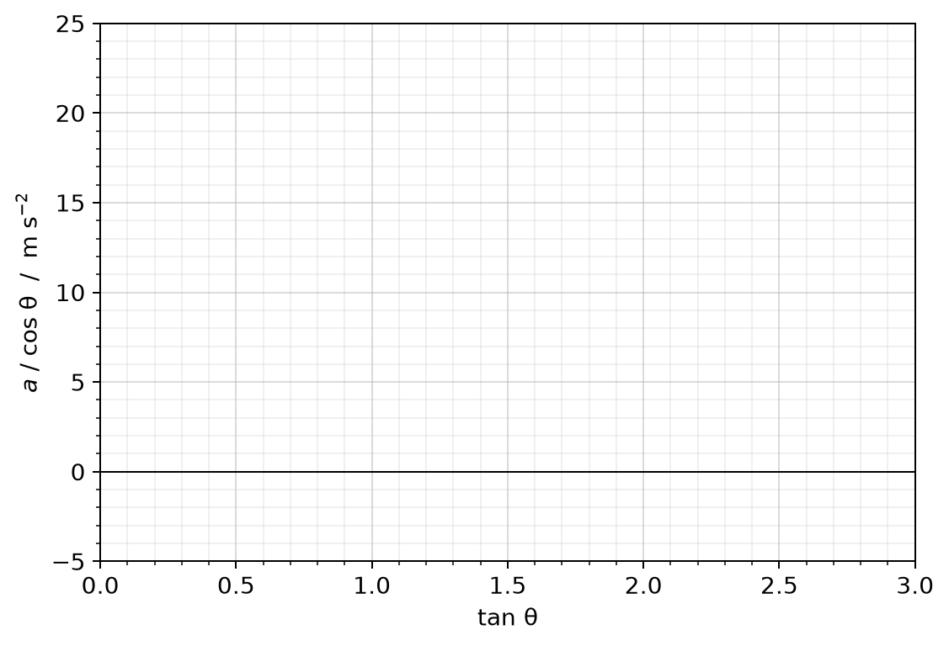
12. Gradient = __________ m s⁻² Intercept = __________ m s⁻² ⇒ μ_{d} = __________
13. Calculate the acceleration of the block sliding down the bench at 35° (μ_{d} = 0.30) and the time it takes to slide 0.80 m from rest.
Working

14. The 0.500 kg block is released on the bench at 15° (μ_{s} = 0.41). Draw its free-body diagram. Does it move? Calculate the friction force acting and compare it with μ_{s}F_{N}.
Free-body diagram

Working

15. A car is parked on a steep hill. On a dry road it stays put; on ice it slides down. Explain why, using tan θ and μ_{s}. Does a heavier car slide more easily?
______________________________________________________________________________________
______________________________________________________________________________________
______________________________________________________________________________________
______________________________________________________________________________________

