Worksheet — Collisions and Explosions Simulation
Use with Simulation - Collisions and explosions.html · conservation of momentum (Block 7): elastic, inelastic, stick together, explosions and recoil
Biljana Taneska · Physics teacher · btaneska@vis.ac.at

Name: ______________________________ Class: ________ Date: _______________
How to use this worksheet  Scan the QR code or open biba0112.github.io/physics-sims/18-collisions-explosions in a browser (offline: Simulation - Collisions and explosions.html). Choose the type at the top: Elastic · Inelastic · Stick together · Explosion. Pick an Example (class demo, slide problems, skaters, cannon) or set the masses and velocities yourself: set a value with ▼ ▲ or type it in the box.  Velocities have a sign: + is to the right. The readouts give u, v and p for A, B and the total, and the kinetic energy before and after. The contact plays in slow motion; ◂ / ▸ step through it.  Part 1 before the lab (≈ 15 min) · Part 2 during the lab (≈ 20 min) · Part 3 homework (≈ 30 min). The Tasks tab has the same three parts. Σp_{before} = Σp_{after}; E_{k} = ½mv² for the questions marked (A.3 link). Answers to 3 s.f. with units. |   Scan to open

Part 1 — Pre-lab: predict, then test
Question | My prediction (before) | What the simulation showed | Physics explanation
1. 🩹 Cart A (0.25 kg) at 0.50 m s⁻¹ sticks to cart B (0.50 kg) at rest. Their common velocity is ______ m s⁻¹.
2. During that collision, is the force of A on B larger than, smaller than or equal to the force of B on A?
3. 💥 The same carts start at rest and a spring pushes them apart. Which one moves off faster, and by what factor?
4. 🧲 Two equal balls, elastic: A at 1.0 m s⁻¹ hits B at rest. What happens to A and to B?
5. (A.3 link) Same carts and speeds: which type loses the most kinetic energy — elastic, inelastic or stick together?

6. (slide 14) A 2.0 kg trolley at 3.0 m s⁻¹ hits a 1.0 kg trolley at rest and they stick together. Sketch the trolleys before and after (with velocity arrows), then calculate their common velocity. Check: Example → Slide 14: trolleys stick.
Before / after sketch and working

7. (exit question) A 1.2 kg cart at 0.50 m s⁻¹ sticks to a 0.80 kg cart at rest. Calculate the common velocity.
Working

Part 2 — During the lab
PASCO Smart Cart demo: three runs. Simulation examples: Class demo: elastic (magnets), Class demo: Velcro, Class demo: explosion (A = 0.25 kg, B = 0.50 kg, + → right). Press ▶ Start and ● Record for each. Write the class (Capstone) velocities in the grey rows.
run | u_{A} / m s⁻¹ | v_{A} / m s⁻¹ | v_{B} / m s⁻¹ | Σp before / kg m s⁻¹ | Σp after / kg m s⁻¹ | KE before → after / J (A.3 link)
elastic — simulation
elastic — class data
Velcro — simulation
Velcro — class data
explosion — simulation
explosion — class data

8. For each run, is the total momentum conserved? Is the kinetic energy conserved? (A.3 link) Calculate the percentage of KE lost in the Velcro run.
Working

9. The class elastic run gave v_{A} = −0.15 m s⁻¹ and v_{B} = +0.32 m s⁻¹, not −0.167 and +0.333 m s⁻¹. Set Inelastic with bounciness 0.94: what does this tell you about real magnetic bumpers? Give one other reason why real data differ from the model.
______________________________________________________________________________________
______________________________________________________________________________________
______________________________________________________________________________________
______________________________________________________________________________________
10. In the explosion run, use the F–t graph (tick Area and Zoom) to compare the impulse on A and on B. Explain the result with Newton's third law.
______________________________________________________________________________________
______________________________________________________________________________________
______________________________________________________________________________________
______________________________________________________________________________________

Part 3 — Homework
11. (slide 14) As in question 6, but now the 1.0 kg trolley moves towards the 2.0 kg trolley at 1.0 m s⁻¹. They stick. Calculate the common velocity.
Working

12. ⛸️ A 60 kg skater pushes a 40 kg skater; both start at rest. The 40 kg skater moves off at 1.5 m s⁻¹. Calculate the velocity of the 60 kg skater. (A.3 link) How much kinetic energy did the push give them, and where did it come from?
Working

13. (slide 16) A 500 kg cannon fires a 5.0 kg shell at 120 m s⁻¹. Calculate the recoil velocity of the cannon. Explain why the shell has far more kinetic energy than the cannon although their momenta have the same size.
Working

14. A 1.0 kg cart at 2.0 m s⁻¹ hits a 3.0 kg cart at rest and bounces back at 0.50 m s⁻¹. Calculate the velocity of the 3.0 kg cart. (A.3 link) What percentage of the kinetic energy is lost? What type of collision is this?
Working

15. Record at least six trials of different types (some with negative velocities). Copy Σp before and after into the table, plot them and draw the best-fit line.
trial | 1 | 2 | 3 | 4 | 5 | 6
type
Σp before / kg m s⁻¹
Σp after / kg m s⁻¹

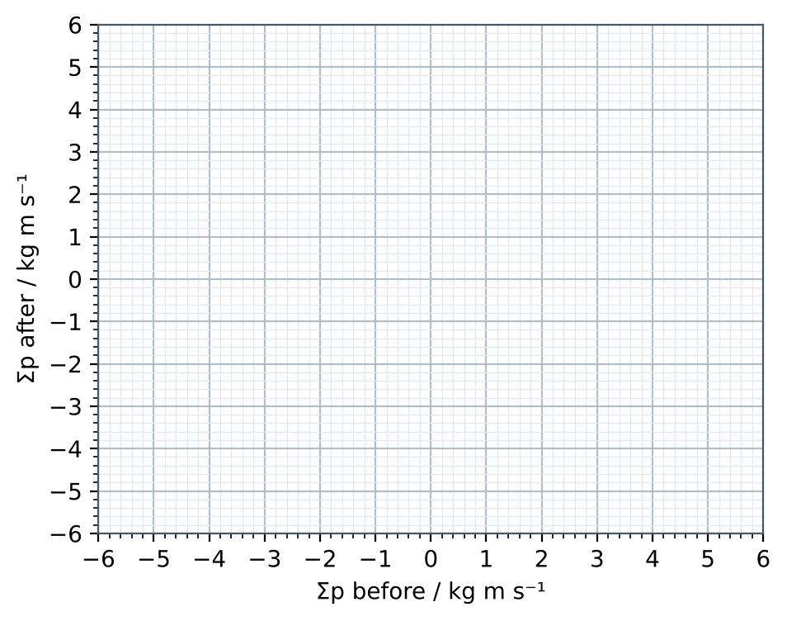
Gradient = __________ . What does it show?
16. Use Newton's third law to explain why the total momentum of two colliding carts does not change.
______________________________________________________________________________________
______________________________________________________________________________________
______________________________________________________________________________________
______________________________________________________________________________________

