Worksheet — Power Simulation
Use with Simulation - Power.html · power as the rate of doing work, P = Fv, human and machine power (Block 11)
Biljana Taneska · Physics teacher · btaneska@vis.ac.at

Name: ______________________________ Class: ________ Date: _______________
How to use this worksheet  Scan the QR code or open biba0112.github.io/physics-sims/21-power/ in a browser (offline: Simulation - Power.html). Choose the example at the top: Stair race · Car up a hill · Lift motor. Pick a preset in Example or set the values yourself (type a value and press Enter).  Press ▶ Start; ◂ / ▸ step through the motion. The middle column shows the free-body diagram and a Sankey diagram of the energy transferred so far. On an energy–time graph tick Tangent: the gradient is the power. Under P–t tick Area: the area is the energy.  Part 1 before the lab (≈ 15 min) · Part 2 during the lab (≈ 20 min) · Part 3 homework (≈ 30 min). P = ΔW/Δt = Fv · 1 W = 1 J s⁻¹ · 1 hp = 746 W. g = 9.81 N kg⁻¹. Answers to 3 s.f. with units. | Scan to open

Part 1 — Pre-lab: predict, then test
Question | My prediction (before) | What the simulation showed | Physics explanation
1. 🏃 You walk up the stairs, then run up them. Which needs more energy? Which needs more power?
2. 🚗 A car drives up a hill at constant speed. Is the driving force zero, equal to the resistive force, or bigger?
3. 🛗 A lift speeds up while it rises. Is the motor's power bigger, smaller or the same as at steady speed?
4. A car accelerates at full power. As it speeds up, does its driving force go up, down or stay the same?
5. Why do you get hot when you run up the stairs?

6. (exit question) A 75 kg student climbs 4.0 m of stairs in 5.0 s. Calculate the useful power. Check: Stair race → Exit question.
Working

7. (exit question) A car cruises at 25 m s⁻¹ against 800 N of resistive forces. Calculate the useful power.
Working

8. (retrieval) A driving force of 2.0 kN keeps a van at 15 m s⁻¹. Calculate the power.
Working

Part 2 — During the lab: who is the most powerful?
Count the steps, measure one step height and time each climb with two stopwatches (take the mean). Put each student's values into Stair race and ● Record. The first row is the simulation's walking demo.
student | m / kg | steps | step height / m | h / m | t₁ / s | t₂ / s | mean t / s | mgh / J | P / W
demo (walk) | 60 | 16 | 0.17 |  | 8.0 | 8.0 | 8.0

9. Running demo: the same 60 kg student runs up the 16 steps (17 cm each) in 3.0 s. Calculate the height, the useful power and the power in horsepower.
Working

10. Muscles are about 25 % efficient. Calculate the chemical energy used for the run and sketch the Sankey diagram (check: Sankey in the middle column).
Working and Sankey diagram

11. Record the 60 kg walker 6 times with different times (2, 3, 4, 6, 8, 10 s). Plot P against 1/t. What does the gradient represent?
t / s | 2 | 3 | 4 | 6 | 8 | 10
1/t / s⁻¹
P / W

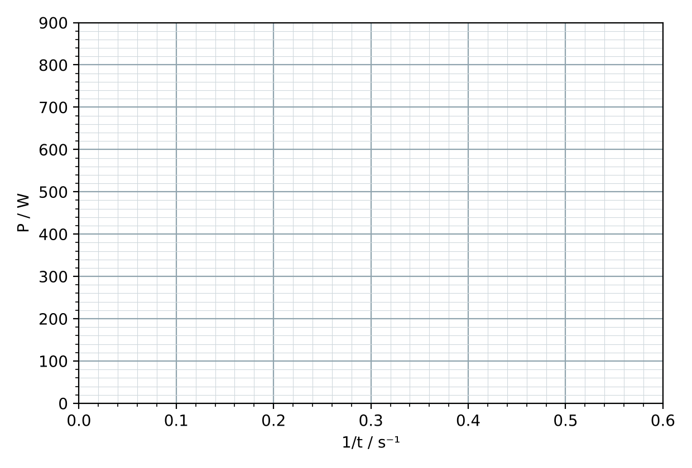
Gradient = ______________ . It represents ______________________________ .
Part 3 — Homework
12. (card P2) A 1200 kg car drives up a 5.0° hill at a constant 20 m s⁻¹ against 500 N of resistive forces. Draw the free-body diagram, then calculate the driving force and the power.
Working

13. (card P3) An 800 kg lift rises at a steady 1.5 m s⁻¹. Calculate the power output of the motor.
Working

14. The same lift starts with an acceleration of 1.0 m s⁻². Calculate the tension and the power at the moment its speed reaches 1.5 m s⁻¹.
Working

15. The card P2 car has a maximum power of 60 kW. Calculate its top speed up the 5.0° hill. Explain why it cannot go faster.
Working

16. Cruise the card P2 car up the hill at 10, 15, 20, 25, 30 and 35 m s⁻¹ and record P. Plot P against v; find the gradient. What does it represent?
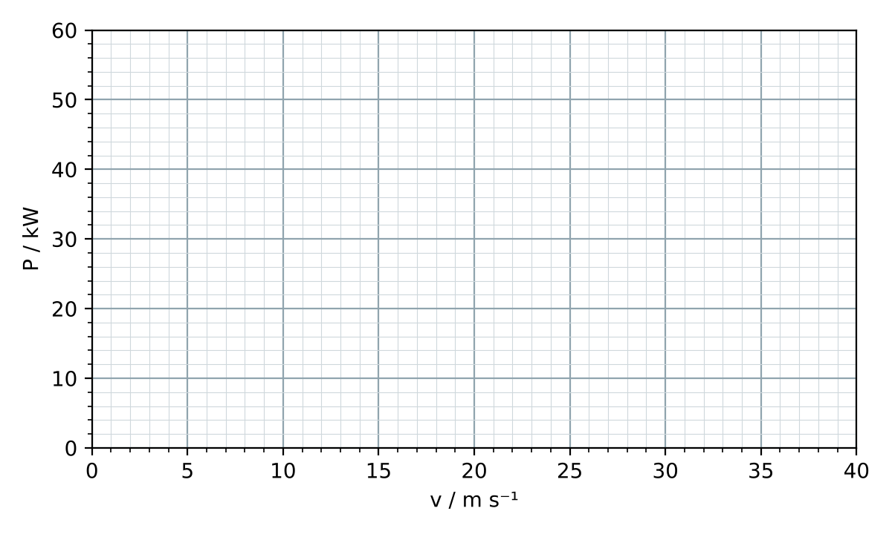
Gradient = ______________ . It represents ______________________________ .

