Worksheet — Efficiency and Energy Density Simulation
Use with Simulation - Efficiency and energy density.html · efficiency, Sankey diagrams and the energy density of fuels (Block 12)
Biljana Taneska · Physics teacher · btaneska@vis.ac.at

Name: ______________________________ Class: ________ Date: _______________
How to use this worksheet  Scan the QR code or open biba0112.github.io/physics-sims/22-efficiency-energy-density/ in a browser (offline: Simulation - Efficiency and energy density.html). Choose the example at the top: Bouncing ball · Motor lift · Sankey · Fuel tank. Pick a preset in Example or set the values yourself (type a value and press Enter).  Press ▶ Start (not needed for the Sankey builder); ◂ / ▸ step through the motion. The Sankey builder draws the diagram to scale on squared paper; one output is found by conservation.  Part 1 before the lab (≈ 15 min) · Part 2 during the lab (≈ 20 min) · Part 3 homework (≈ 30 min). efficiency = useful output ÷ total input · E = energy density × mass · 1 kWh = 3.6 × 10⁶ J. g = 9.81 N kg⁻¹. Answers to 3 s.f. | Scan to open

Part 1 — Pre-lab: predict, then test
Question | My prediction (before) | What the simulation showed | Physics explanation
1. 🏀 A tennis ball, a bouncy ball and a plasticine ball are dropped from 1.0 m. Which keeps the most energy in the bounce? Which the least?
2. A tennis ball keeps 55 % of its energy in each bounce. What fraction of its starting energy does it have after two bounces?
3. Spot the mistake: 'the motor's efficiency is 120 %'.
4. Spot the mistake: a 10 % sound arrow is drawn wider than the 60 % thermal arrow.
5. ⛽ Why is an electric car's battery so much heavier than a petrol car's full tank?

6. A tennis ball dropped from 1.00 m bounces back to 55 cm. What fraction of its energy did it keep? Check: Bouncing ball → Class demo: tennis ball.
Working

7. (retrieval) Convert 1 kWh to joules.
Working

8. (slide 13) An electric motor takes in 2.0 kW. Its useful output is 1.4 kW and 0.5 kW is thermal; the rest is sound. Find the sound output and the efficiency. Check: Sankey → Slide 13.
Working

9. (exit question) Petrol stores 46 MJ kg⁻¹. What mass of petrol stores 920 MJ?
Working

Part 2 — During the lab
Bouncing ball demo. Drop each ball from 1.0 m next to a metre stick and film it; read the first bounce height h₁. Simulation: run each class-demo ball.
ball | h₀ / cm | h₁ (class) / cm | h₁ (simulation) / cm | energy kept = h₁/h₀ | h₂ (simulation) / cm
tennis ball | 100
bouncy ball | 100
plasticine | 100

10. Drop the tennis ball from 50, 80, 100, 150 and 200 cm (● Record each). Plot h₁ against h₀ and find the gradient. What does it tell you?
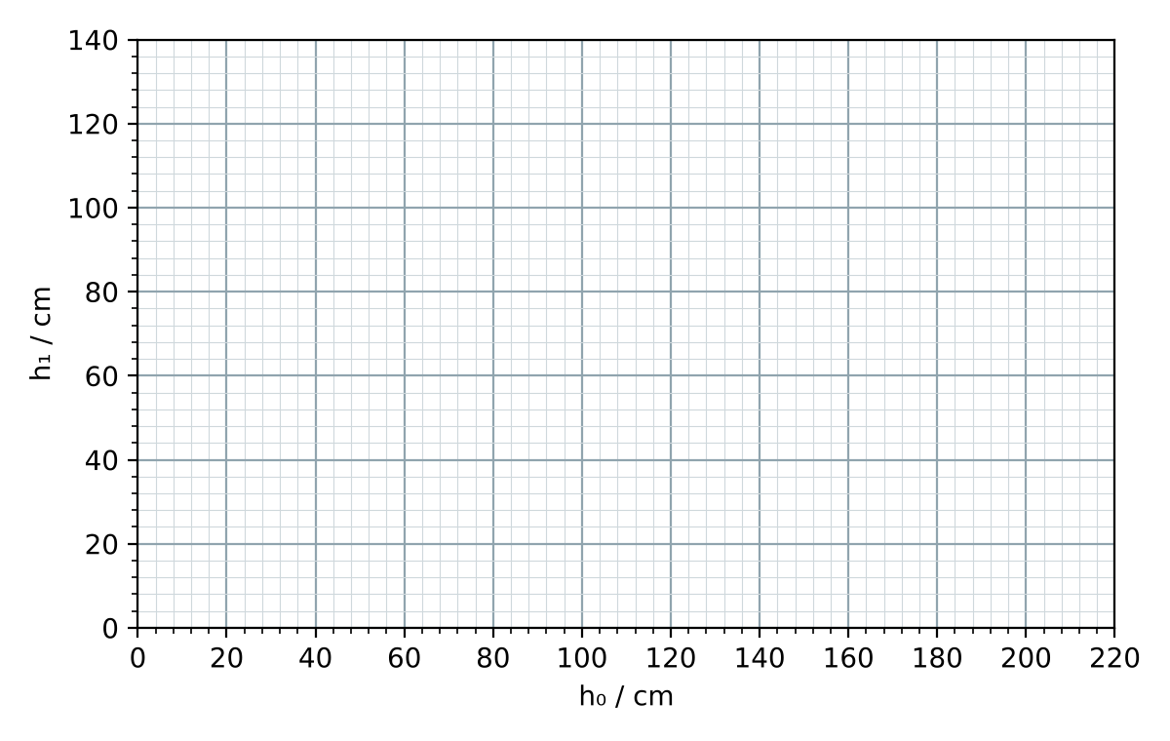
Gradient = ______________ .
11. (Oxford worked example) A motor raises a 150 N weight through 7.2 m. The energy supplied to it is 3.5 × 10³ J. Calculate the useful work and the efficiency. Check: Motor lift → Oxford preset.
Working

12. Draw the slide 13 motor's Sankey diagram to scale on the squared paper (1 square = 100 W). Read the efficiency from the widths.
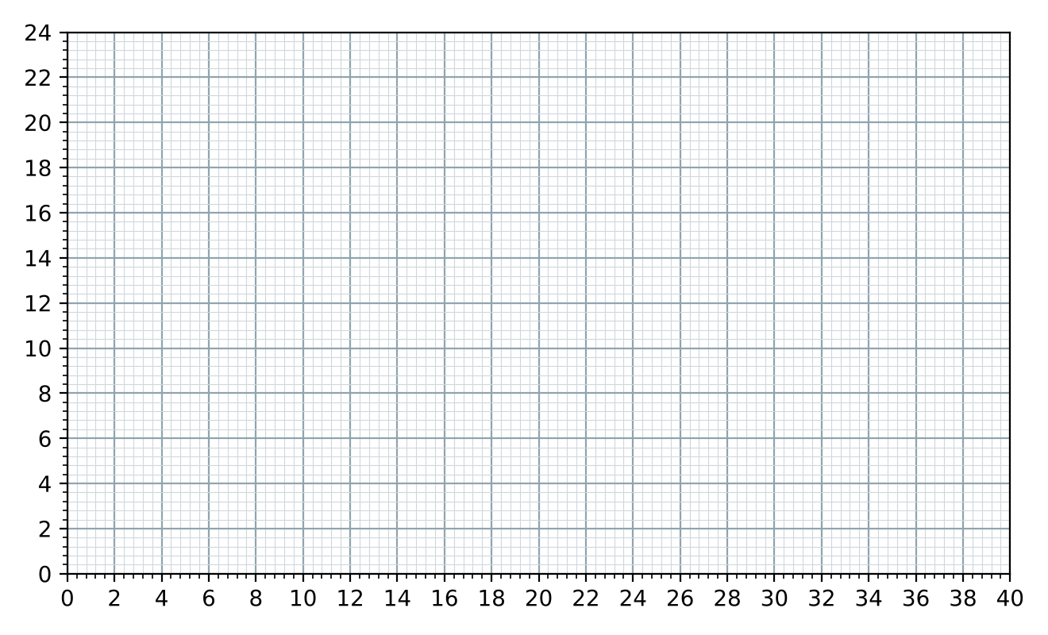
Part 3 — Homework
13. (exit question) A motor takes in 500 W and gives 350 W of useful power. Calculate its efficiency and sketch the Sankey diagram.
Working

14. (slide 15) The 2.0 kW motor of question 8 runs for one hour. Calculate the energy wasted.
Working

15. (slide 18) A car carries 40 kg of petrol (46 MJ kg⁻¹). Its engine is 25 % efficient and it needs 20 kW of useful power at 25 m s⁻¹. Calculate the energy stored, the useful energy, the time and the distance on one tank. Check: Fuel tank → Slide 18.
Working

16. An electric car carries 400 kg of Li-ion cells (0.9 MJ kg⁻¹, 90 % efficient) and needs the same 20 kW at 25 m s⁻¹. How far does it go? Why are batteries heavy?
Working

17. What mass of uranium (≈ 8 × 10⁷ MJ kg⁻¹) releases the same energy as 40 kg of petrol? Give one reason why cars do not use it.
Working

18. (slide 16: spot the mistake) A: input 100 J → useful 60 J, thermal 30 J. B: 'efficiency = 75 J wasted ÷ 100 J = 75 %'. What is wrong with each?
__________________________________________________________________________________________________
__________________________________________________________________________________________________
__________________________________________________________________________________________________

