Worksheet — Normal Force Simulation
Use with Simulation - Normal force.html · goes with carousel Station 1 (weight and normal force)
Biljana Taneska · Physics teacher · btaneska@vis.ac.at

Name: ______________________________ Class: ________ Date: ______________
How to use this worksheet  Scan the QR code or open physics.taneski.com/02-normal-force in a browser (offline: Simulation - Normal force.html). Choose the situation at the bottom: Push / pull, Ramp, Lift or Stack. The Tasks tab has the same three parts as this sheet. The simulation checks your numbers; write your explanations here.  Part 1 before the lab (≈ 15 min) · Part 2 during the lab, Station 1 (≈ 10 min) · Part 3 homework (≈ 30 min).  Use g = 9.81 N kg⁻¹. A scale shows F_{N}/g in kg. |   Scan to open

Part 1 — Pre-lab: predict, then test
Write your prediction before you test it. Lock it in on the sim, test it, then explain.
Question | My prediction (before) | What the simulation showed | Physics explanation
1. You press down on a 1.00 kg mass on a kitchen scale with 5.0 N. What does the scale read?
2. You pull up on the same mass with 5.0 N (it stays on the scale). What does the scale read?
3. The scale with the 1.00 kg mass is tilted to 30°. What happens to the reading?
4. A 60 kg student is on a bathroom scale in a lift that speeds up going up. Reading?
5. The lift cable snaps and the lift falls freely. Reading?
6. A 2.0 kg block sits on a 3.0 kg block on a table. How hard does the table push up?

7. Draw the free-body diagram of the 1.00 kg mass while you push down with 5.0 N. Then calculate F_{N} (five steps).
Free-body diagram and working

F_{N} = __________ N Scale reading = __________ kg

Part 2 — During the lab: Station 1
1.00 kg mass on the kitchen scale. Use the sim, then compare with your Station 1 measurements.
Angle θ / ° | Sim reading / kg | Predicted m cos θ / kg | Our reading / kg | F_{N} = mg cos θ / N
0
15
30

8. Give one reason why your measured readings differ from the simulation.
______________________________________________________________________________________
______________________________________________________________________________________
9. Why does the scale read less on the slope? Which force holds the mass up along the slope?
______________________________________________________________________________________
______________________________________________________________________________________
______________________________________________________________________________________
10. At Station 1 you pressed down with one finger. Explain what happened to the reading using the FBD.
______________________________________________________________________________________
______________________________________________________________________________________

Part 3 — Homework: analyse

A. Pushing and pulling (m = 2.00 kg)
Hand force F / N (push +) | -15 | -10 | -5 | 0 | 5 | 10 | 15
F_{N} / N

11. Plot F_{N} against F and draw the best-fit line.
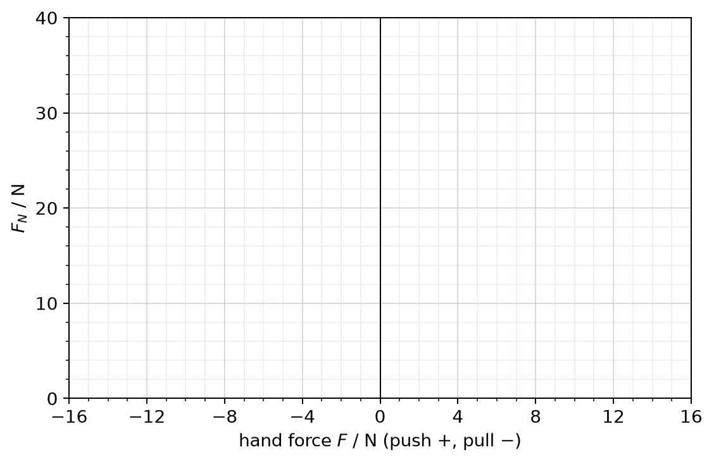
12. Gradient = __________ Intercept = __________ N. What does each one mean physically?
______________________________________________________________________________________
______________________________________________________________________________________

B. Tilting (m = 2.00 kg)
θ / ° | 0 | 10 | 20 | 30 | 40
cos θ
F_{N} / N

13. Plot F_{N} against cos θ. Gradient = __________ N. Which quantity does the gradient equal?
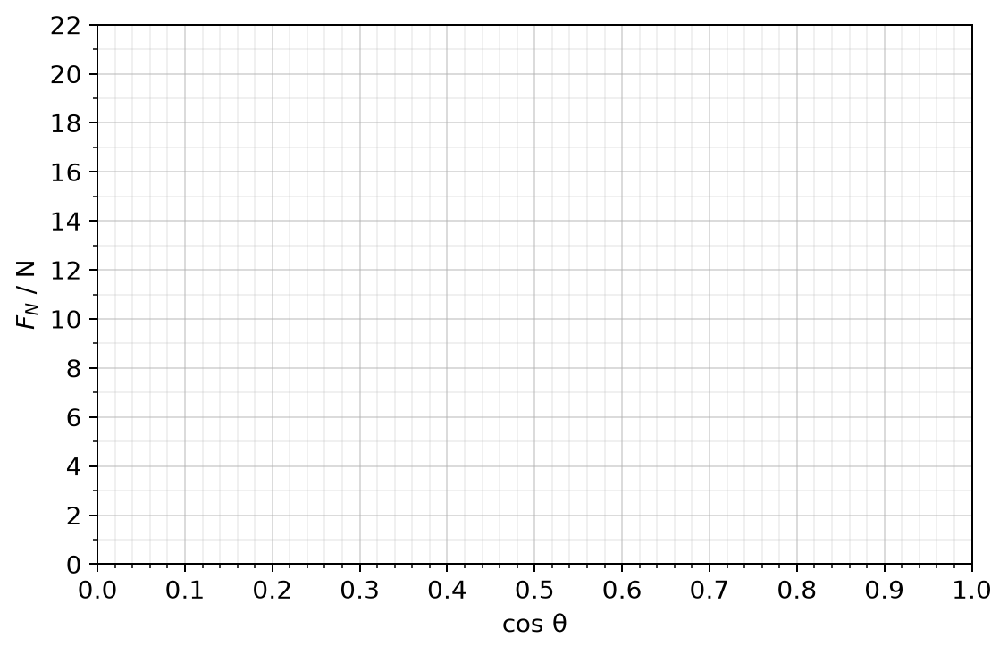

C. Lift (Newton's 2nd law — Blocks 3–4)
14. A 60 kg student stands on a bathroom scale in a lift that accelerates upward at 1.5 m s⁻². Draw the FBD and calculate the scale reading in N and in kg.
Free-body diagram and working

15. The lift now slows down while going up (acceleration 1.5 m s⁻² downward). What does the scale show in kg?
Working

16. Explain why the scale reads 0 kg in free fall, even though the student's weight is still 589 N.
______________________________________________________________________________________
______________________________________________________________________________________

D. Stack
17. Blocks 1 (3.0 kg, bottom), 2 (2.0 kg) and 3 (1.0 kg, top) are stacked on a table. Draw the FBD of block 1 and calculate the force of block 2 on block 1 and the force of the table on block 1.
Free-body diagram and working

18. Name the Newton's 3rd-law partner of 'the force of block 2 on block 1'. Why is the weight of block 2 not its partner?
______________________________________________________________________________________
______________________________________________________________________________________
______________________________________________________________________________________

