Worksheet — Incline with a Pulley Simulation
Use with Simulation - Incline with pulley.html · Newton's 2nd law (Blocks 3–4) · goes with card C2★★ and the Block 3 Smart Cart demo
Biljana Taneska · Physics teacher · btaneska@vis.ac.at

Name: ______________________________ Class: ________ Date: ______________
How to use this worksheet  Scan the QR code or open physics.taneski.com/04-incline-pulley in a browser (offline: Simulation - Incline with pulley.html). Set the surfaces, m₁, m₂ and θ, then press ▶ Release. The Tasks tab has the same three parts as this sheet; write your explanations here.  Part 1 before the lesson (≈ 15 min) · Part 2 with the Block 3 Smart Cart demo (≈ 10 min) · Part 3 homework (≈ 30 min).  Use g = 9.81 N kg⁻¹. Take 'the hanging mass falls, the block moves up the slope' as positive. |   Scan to open

Part 1 — Pre-lab: predict, then test
Question | My prediction (before) | What the simulation showed | Physics explanation
1. Card C2★★ (4.0 kg on a smooth 30° slope, 3.0 kg hanging): which way does it move?
2. While it accelerates, is T less than, equal to or more than m₂g?
3. Smooth slope, m₂ = 2.0 kg (m₂g = m₁g sin 30°). What happens after release?
4. Wood slope (μs = 0.41), m₁ = 4.0 kg: which hanging masses keep it at rest?

5. Draw separate free-body diagrams for the block and for the hanging mass of card C2★★ while they move.
Free-body diagrams (block | hanging mass)

6. Use Newton's 2nd law on each body to calculate the acceleration and the tension for card C2★★. Check with the sim.
Working

a = __________ m s⁻² T = __________ N

Part 2 — During the lab: Block 3 Smart Cart demo
Sim: Smart Cart wheels on bench, m₁ = 0.500 kg, θ = 0°. Fill in the sim and the demo's shared data.
m₂ / g | Sim a / m s⁻² | Sim T / N | Demo a / m s⁻² | Demo T / N | m₂g / N
20
40
60
80
100

7. Plot a against T (demo or sim data) and draw the best-fit line.
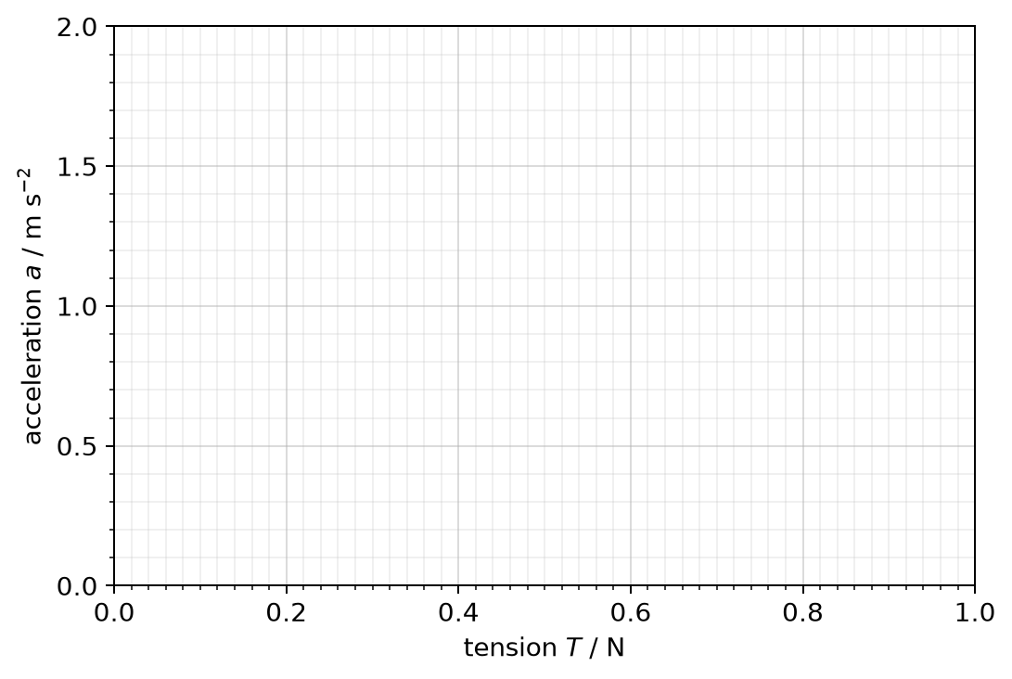
8. Gradient = __________ kg⁻¹ ⇒ mass of the cart = __________ kg. x-intercept = __________ N = ______________
9. Why is the tension while the cart accelerates smaller than m₂g? Why do we plot a against T, not against m₂g?
______________________________________________________________________________________
______________________________________________________________________________________
______________________________________________________________________________________

Part 3 — Homework: analyse
Wood on bench (μ_{s} = 0.41, μ_{d} = 0.30), m₁ = 1.0 kg, θ = 35°.
10. Find the smallest and the largest hanging mass that keep the block at rest. Draw the FBD of the block for each case — which way does static friction act?
Free-body diagrams and working

m_{2,min} = __________ kg m_{2,max} = __________ kg
11. m₂ = 1.5 kg. Calculate the acceleration and the tension.
Working

12. m₂ = 0.10 kg: the block slides down. Calculate the size of the acceleration and the tension. Why is T now greater than m₂g?
Working

