Worksheet — Drag and Stokes' Law Simulation
Use with Simulation - Drag and Stokes law.html · goes with Station 5 (race to the bottom)
Biljana Taneska · Physics teacher · btaneska@vis.ac.at

Name: ______________________________ Class: ________ Date: ______________
How to use this worksheet  Scan the QR code or open physics.taneski.com/07-drag-stokes in a browser (offline: Simulation - Drag and Stokes law.html). Ball in a liquid: ▶ Drop, and the stopwatch times the ball between bands A and B (20.0 cm apart). Use ×5 or ×20 for slow runs. Skydiver: ▶ Jump, then ☂.  Part 1 before the lab (≈ 15 min) · Part 2 during the lab, Station 5 (≈ 10 min) · Part 3 homework (≈ 30 min).  Use g = 9.81 N kg⁻¹. Stokes' law: F_{d} = 6πηrv. Glycerol: ρ = 1260 kg m⁻³, η = 1.41 Pa s. Steel: ρ = 7850 kg m⁻³. |   Scan to open

Part 1 — Pre-lab: predict, then test
Question | My prediction (before) | What the simulation showed | Physics explanation
1. What happens to the speed of the ball after it is let go?
2. At terminal velocity, what is the resultant force?
3. You double the radius of the ball. Terminal speed?
4. The same steel ball in water instead of glycerol?

5. Draw the free-body diagram of the ball at terminal velocity. Then show that v_{t} = 2r²(ρ_{ball} − ρ_{fluid})g / (9η).
Free-body diagram and derivation

6. Calculate v_{t} for the steel ball (r = 1.0 mm) in glycerol.
Working

Part 2 — During the lab: Station 5
ball | r / mm | sim t_{AB} / s | our t / s (3 trials) | our mean t / s | v = 0.200/t / cm s⁻¹
small | 1.0
large | 2.0

7. By what factor is the large ball faster? What does Stokes' law predict? Why is the sim's ratio a little less than 4?
______________________________________________________________________________________
______________________________________________________________________________________
______________________________________________________________________________________
8. How could you check that the ball has reached terminal speed before band A?
______________________________________________________________________________________
______________________________________________________________________________________

Part 3 — Homework: viscosity from a graph
r / mm | 0.50 | 0.75 | 1.00 | 1.25 | 1.50
r² / mm²
t_{AB} / s
v_{t} / cm s⁻¹

9. Plot v_{t} against r² and draw the best-fit line through the origin.
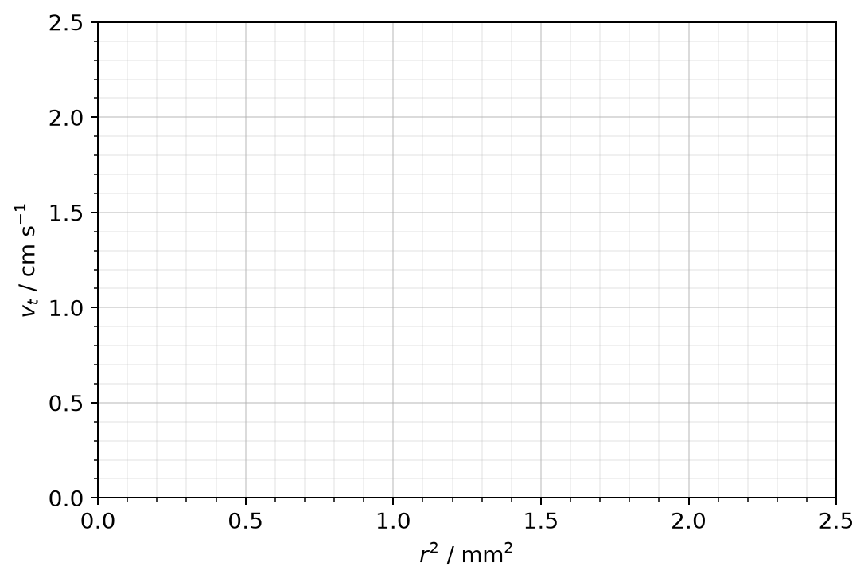
10. Use the gradient to find the viscosity of glycerol (convert the gradient to m⁻¹ s⁻¹ first).
Working

11. Sketch the v–t graph of a skydiver who opens a parachute after 18 s. Explain each part using the forces. Why can't Stokes' law be used for the skydiver?
Sketch and explanation

