Worksheet — Spring Force Simulation
Use with Simulation - Spring force.html · goes with Station 3 and the Forces investigation (spring)
Biljana Taneska · Physics teacher · btaneska@vis.ac.at

Name: ______________________________ Class: ________ Date: ______________
How to use this worksheet  Scan the QR code or open biba0112.github.io/physics-sims/05-spring-force in a browser (offline: Simulation - Spring force.html). Hang masses: add 50 g at a time and read the pointer on the ruler. Push / pull: stretch or squash a spring on a table. The Tasks tab has the same three parts as this sheet; write your explanations here.  Part 1 before the lab (≈ 15 min) · Part 2 during the lab (≈ 10 min) · Part 3 homework (≈ 30 min).  Use g = 9.81 N kg⁻¹. Extension x = pointer reading − unloaded reading. Always convert x to metres for k. |   Scan to open

Part 1 — Pre-lab: predict, then test
Question | My prediction (before) | What the simulation showed | Physics explanation
1. A mass hangs at rest on the spring. Is the spring force bigger than, equal to or smaller than its weight?
2. You double the load from 100 g to 200 g. What happens to the extension?
3. You load the soft spring (limit ≈ 3 N) with 400 g, then unload it. What happens?
4. You squash the spring by 6.0 cm. Which way does the spring push the block?

5. Draw the free-body diagram of a 200 g mass hanging at rest on the spring.
Free-body diagram

6. The investigation spring has k = 25.0 N m⁻¹. Calculate the extension (in cm) with 200 g hanging.
Working

x = __________ cm Sim check: __________ cm

Part 2 — During the lab: Station 3 / Forces investigation
Investigation spring, reading uncertainty ON. Record the sim values and your own measurements.
mass m / g (±1) | load F = mg / N | sim pointer / cm | sim x / cm (±0.1) | our x / cm (±0.1)
100
150
200
250
300

7. Plot F against x with error bars (±0.1 cm). Draw the best-fit line and the steepest and shallowest lines through the error bars of the first and last points.
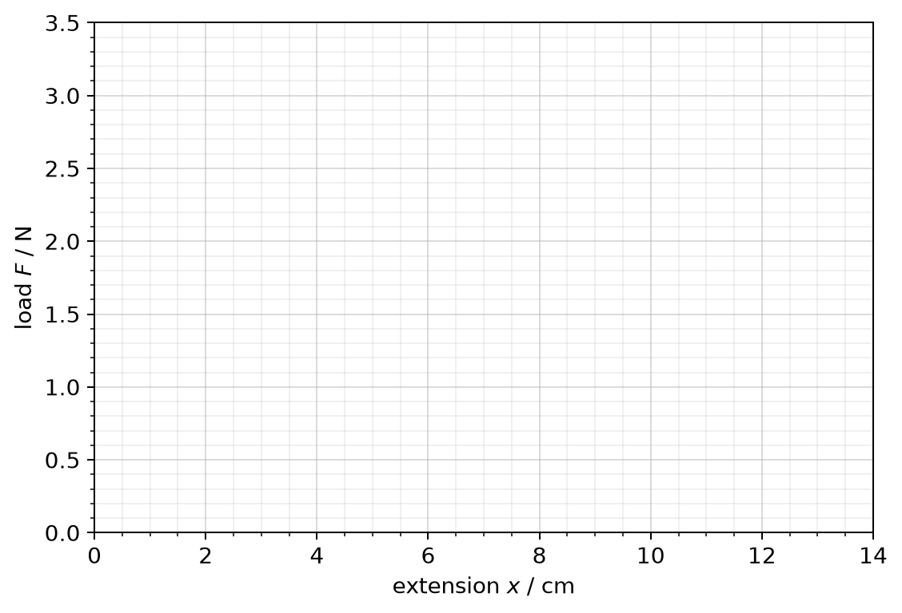
8. k = __________ ± __________ N m⁻¹ (Δk = ½(k_{max} − k_{min}))
9. Mystery bag: x = __________ cm ⇒ F = kx = __________ N ⇒ m = __________ kg. Balance: __________ kg
10. Would your method still work for a 5 kg load? Explain.
______________________________________________________________________________________
______________________________________________________________________________________
______________________________________________________________________________________

Part 3 — Homework: analyse
Station 3 spring, uncertainty ON. Record 100 g to 400 g in 50 g steps.
m / g | 100 | 150 | 200 | 250 | 300 | 350 | 400
F / N
x / cm

11. Plot F against x with error bars and find k ± Δk.
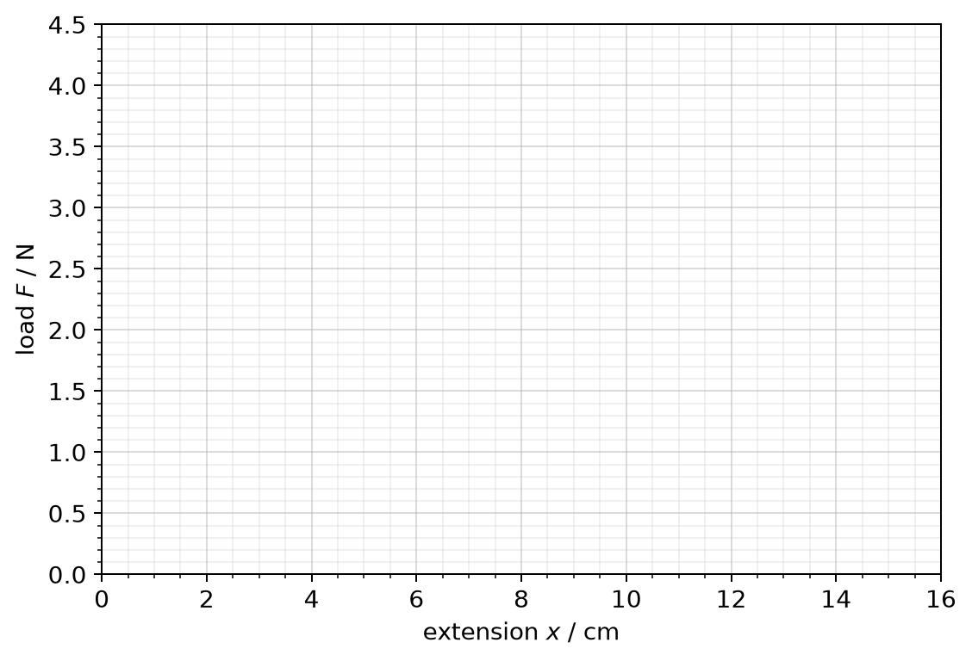
k = __________ ± __________ N m⁻¹
12. The investigation spring is stretched by 6.0 cm on a table. Calculate the spring force and give its direction. What does the minus sign in F_{H} = −kx mean?
Working

13. The stiff spring (k = 40.0 N m⁻¹) stretches 4.5 cm when an object hangs from it. Calculate the mass of the object.
Working

14. Sketch the F–x graph of a spring loaded past its limit of proportionality. Mark the limit of proportionality. Explain why an overloaded spring is no longer a good force meter.
Sketch and explanation

