Worksheet — Free Fall Simulation
Use with Simulation - Free fall.html · A.1 Kinematics: free fall, suvat, h against t² → g; goes with the class ball-drop experiment (stopwatch)
Biljana Taneska · Physics teacher · btaneska@vis.ac.at

Name: ______________________________ Class: ________ Date: ______________
How to use this worksheet  Scan the QR code or open biba0112.github.io/physics-sims/10-free-fall in a browser (offline: Simulation - Free fall.html). Set the height h, the launch velocity v₀ (0 = drop, + = throw up), the field, ball A and an optional ball B. ▶ Drop runs it; the strobe shows the ball every 0.1 s.  Part 1 before the lab (≈ 15 min) · Part 2 during the ball-drop lab (≈ 15 min) · Part 3 homework (≈ 30 min).  Use g = 9.81 m s⁻² and up is positive: a falling ball has a negative velocity and a = −9.81 m s⁻². |   Scan to open

Part 1 — Pre-lab: predict, then test
Write your prediction before you run the simulation. Then test it and explain what you saw.
Question | My prediction (before) | What the simulation showed | Physics explanation
1. Steel ball (64 g) and ping-pong ball (2.7 g) dropped together from 1.00 m in a vacuum. Which lands first?
2. Air resistance on: steel ball and paper cupcake case dropped from 2.00 m. What happens?
3. The drop height is doubled from 1.00 m to 2.00 m. By what factor does the fall time change?
4. Which v–t graph (A–D below) shows a ball dropped from rest? (up positive)

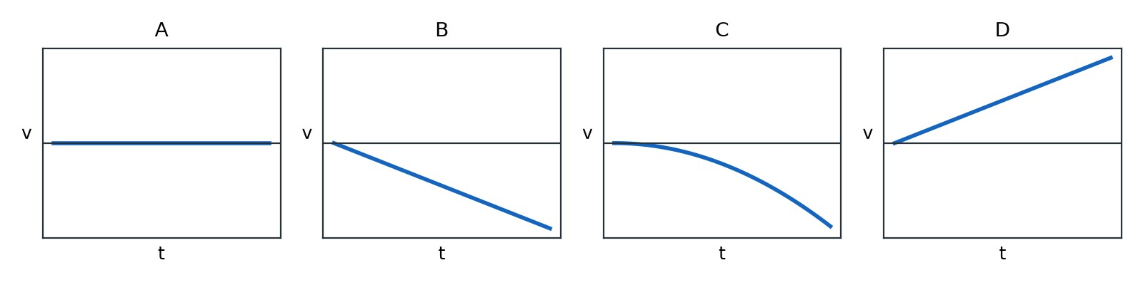
Q4 options (up is positive)
5. Calculate the time for a ball to fall 1.00 m from rest. Then check it with the simulation (light gate).
______________________________________________________________________________________
______________________________________________________________________________________
______________________________________________________________________________________
______________________________________________________________________________________
t = ____________ s simulation: ____________ s

Part 2 — During the lab: compare with the ball drop
Class experiment. Drop a ball from each height and time the fall with a stopwatch. Do 3 drops per height.
h / m | t₁ / s | t₂ / s | t₃ / s | mean t / s | t² / s²
0.50
1.00
1.50
2.00

Simulation. Timing = Stopwatch. Do the same drops (3 per height) and press ● Record each time.
h / m | t₁ / s | t₂ / s | t₃ / s | mean t / s | t² / s²
0.50
1.00
1.50
2.00

1. Calculate the true fall time from 0.50 m. How does it compare with your stopwatch times?
______________________________________________________________________________________
______________________________________________________________________________________
______________________________________________________________________________________
______________________________________________________________________________________
2. What is the main cause of the spread in your stopwatch times? Is it a random or a systematic uncertainty?
______________________________________________________________________________________
______________________________________________________________________________________
______________________________________________________________________________________
______________________________________________________________________________________
3. g from the simulation's best-fit line (Data tab, g = 2 × gradient): g = ________ m s⁻²
4. g from the class data (plot h against t² in Part 3 or on graph paper): g = ________ m s⁻²
5. Percentage difference from 9.81 m s⁻², and one improvement to the experiment:
______________________________________________________________________________________
______________________________________________________________________________________
______________________________________________________________________________________
______________________________________________________________________________________

Part 3 — Homework: analyse
Timing = Real data ±2 %, steel ball. Record one drop from each height.
h / m | t / s | t² / s²
0.40
0.80
1.20
1.60
2.00

1–2. Plot h (y-axis) against t² (x-axis). Draw the best-fit line through the origin.
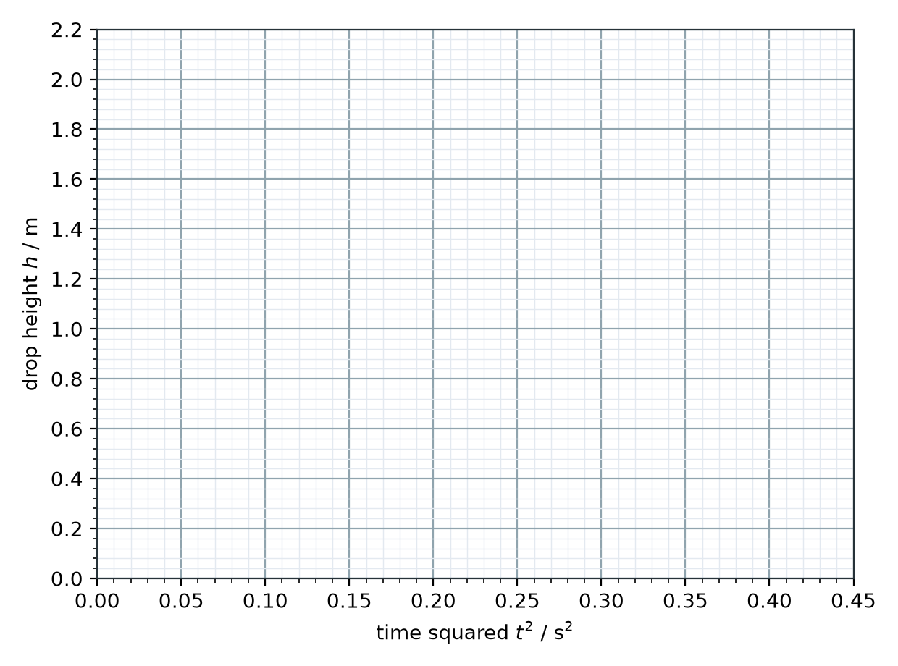
3. Gradient = ____________ m s⁻² ⇒ g = 2 × gradient = ____________ m s⁻²
Explain why the gradient of h against t² is g/2:
______________________________________________________________________________________
______________________________________________________________________________________
______________________________________________________________________________________
4. A ball is dropped from rest from 1.80 m. Calculate the time it takes to reach the floor.
______________________________________________________________________________________
______________________________________________________________________________________
______________________________________________________________________________________
______________________________________________________________________________________
5. Calculate the speed of the ball just before it hits the floor.
______________________________________________________________________________________
______________________________________________________________________________________
______________________________________________________________________________________
______________________________________________________________________________________
6. A ball is thrown straight up at 8.0 m s⁻¹. How high does it rise above the hand?
______________________________________________________________________________________
______________________________________________________________________________________
______________________________________________________________________________________
______________________________________________________________________________________
7. How long after the throw is the ball back at the level of the hand?
______________________________________________________________________________________
______________________________________________________________________________________
______________________________________________________________________________________
______________________________________________________________________________________
8. At the very top of the throw, what are the velocity and the acceleration? Explain.
______________________________________________________________________________________
______________________________________________________________________________________
______________________________________________________________________________________
______________________________________________________________________________________
9. An astronaut drops a hammer from 1.80 m on the Moon (g = 1.62 m s⁻²). Calculate the fall time and compare it with Q4.
______________________________________________________________________________________
______________________________________________________________________________________
______________________________________________________________________________________
______________________________________________________________________________________

