Salt naming — simulation worksheet
Grade 7 · IB MYP 2 Sciences · Unit 1 Chemistry's Secrets Unlocked · Neutralisation and salts

Name: ______________________________ Class: ________ Date: _______________
How to use this worksheet  • Open the simulation: scan the QR code or type school.taneski.com/science/g07/01-salt-naming/ (offline: the file Simulation - Salt naming.html).  • The simulation has a Tasks tab (on the right) with the same three parts as this sheet. It checks your answers.  • This sheet collects your explanations, tables and drawings. Write full sentences and use the new words below.  • Part 1 Pre-lab (before the practical) · Part 2 During the lab (with Workbook Activity 9) · Part 3 Homework. |   Scan to open

New words
neutralisation — the reaction of an acid with an alkali. It makes a salt and water, and the pH moves towards 7 (neutral).
salt — a new substance: a metal joined to the part of an acid that is left without its hydrogen. Table salt (sodium chloride) is just one salt.
alkali — a base that dissolves in water. base — any substance that neutralises an acid.
hydroxide — the OH part of an alkali, for example sodium hydroxide, NaOH.
reactants — the substances you start with. products — the new substances that are made.

Part 1 · Pre-lab: predict (about 15 minutes)
Open Tasks → 1 · Pre-lab in the simulation. Do each step there, then write your answers here.
1 Hydrochloric acid and sodium hydroxide are set up. Predict what the reaction will make. Then press React! and write what the simulation shows.
My prediction
What the simulation shows

2 Before the reaction the pieces look like this. Press React! and watch where each piece goes. Complete the table.
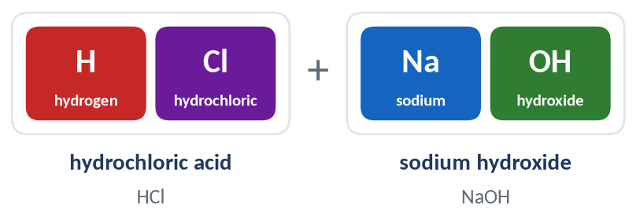
Piece | Colour in the simulation | Comes from (acid or alkali?) | Ends up in (salt or water?)
H
Cl
Na
OH

3 Complete the sentences.
The 1st name of the salt is the ____________________ from the ____________________.
The 2nd name of the salt comes from the ____________________.
4 Explain why every reaction between an acid and an alkali makes water. Use the words hydrogen and hydroxide.

5 Name the salts. Type each answer in the Tasks tab to check it.
Acid | Alkali | Salt | Other product
hydrochloric acid | potassium hydroxide
sulfuric acid | sodium hydroxide

6 Complete the rule table. The box How to name the salt → Acid name → salt ending in the simulation helps you.
The acid's name… | The salt's name ends in… | One example from the simulation
hydro…ic acid
…ic acid
…ous acid

Part 2 · During the lab: compare (about 10 minutes)
With Workbook Activity 9 (page 16): add hydrochloric acid to sodium hydroxide with universal indicator until it turns green, then filter and evaporate the water to get salt crystals. Open Tasks → 2 · During the lab.
⚠ Safety
• Wear eye protection. Sodium hydroxide and hydrochloric acid hurt eyes and skin: rinse any splash with plenty of cold water and tell your teacher.
• The burner and the evaporating basin get hot. Switch the burner off when a little water is left, and let the basin cool.
• Never taste the salt: there may be other chemicals on the equipment.

7 Compare what you see in the lab with what the simulation shows. Write "not shown" if the simulation does not show it.
 | In the lab I see… | The simulation shows…
Reactants (what I start with)
Colour of the indicator at the start
Colour when the solution is neutral
What is left after evaporating
Name of the salt
The other product

8 Write the word equation for the reaction in the lab.

9 Another group used potassium hydroxide instead of sodium hydroxide. Which salt did they make? Explain how you know.

10 The simulation is a model. Give two ways in which the real reaction in the beaker is different from what the simulation shows.

Part 3 · Homework: analyse (about 20 minutes)
Open Tasks → 3 · Homework. Work out each answer first, then check it in the simulation.
11 Complete the table. In the last column write which rule you used (…ide, …ate or …ite).
Acid | Alkali or base | Salt | Rule
nitric acid | calcium hydroxide
phosphoric acid | sodium hydroxide
ethanoic acid (in vinegar) | potassium hydroxide
sulfurous acid | sodium hydroxide
hydrobromic acid | magnesium hydroxide

12 Work backwards. A fertiliser bag says it contains potassium nitrate. Which acid and which alkali could make it? Write the word equation.

13 In the simulation, magnesium hydroxide is called a base, not an alkali. Explain the difference between a base and an alkali. Then give one everyday use of magnesium hydroxide and say what it neutralises.

14 Reflection. Explain to a friend, in three steps, how to name the salt made from any acid and any alkali.

