Worksheet – Heat transfer simulation  Grade 6 · Physics · Unit 1 Thinking about Energy · Heat and temperature, conduction, convection, radiation  Name: ______________________ Class: ______ Date: ____________  Open the simulation (scan the QR code), do the 4 stations with Marie and fill in this sheet as you go. Write temperatures with the unit °C. |   school.taneski.com/science/g06/06-heat-transfer/
Station 1 · Heat or temperature? (1A Heating race · 1B Big and small)

1 Heating race: both beakers get the same heat for 5 minutes. Temperature after 5 minutes: small beaker (100 g) ______ big beaker (400 g) ______
2 Why did the big beaker warm up less? Use the word particles.

3 Big and small: both at 60 °C, the same ice cube in each. After 5 minutes: small cup ______ big beaker ______. Where did more ice melt? ______________
4 A match flame is about 600 °C and a bath is 40 °C. Which has more thermal energy? ____________ Why?

5 Temperature is measured in ________ with a ____________. Thermal energy (heat) is measured in __________. Heat always moves from ________ to ________.
Station 2 · Conduction – the metal star

6 Copy the times from the results table.
Metal | Copper | Aluminium | Brass | Nickel | Steel
Time for the pin to drop (s)

7 The best conductor is __________ and the worst of the five is __________, because ______________________________.
8 Draw 6 particles in each box (look at the particle model). Show how much they vibrate with little lines.
Cool end of the arm | Hot centre of the star

9 Conduction: the particles __________ more and bump into their ____________. The particles stay in their places – only the ________ moves along.

Station 3 · Convection – the convection tube

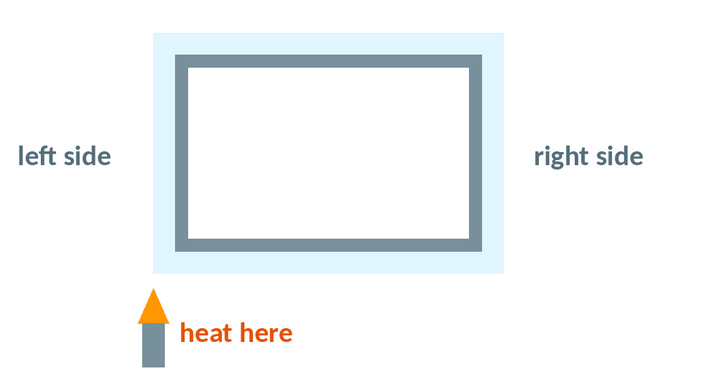 | 10 On the picture, draw arrows to show how the purple colour moved.  11 Why does the hot water rise? Use: particles · spread out · less dense  12 Convection happens in liquids and ________, but not in ________, because ______________________.
Station 4 · Radiation (4A Three bottles · 4B Leslie cube)

13 Bottles under the infrared lamp – temperature of the air after 6 minutes:
Bottle | Black | White | Shiny silver
Temperature after 6 min (°C)

14 The best absorber is the __________ bottle. The silver bottle stayed coolest because __________________________________.
15 Leslie cube full of 80 °C water – infrared thermometer readings:
Face | Matt black | Matt white | Dull silver | Shiny silver
Reading (°C)

16 Sam says: “The black face is hotter than the shiny face.” Is Sam right? Explain.

Summary · three ways heat moves

 | Conduction | Convection | Radiation
Does it need particles? (yes / no)
Where does it happen? (solid, liquid, gas, vacuum)
An example from the simulation

17 One thing I learned today:

