Worksheet — Friction Block Simulation
Use with Simulation - Friction block.html · goes with the Block 2 friction lab
Biljana Taneska · Physics teacher · btaneska@vis.ac.at

Name: ______________________________ Class: ________ Date: ______________
How to use this worksheet  Scan the QR code or open school.taneski.com/physics/dp/01-friction-block in a browser (laptop, Chromebook or tablet). The Tasks tab in the simulation has the same three parts as this sheet. The simulation checks your numbers; write your explanations here.  Part 1 before the lab (≈ 15 min) · Part 2 during the lab (≈ 10 min) · Part 3 homework (≈ 30 min).  Use g = 9.81 N kg⁻¹. Give every value with its unit. |   Scan to open

Part 1 — Pre-lab: predict, then test
For each question, write your prediction before you test it. Lock it in on the sim, test it, then explain.
Question | My prediction (before) | What the simulation showed | Physics explanation
1. Set the pull rate to 0.5 N s⁻¹. Hold the pull at about 0.5 N; the block does not move. What is the friction force?
2. What happens to the newton-meter reading at the moment the block starts to slide?
3. You add masses so that F_{N} is about twice as large (1 mass → 3 masses). What happens to the peak force?
4. You turn the block onto its small face (smaller contact area). What happens to the peak force?
5. You change the pull rate from 1.0 N s⁻¹ to 3.0 N s⁻¹. What changes?

6. Sketch the force–time graph you expect for one run. Label the peak and the sliding value, and mark where the block is at rest and where it slides.
Sketch: pull F / N (vertical) against time t / s (horizontal)

7. Calculate the pull needed to start the 0.250 kg wood block sliding (μ_{s} = 0.41, θ = 0°). Use the five steps: Given/Find → Physics → Equation → Working → Answer.
Working

F = __________ N Sim check: __________ N

Part 2 — During the lab: compare the simulation with your measurements
Wood on bench, θ = 0°, noise ON. Use the same loads as in your lab. Fill in the sim values and your group's newton-meter values.
Slotted masses | m / kg | F_{N} = mg / N | Sim peak / N | Sim sliding / N | Our peak / N | Our sliding / N
0 | 0.250
1 | 0.450
2 | 0.650
3 | 0.850
4 | 1.050
5 | 1.250

8. For 2 slotted masses (m = 0.650 kg): μ_{d} from the sim = F_{f} ÷ F_{N} = ______________
9. μ_{d} from your group's data for the same load = ______________
10. Give two reasons why your measured values differ from the simulation.
______________________________________________________________________________________
______________________________________________________________________________________
______________________________________________________________________________________
______________________________________________________________________________________
11. Which peak value is harder to read in the real lab, and why? How does a slow-motion video help?
______________________________________________________________________________________
______________________________________________________________________________________
______________________________________________________________________________________

Part 3 — Homework: find μ_{s} and μ_{d} from a graph
Rubber sole on bench, θ = 0°, noise ON. Run and ● Record trial for 0–5 slotted masses. Copy your table.
Slotted masses | m / kg | F_{N} / N | F_{f,max} (peak) / N | F_{f,d} (sliding) / N
0 | 0.250
1 | 0.450
2 | 0.650
3 | 0.850
4 | 1.050
5 | 1.250

12. Plot F_{f,max} and F_{f,d} against F_{N} on the grid. Draw a best-fit line through the origin for each set. Use different symbols for the two sets.
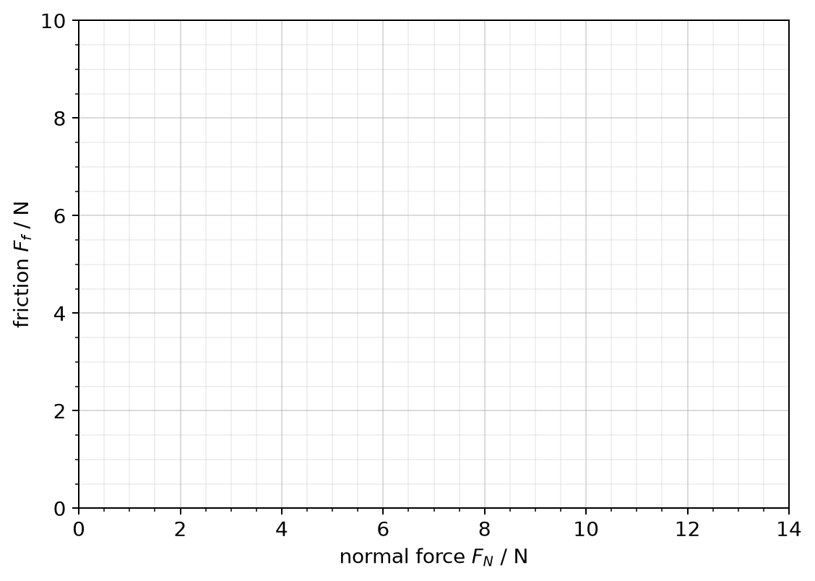
13. Draw a large gradient triangle on each line. μ_{s} = gradient = __________ μ_{d} = gradient = __________
14. Why should each line pass through the origin?
______________________________________________________________________________________
______________________________________________________________________________________

Angled pull
15. Wood on bench, m = 0.650 kg, the string pulls at θ = 20° above the horizontal. Draw the free-body diagram, then calculate the pull F needed to start the block sliding and the normal force at that moment. Check both with the simulation.
Free-body diagram (label W, F_{N}, F_{f}, F and the components of F)

Working

F = __________ N F_{N} = __________ N
16. Explain why F_{N} is smaller than mg when you pull at 20°, and why this makes the block easier to move.
______________________________________________________________________________________
______________________________________________________________________________________
______________________________________________________________________________________
17. Name one way the simulation is simpler than the real experiment.
______________________________________________________________________________________
______________________________________________________________________________________

