Worksheet — Spring Force Simulation
Use with Simulation - Spring force.html · goes with Station 3 and the Forces investigation (spring)
Biljana Taneska · Physics teacher · btaneska@vis.ac.at

Name: ______________________________ Class: ________ Date: ______________
How to use this worksheet  Scan the QR code or open school.taneski.com/physics/dp/05-spring-force in a browser (offline: Simulation - Spring force.html). Hang masses: add 50 g at a time and read the pointer on the ruler. Push / pull: stretch or squash a spring on a table. The Tasks tab has the same four parts as this sheet; write your explanations here.  Part 1 before the lab (≈ 15 min) · Part 2 during the lab (≈ 10 min) · Part 3 homework (≈ 30 min) · Part 4 checkpoint: hysteresis and the elastic limit (≈ 15 min).  Use g = 9.81 N kg⁻¹. Extension x = pointer reading − unloaded reading. Always convert x to metres for k. |   Scan to open

Part 1 — Pre-lab: predict, then test
Question | My prediction (before) | What the simulation showed | Physics explanation
1. A mass hangs at rest on the spring. Is the spring force bigger than, equal to or smaller than its weight?
2. You double the load from 100 g to 200 g. What happens to the extension?
3. You load the soft spring (limit ≈ 3 N) with 400 g, then unload it. What happens?
4. You squash the spring by 6.0 cm. Which way does the spring push the block?

5. Draw the free-body diagram of a 200 g mass hanging at rest on the spring.
Free-body diagram

6. The investigation spring has k = 25.0 N m⁻¹. Calculate the extension (in cm) with 200 g hanging.
Working

x = __________ cm Sim check: __________ cm

Part 2 — During the lab: Station 3 / Forces investigation
Investigation spring, reading uncertainty ON. Record the sim values and your own measurements.
mass m / g (±1) | load F = mg / N | sim pointer / cm | sim x / cm (±0.1) | our x / cm (±0.1)
100
150
200
250
300

7. Plot F against x with error bars (±0.1 cm). Draw the best-fit line and the steepest and shallowest lines through the error bars of the first and last points.
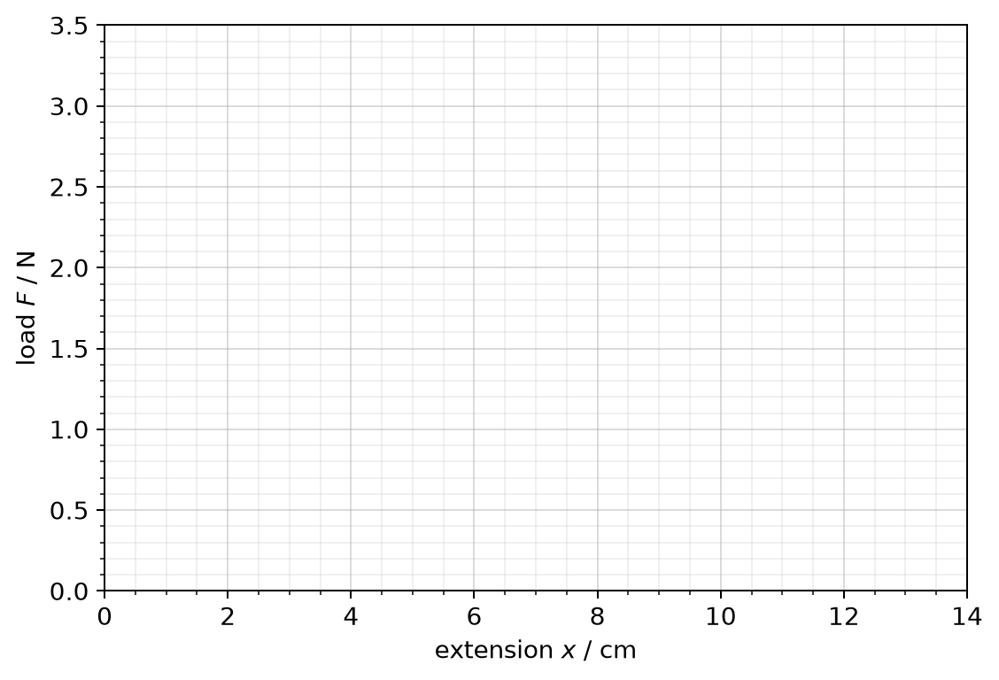
8. k = __________ ± __________ N m⁻¹ (Δk = ½(k_{max} − k_{min}))
9. Mystery bag: x = __________ cm ⇒ F = kx = __________ N ⇒ m = __________ kg. Balance: __________ kg
10. Would your method still work for a 5 kg load? Explain.
______________________________________________________________________________________
______________________________________________________________________________________
______________________________________________________________________________________

Part 3 — Homework: analyse
Station 3 spring, uncertainty ON. Record 100 g to 400 g in 50 g steps.
m / g | 100 | 150 | 200 | 250 | 300 | 350 | 400
F / N
x / cm

11. Plot F against x with error bars and find k ± Δk.
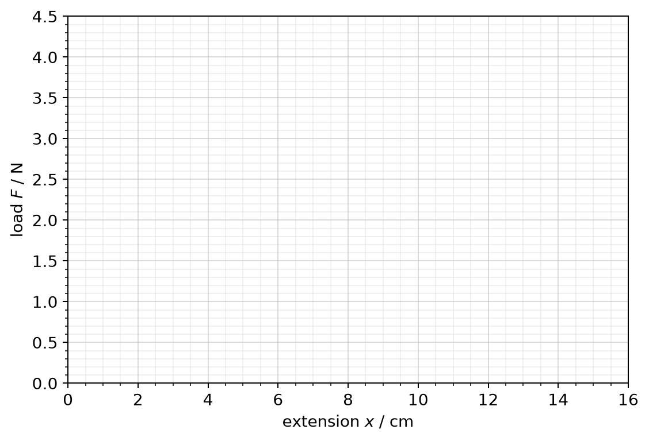
k = __________ ± __________ N m⁻¹
12. The investigation spring is stretched by 6.0 cm on a table. Calculate the spring force and give its direction. What does the minus sign in F_{H} = −kx mean?
Working

13. The stiff spring (k = 40.0 N m⁻¹) stretches 4.5 cm when an object hangs from it. Calculate the mass of the object.
Working

14. Sketch the F–x graph of a spring loaded past its limit of proportionality. Mark the limit of proportionality. Explain why an overloaded spring is no longer a good force meter.
Sketch and explanation

Part 4 — Checkpoint: hysteresis and the elastic limit
Simulation: mode Load & unload. Spring: Investigation spring (k = 25.0 N m⁻¹, elastic limit E at 6.0 N). Load it in steps up to 800 g, then unload. Record the extension readout (pointer − 30.0 cm) x each time the load is at rest.
mass m / g | load F = mg / N | loading: x / cm | unloading: x / cm
0
200
400
600
700
800 |  |  | (turning point)

15. Plot the loading points and the unloading points on the grid and join each set. Mark the elastic limit E and label the loading and unloading lines with arrows.
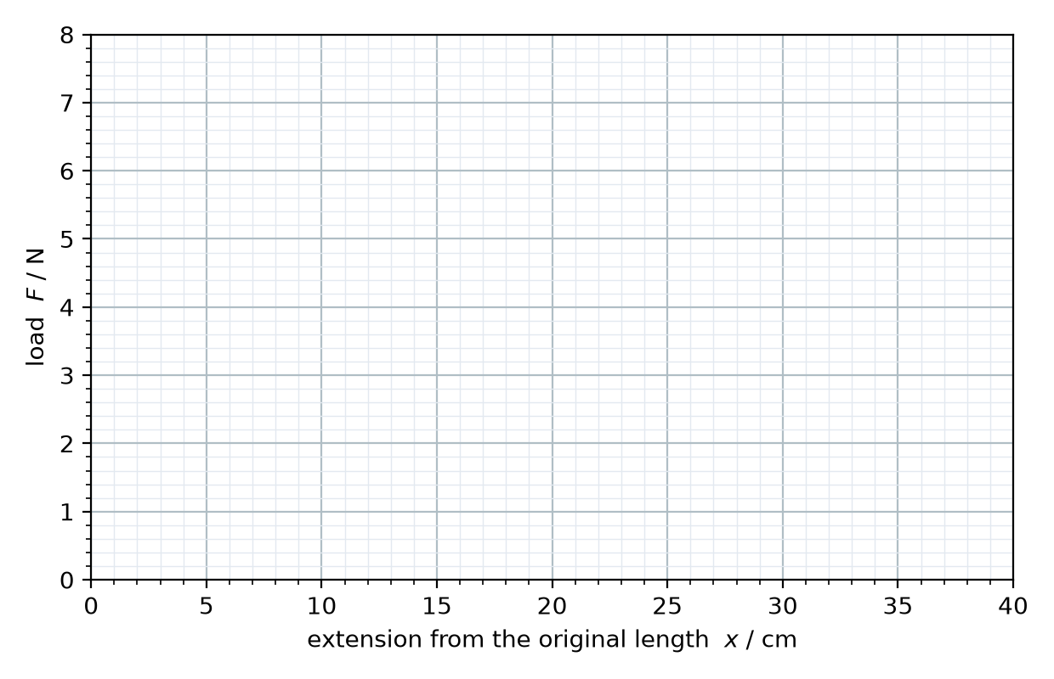
16. Read the permanent extension from your graph: __________ cm. Explain why the unloading line does not go back through the origin.
______________________________________________________________________________________
______________________________________________________________________________________
17. Spring: Rubber band. Load it to 500 g in 50 g steps, then unload to 0 g. Sketch the loop (no numbers needed). Use arrows for loading and unloading and shade the area that equals the energy turned into heat.
Sketch

18. From the readouts after the full cycle: energy stored = __________ J, energy given back = __________ J, so energy → heat = __________ J = __________ % of the energy stored.

19. This is called hysteresis. Explain why a rubber band that is stretched and released many times gets warm. Would you choose a material with a large or a small loop for the rubber mounts that stop a washing machine shaking? Why?
______________________________________________________________________________________
______________________________________________________________________________________
______________________________________________________________________________________

