Worksheet — Springs in Series and Parallel
Use with Simulation - Springs in series and parallel.html · extension of Hooke's law (beyond the IB SL guide)
Biljana Taneska · Physics teacher · btaneska@vis.ac.at

Name: ______________________________ Class: ________ Date: ______________
How to use this worksheet  Scan the QR code or open school.taneski.com/physics/dp/06-springs-series-parallel in a browser (offline: Simulation - Springs in series and parallel.html). Choose the arrangement and the two springs, add a load and press ● Record. The Tasks tab has the same four parts as this sheet.  Part 1 before the lab (≈ 15 min) · Part 2 during the lab with two school springs (≈ 10 min) · Part 3 homework (≈ 30 min) · Part 4 checkpoint: hysteresis and the elastic limit (≈ 15 min).  Use g = 9.81 N kg⁻¹. Effective spring constant k_{eff} = F/x, with x the total extension in metres. |   Scan to open

Part 1 — Pre-lab: predict, then test
Question | My prediction (before) | What the simulation showed | Physics explanation
1. Two identical springs in series carry the same load as one spring. Total extension?
2. The same two springs in parallel carry the same load. Extension?
3. In series with 200 g (1.96 N), what force acts in the top spring?
4. Soft (12 N m⁻¹) and stiff (40 N m⁻¹) springs in parallel share a load. Which pulls harder?

5. Show that for two springs in series 1/k_{eff} = 1/k_{A} + 1/k_{B}, and for two springs in parallel k_{eff} = k_{A} + k_{B}. (Hint: in series the force is the same; in parallel the extension is the same.)
Working

Part 2 — During the lab: two school springs
load / g | F / N | one spring x / cm | series x / cm | parallel x / cm
100
200
300

6. Plot all three sets on one graph and draw a best-fit line through the origin for each.
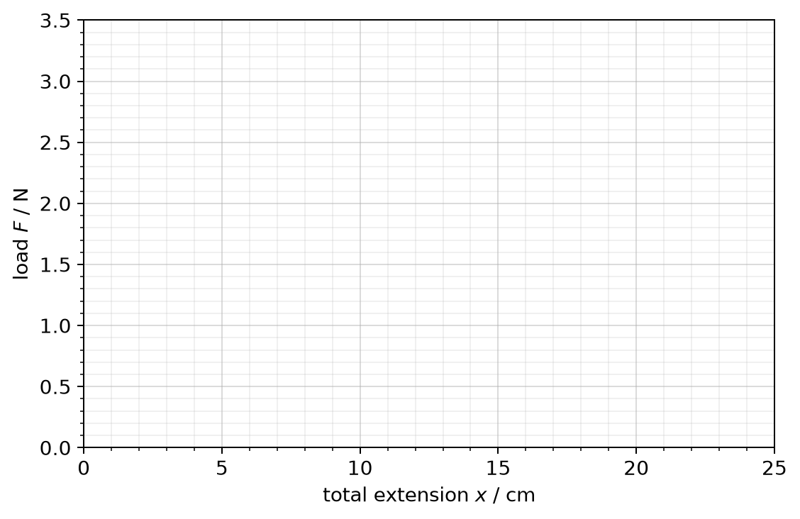
7. k (one spring) = ________ k (series) = ________ k (parallel) = ________ N m⁻¹. Which rule do your results support?
______________________________________________________________________________________
______________________________________________________________________________________

Part 3 — Homework
8. Soft (12 N m⁻¹) and stiff (40 N m⁻¹) springs in series: calculate k_{eff} and the total extension with 200 g hanging.
Working

9. The same springs in parallel with 200 g: calculate k_{eff}, the common extension and the force in each spring. Draw the free-body diagram of the load.
Working

10. A 1200 kg car rests on 4 identical springs, each compressed by 3.0 cm. Calculate the spring constant of one spring and the effective spring constant of all four together.
Working

11. A rubber band's F–x graph curves. Why can't you give it a single spring constant?
______________________________________________________________________________________
______________________________________________________________________________________
______________________________________________________________________________________

Part 4 — Checkpoint: hysteresis and the elastic limit
Simulation: arrangement Load & unload. Spring A: Steel — medium (investigation) (k = 25.0 N m⁻¹, elastic limit E at 6.0 N). Load it in steps up to 800 g, then unload. Record the extension readout x each time the load is at rest.
mass m / g | load F = mg / N | loading: x / cm | unloading: x / cm
0
200
400
600
700
800 |  |  | (turning point)

12. Plot the loading points and the unloading points on the grid and join each set. Mark the elastic limit E and label the loading and unloading lines with arrows.
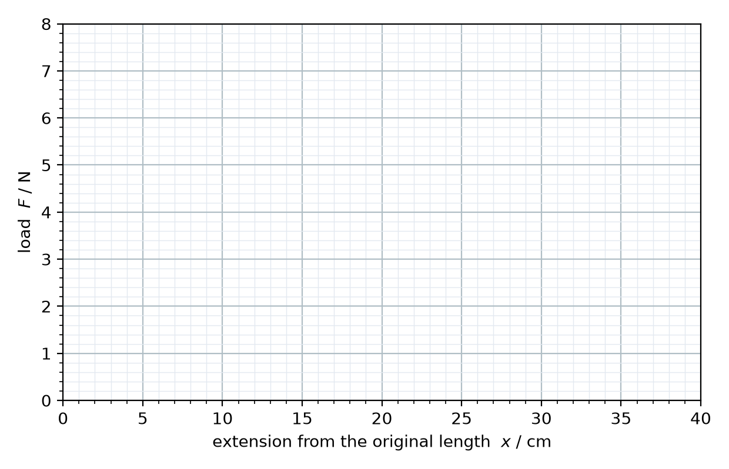
13. Read the permanent extension from your graph: __________ cm. Explain why the unloading line does not go back through the origin.
______________________________________________________________________________________
______________________________________________________________________________________
14. Spring A: Rubber band. Load it to 500 g in 50 g steps, then unload to 0 g. Sketch the loop (no numbers needed). Use arrows for loading and unloading and shade the area that equals the energy turned into heat.
Sketch

15. From the readouts after the full cycle: energy stored = __________ J, energy given back = __________ J, so energy → heat = __________ J = __________ % of the energy stored.

16. This is called hysteresis. Explain why a rubber band that is stretched and released many times gets warm. Would you choose a material with a large or a small loop for the rubber mounts that stop a washing machine shaking? Why?
______________________________________________________________________________________
______________________________________________________________________________________
______________________________________________________________________________________

