Worksheet — Pendulum Tension Simulation
Use with Simulation - Pendulum tension.html · tension, circular motion (Block 5) and energy (Block 10)
Biljana Taneska · Physics teacher · btaneska@vis.ac.at

Name: ______________________________ Class: ________ Date: ______________
How to use this worksheet  Scan the QR code or open school.taneski.com/physics/dp/09-pendulum-tension in a browser (offline: Simulation - Pendulum tension.html). Choose the object, its size, the string length and θ₀. ✋ Hold aside holds the bob still; ▶ Release lets it swing. The newton meter at the top shows the tension.  Part 1 before the lab (≈ 15 min) · Part 2 with a newton-meter pendulum (≈ 10 min) · Part 3 homework (≈ 30 min).  Use g = 9.81 N kg⁻¹. L is measured to the centre of the bob. |   Scan to open

Part 1 — Pre-lab: predict, then test
Question | My prediction (before) | What the simulation showed | Physics explanation
1. A 200 g mass is held still at 30° by a horizontal pull. Is T less than, equal to or more than mg?
2. Released from 30°: T at the bottom of the swing compared with mg?
3. Triple the string length, same 30° release. The peak tension?
4. Double the mass. Peak tension? Period?
5. Ping-pong ball or steel ball (same size): which keeps swinging longer?

6. Draw the free-body diagram of the 200 g mass held still at 30°, and calculate the tension and the hand's pull.
Free-body diagram and working

Part 2 — During the lab: newton-meter pendulum (200 g)
situation | sim T / N | our reading / N | theory
at rest |  |  | mg
held at 20° |  |  | mg / cos 20°
held at 40° |  |  | mg / cos 40°
bottom of a swing from 40° |  |  | mg(3 − 2 cos 40°)

7. Why is the peak tension of a swing so hard to read on a real newton meter? How could you measure it better?
______________________________________________________________________________________
______________________________________________________________________________________
______________________________________________________________________________________

Part 3 — Homework
8. Use energy and the circular-motion equation to show that the tension at the bottom of a swing from θ₀ is T = mg(3 − 2 cos θ₀). Why does it not depend on L?
Derivation

θ₀ / ° | 10 | 20 | 30 | 40 | 50 | 60 | 70
T_{max} / N
T_{max}/mg
1 − cos θ₀

9. Plot T_{max}/mg against (1 − cos θ₀). Gradient = ________ Intercept = ________
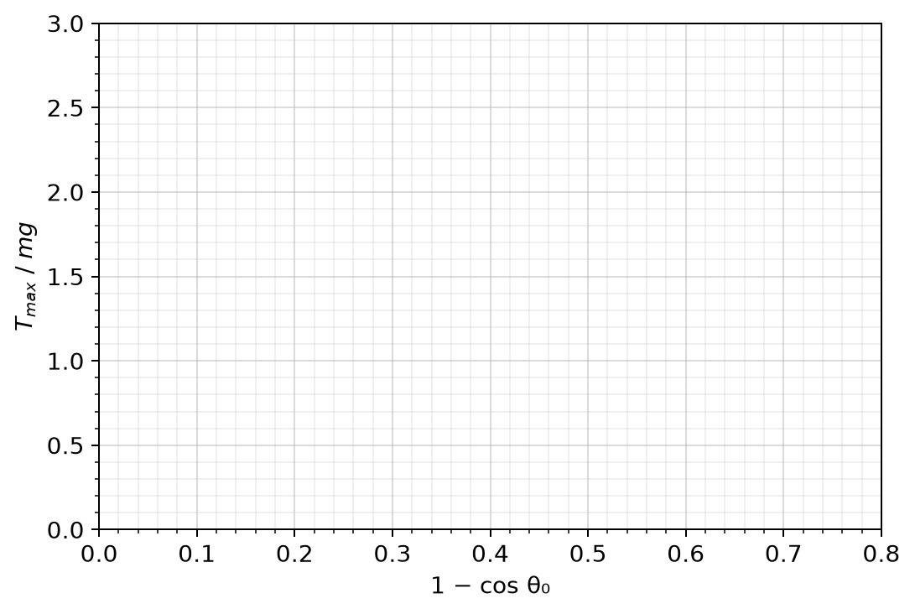
10. Block 10 pendulum: L = 1.0 m released from 25°. Calculate the speed at the bottom and the tension there for a 1.0 kg bob. Then calculate the period for small swings.
Working

11. Explain why the balloon pendulum stops after a few swings while the steel ball keeps going.
______________________________________________________________________________________
______________________________________________________________________________________
______________________________________________________________________________________

