Worksheet — Horizontal Launch Simulation
Use with Simulation - Horizontal launch.html · A.1 Kinematics: projectile launched horizontally, horizontal and vertical motion treated separately; goes with the ball-off-the-bench experiment (carbon paper)
Biljana Taneska · Physics teacher · btaneska@vis.ac.at

Name: ______________________________ Class: ________ Date: ______________
How to use this worksheet  Scan the QR code or open school.taneski.com/physics/dp/11-horizontal-launch in a browser (offline: Simulation - Horizontal launch.html). Set the height h and the launch speed u, then ▶ Launch. Ball B is dropped from the edge at the same moment. The strobe shows the ball every 0.1 s and the shadows split the motion into horizontal (floor) and vertical (wall) parts.  Part 1 before the lab (≈ 15 min) · Part 2 during the lab (≈ 15 min) · Part 3 homework (≈ 30 min).  Use g = 9.81 m s⁻². The two directions share only the time t: horizontal a_{x} = 0, x = ut; vertical a_{y} = −g, from v_{y} = 0. |   Scan to open

Part 1 — Pre-lab: predict, then test
Write your prediction before you run the simulation. Then test it and explain what you saw.
Question | My prediction (before) | What the simulation showed | Physics explanation
1. Ball A rolls off the edge at 2.0 m s⁻¹; ball B is dropped from the same height at the same moment. Which lands first?
2. The launch speed is doubled (same height). What happens to the time of flight and to the range?
3. What happens to the horizontal velocity v_{x} while the ball is in the air?
4. What shape is the path? Sketch it.

5. Your bench is 0.90 m high. Calculate the time of flight of a ball rolling off it. Then check with the simulation.
______________________________________________________________________________________
______________________________________________________________________________________
______________________________________________________________________________________
______________________________________________________________________________________
______________________________________________________________________________________

Part 2 — During the lab: compare with the experiment
Class experiment. Roll the ball down the ramp, off the bench, onto carbon paper. Measure the bench height h and the range R from the edge (use a plumb line) for 3 launches.
h / m | R₁ / m | R₂ / m | R₃ / m | mean R / m | t = √(2h/g) / s | u = R/t / m s⁻¹

Simulation. h = 0.90 m, u = 1.5 m s⁻¹, landing mark = carbon paper. Launch 3 times and ● Record.
h / m | R₁ / m | R₂ / m | R₃ / m | mean R / m
0.90

1. Mean range from the simulation: R = ________ m
2. A group measured R = 0.64 m from the 0.90 m bench. Calculate the launch speed of their ball.
______________________________________________________________________________________
______________________________________________________________________________________
______________________________________________________________________________________
______________________________________________________________________________________
3. Group 1's ball lands twice as far from the bench as group 2's (same bench). What can you conclude? Explain.
______________________________________________________________________________________
______________________________________________________________________________________
______________________________________________________________________________________
______________________________________________________________________________________
4. Give two sources of uncertainty in the class experiment and say how to reduce each.
______________________________________________________________________________________
______________________________________________________________________________________
______________________________________________________________________________________
______________________________________________________________________________________

Part 3 — Homework: analyse
h = 0.90 m, landing mark = carbon paper. Record one launch at each speed.
u / m s⁻¹ | R / m
0.5
1.0
1.5
2.0
2.5
3.0

1–2. Plot R (y-axis) against u (x-axis). Draw the best-fit line through the origin.
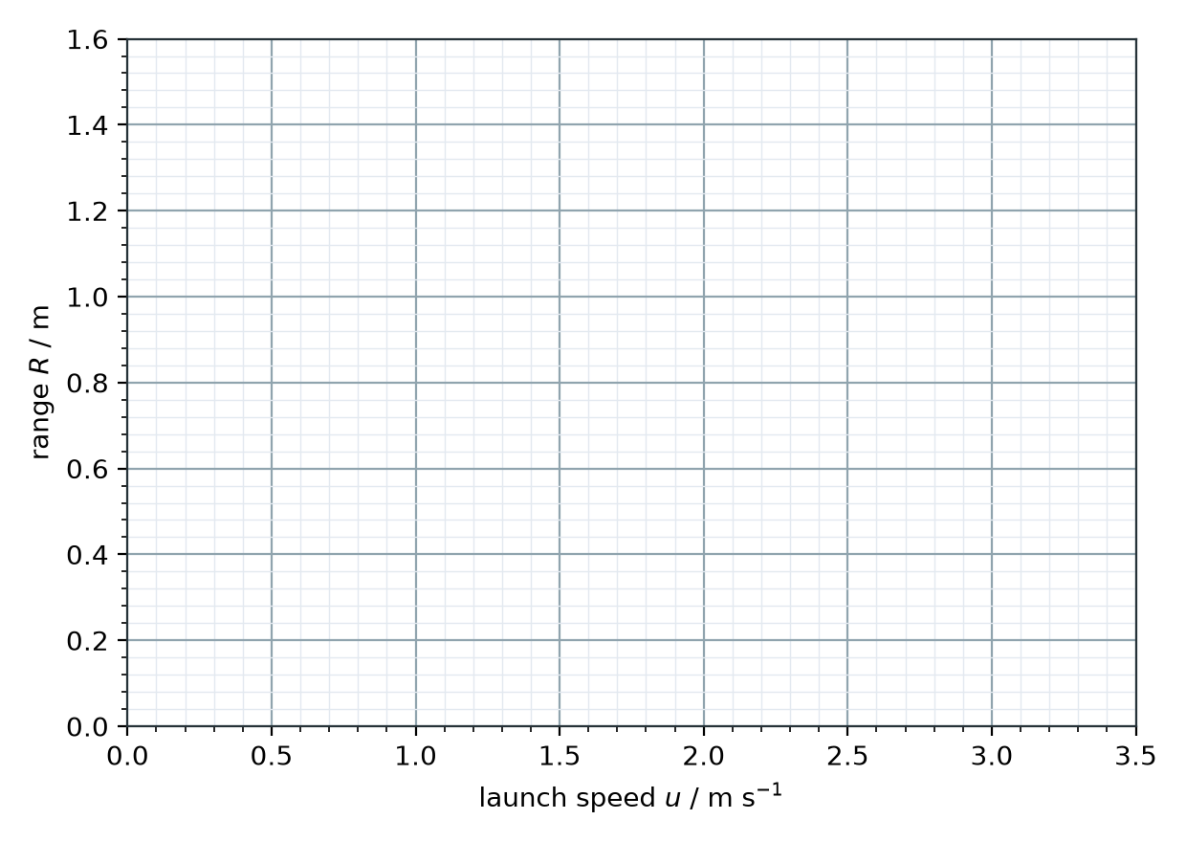
3. Gradient = ____________ s. What does the gradient represent? Use it to find g.
______________________________________________________________________________________
______________________________________________________________________________________
______________________________________________________________________________________
______________________________________________________________________________________
4. A ball rolls off a 1.20 m high table at 3.0 m s⁻¹. How far from the foot of the table does it land?
______________________________________________________________________________________
______________________________________________________________________________________
______________________________________________________________________________________
______________________________________________________________________________________
5. Calculate the speed of the ball just before it lands.
______________________________________________________________________________________
______________________________________________________________________________________
______________________________________________________________________________________
______________________________________________________________________________________
6. At what angle below the horizontal does it land? Draw the velocity triangle.
______________________________________________________________________________________
______________________________________________________________________________________
______________________________________________________________________________________
______________________________________________________________________________________
______________________________________________________________________________________
7. A stone is thrown horizontally from a 20 m high cliff and lands 30 m from the foot of the cliff. Calculate its launch speed.
______________________________________________________________________________________
______________________________________________________________________________________
______________________________________________________________________________________
______________________________________________________________________________________
8. The ball of Q4 is launched in the same way on the Moon (g = 1.62 m s⁻²). Calculate the range and compare.
______________________________________________________________________________________
______________________________________________________________________________________
______________________________________________________________________________________
______________________________________________________________________________________

