Worksheet — Angled Launch Simulation
Use with Simulation - Angled launch.html · A.1 Kinematics: projectile launched at an angle — components of u, maximum height, time of flight, range; goes with the launcher / water-jet range demo
Biljana Taneska · Physics teacher · btaneska@vis.ac.at

Name: ______________________________ Class: ________ Date: ______________
How to use this worksheet  Scan the QR code or open school.taneski.com/physics/dp/12-angled-launch in a browser (offline: Simulation - Angled launch.html). Set the speed u, the angle θ and the launch height h, then ▶ Launch. With Keep paths on, earlier launches stay on the screen so you can compare angles.  Part 1 before the lab (≈ 15 min) · Part 2 during the demo (≈ 15 min) · Part 3 homework (≈ 30 min).  Use g = 9.81 m s⁻². Resolve first: u_{x} = u cos θ, u_{y} = u sin θ. Then horizontal a_{x} = 0, vertical a_{y} = −g. |   Scan to open

Part 1 — Pre-lab: predict, then test
Write your prediction before you run the simulation. Then test it and explain what you saw.
Question | My prediction (before) | What the simulation showed | Physics explanation
1. Same speed, from the ground: which angle gives the longest range?
2. Compare 30° and 60° (same speed). How do the ranges compare?
3. What is the velocity of the ball at the highest point?
4. Which angle (15°, 45° or 75°) keeps the ball in the air longest?

5. Calculate the time of flight for u = 10 m s⁻¹ at 30° from the ground. Check with the simulation.
______________________________________________________________________________________
______________________________________________________________________________________
______________________________________________________________________________________
______________________________________________________________________________________
______________________________________________________________________________________
______________________________________________________________________________________

Part 2 — During the lab: the range demo
Demo. The launcher (or water jet) fires at the same speed at different angles; mark where it lands. Simulation: u = 6.0 m s⁻¹ from the ground, same angles, Keep paths on, ● Record each launch.
θ / ° | R (demo) / m | R (simulation) / m | difference / %
15
30
45
60
75

1. Range at 45° in the simulation (u = 6.0 m s⁻¹). Show the calculation.
______________________________________________________________________________________
______________________________________________________________________________________
______________________________________________________________________________________
______________________________________________________________________________________
2. Which pairs of angles land at the same place? Explain using R = u² sin 2θ / g.
______________________________________________________________________________________
______________________________________________________________________________________
______________________________________________________________________________________
______________________________________________________________________________________
3. In the demo the longest range was 3.0 m, at about 45°. Estimate the launch speed of the demo.
______________________________________________________________________________________
______________________________________________________________________________________
______________________________________________________________________________________
______________________________________________________________________________________
4. Why are the demo ranges a little shorter than the simulation, especially at steep angles? Give two reasons.
______________________________________________________________________________________
______________________________________________________________________________________
______________________________________________________________________________________
______________________________________________________________________________________

Part 3 — Homework: analyse
u = 10 m s⁻¹ from the ground. Record one launch at each angle.
θ / ° | 10 | 20 | 30 | 40 | 50 | 60 | 70 | 80
R / m

1. Plot R (y-axis) against θ (x-axis) and draw a smooth curve.
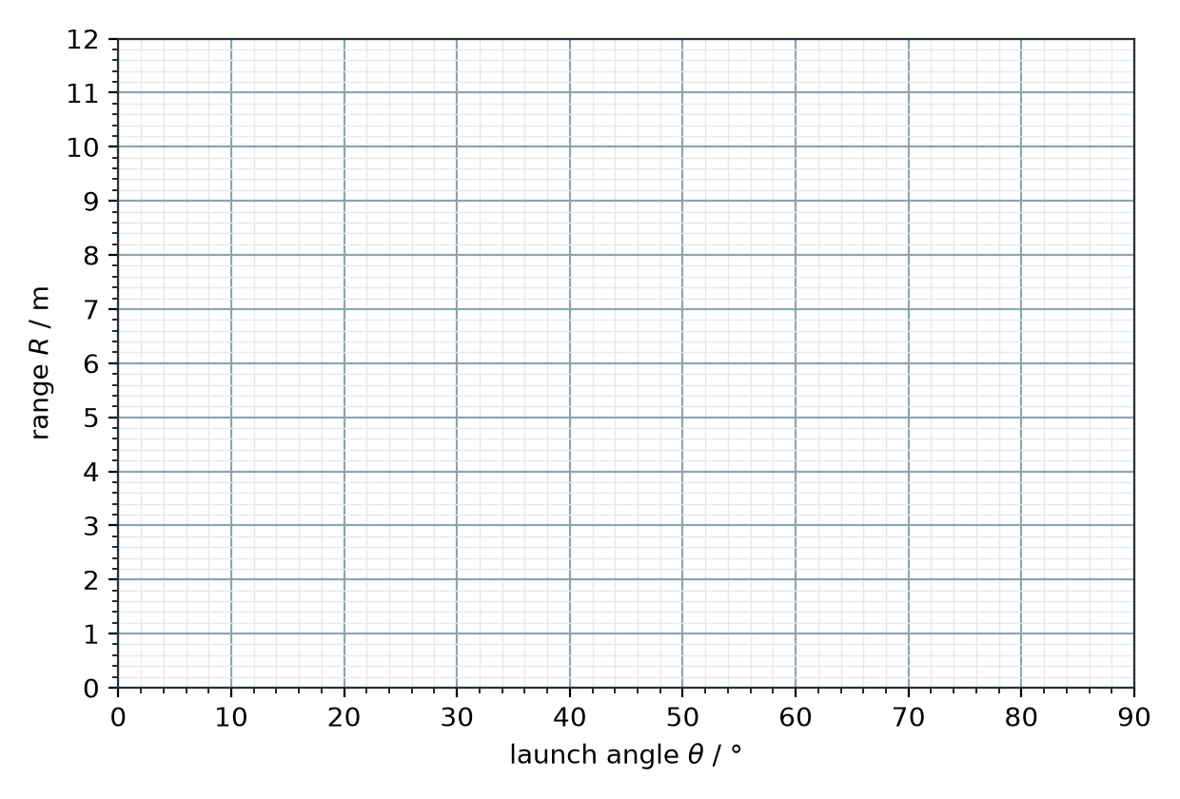
2. Maximum range from your graph: R = ________ m at θ = ________°
3. A football is kicked from the ground at 15 m s⁻¹, 35° above the horizontal. Calculate the maximum height.
______________________________________________________________________________________
______________________________________________________________________________________
______________________________________________________________________________________
______________________________________________________________________________________
4. Calculate the time of flight.
______________________________________________________________________________________
______________________________________________________________________________________
______________________________________________________________________________________
______________________________________________________________________________________
5. Calculate the range.
______________________________________________________________________________________
______________________________________________________________________________________
______________________________________________________________________________________
______________________________________________________________________________________
6. What is the speed of the ball at the highest point?
______________________________________________________________________________________
______________________________________________________________________________________
______________________________________________________________________________________
______________________________________________________________________________________
7. A stone is thrown from the top of a 20 m cliff at 12 m s⁻¹, 30° above the horizontal. How far from the foot of the cliff does it land?
______________________________________________________________________________________
______________________________________________________________________________________
______________________________________________________________________________________
______________________________________________________________________________________
______________________________________________________________________________________
8. From the top of the cliff, is the best angle for the longest range 45°, more or less? Explain.
______________________________________________________________________________________
______________________________________________________________________________________
______________________________________________________________________________________
______________________________________________________________________________________

