Worksheet — Velocity Components Simulation
Use with Simulation - Velocity components.html · A.1 Kinematics: velocity of a projectile — components, speed, direction, Δv = gΔt; goes with video (or strobe-photo) analysis of a thrown ball
Biljana Taneska · Physics teacher · btaneska@vis.ac.at

Name: ______________________________ Class: ________ Date: ______________
How to use this worksheet  Scan the QR code or open school.taneski.com/physics/dp/13-velocity-components in a browser (offline: Simulation - Velocity components.html). Set the launch, press ▶ Launch or set the time probe with ▼ ▲. The velocity diagram draws the velocities every 0.2 s from one point. ● Record reading saves the probe values.  Part 1 before the lab (≈ 15 min) · Part 2 during the video analysis (≈ 15 min) · Part 3 homework (≈ 30 min).  v_{x} = u cos θ (constant) · v_{y} = u sin θ − gt · v = √(v_{x}² + v_{y}²) · φ = tan⁻¹(v_{y}/v_{x}). Use g = 9.81 m s⁻², up positive. |   Scan to open

Part 1 — Pre-lab: predict, then test
u = 12 m s⁻¹ at 50° from the ground. Predict before you look, then test and explain.
Question | My prediction (before) | What the simulation showed | Physics explanation
1. Where on the path is the speed smallest? What is it there?
2. How does the velocity change from one 0.2 s vector to the next?
3. Landing speed and direction compared with the launch (same height)?
4. Is there a point where the acceleration is zero?

5. Calculate the speed of the ball at the top of its path.
______________________________________________________________________________________
______________________________________________________________________________________
______________________________________________________________________________________
______________________________________________________________________________________
______________________________________________________________________________________
______________________________________________________________________________________

Part 2 — During the lab: video analysis
Video. Film a thrown ball next to a metre rule (or use a strobe photo). Read its position every 0.10 s. Average velocity between two frames = Δ(position) ÷ Δt.
t / s | x / m | y / m | v_{x} = Δx/Δt / m s⁻¹ | v_{y} = Δy/Δt / m s⁻¹ | at t = … s (midpoint)

1. Simulation (12 m s⁻¹, 50°): record the positions at t = 0.40 s and 0.60 s. Calculate the average v_{y} between them.
______________________________________________________________________________________
______________________________________________________________________________________
______________________________________________________________________________________
______________________________________________________________________________________
2. At which time does the simulation's v_{y} equal your answer to Q1? Why that time?
______________________________________________________________________________________
______________________________________________________________________________________
______________________________________________________________________________________
______________________________________________________________________________________
3. Record v_{y} every 0.2 s and fit a line on the Data tab. g = ________ m s⁻²
4. g from your video: ________ m s⁻². Give one reason the two values differ.
______________________________________________________________________________________
______________________________________________________________________________________
______________________________________________________________________________________
______________________________________________________________________________________

Part 3 — Homework: analyse
Simulation, 12 m s⁻¹ at 50°: record v_{y} at each time.
t / s | 0.0 | 0.2 | 0.4 | 0.6 | 0.8 | 1.0 | 1.2 | 1.4 | 1.6 | 1.8
v_{y} / m s⁻¹

1. Plot v_{y} against t and draw the best-fit line. Gradient = ________ ; intercept = ________ . What do they represent?
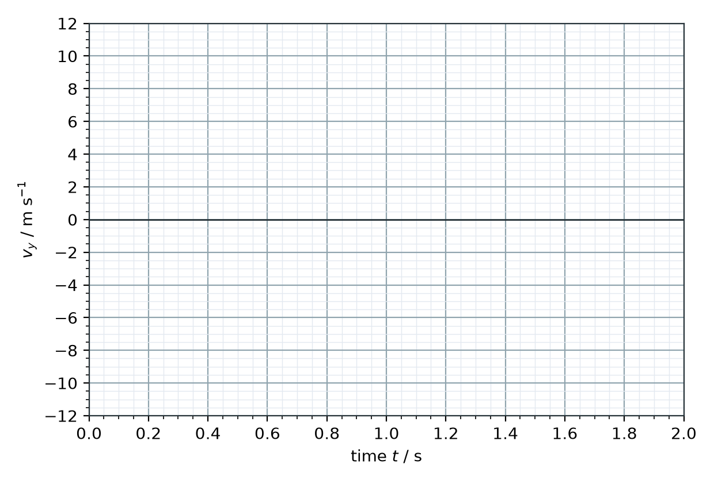
______________________________________________________________________________________
______________________________________________________________________________________
2. A ball is thrown from the ground at 20 m s⁻¹, 60° above the horizontal. Calculate its speed 1.5 s after the throw.
______________________________________________________________________________________
______________________________________________________________________________________
______________________________________________________________________________________
______________________________________________________________________________________
3. At what angle to the horizontal is it moving at that moment? Draw the velocity triangle.
______________________________________________________________________________________
______________________________________________________________________________________
______________________________________________________________________________________
______________________________________________________________________________________
______________________________________________________________________________________
4. At what time is the ball moving at 45° below the horizontal?
______________________________________________________________________________________
______________________________________________________________________________________
______________________________________________________________________________________
______________________________________________________________________________________
5. What is the speed of the ball when it is 10 m above the ground?
______________________________________________________________________________________
______________________________________________________________________________________
______________________________________________________________________________________
______________________________________________________________________________________
6. Ball P is thrown at 20 m s⁻¹ at 30°, ball Q at 20 m s⁻¹ at 70°. When each is 5 m above the launch point, which is faster? Explain.
______________________________________________________________________________________
______________________________________________________________________________________
______________________________________________________________________________________
______________________________________________________________________________________
______________________________________________________________________________________

