Worksheet — Air Resistance Simulation
Use with Simulation - Air resistance.html · A.1 Kinematics: qualitative effect of air resistance on a projectile (drag F_{d} = ½ρC_{d}Av²); goes with throwing / filming a ping-pong ball or shuttlecock beside a tennis ball
Biljana Taneska · Physics teacher · btaneska@vis.ac.at

Name: ______________________________ Class: ________ Date: ______________
How to use this worksheet  Scan the QR code or open school.taneski.com/physics/dp/15-air-resistance in a browser (offline: Simulation - Air resistance.html). Choose an object, the speed and the angle, then ▶ Launch. The solid path has air resistance; the dashed path is the same launch in a vacuum.  Part 1 before the lab (≈ 15 min) · Part 2 during the lab (≈ 15 min) · Part 3 homework (≈ 30 min).  Drag always points opposite to the velocity and grows with v². At SL you must describe its effects; the numbers help you see them. |   Scan to open

Part 1 — Pre-lab: predict, then test
Tennis ball, 25 m s⁻¹ at 45°. Predict before you launch, then test and explain.
Question | My prediction (before) | What the simulation showed | Physics explanation
1. How does the real path differ from the vacuum path? Sketch both.
2. On the way up, is the acceleration smaller than, equal to or larger than g?
3. Which takes longer: going up or coming down?
4. In which direction does the drag act at the top of the path?

5. Calculate the range in a vacuum for 25 m s⁻¹ at 45°. By what percentage is the real range shorter?
______________________________________________________________________________________
______________________________________________________________________________________
______________________________________________________________________________________
______________________________________________________________________________________
______________________________________________________________________________________
______________________________________________________________________________________

Part 2 — During the lab: light and heavy balls
Class. Throw a ping-pong ball (or shuttlecock) and a tennis ball at about the same speed and angle; film them if you can. Simulation: 10 m s⁻¹ at 45° for both.
 | ping-pong ball | tennis ball | vacuum
range R / m
max height H / m
landing angle (steep / similar)
terminal speed v_{t} / m s⁻¹ |  |  | —

1. Describe the shape of the ping-pong ball's path. How is it different from the tennis ball's?
______________________________________________________________________________________
______________________________________________________________________________________
______________________________________________________________________________________
______________________________________________________________________________________
2. Explain why the ping-pong ball is affected much more. Use F_{d}/m.
______________________________________________________________________________________
______________________________________________________________________________________
______________________________________________________________________________________
______________________________________________________________________________________
3. Sketch the path of a shuttlecock from the class (or video) and compare with the simulation.
Sketch

Part 3 — Homework: analyse
Tennis ball, 25 m s⁻¹. Record each angle and copy both ranges.
θ / ° | 20 | 30 | 35 | 40 | 45 | 50 | 60
R with air / m
R vacuum / m

1. Plot both ranges against θ on the same axes.
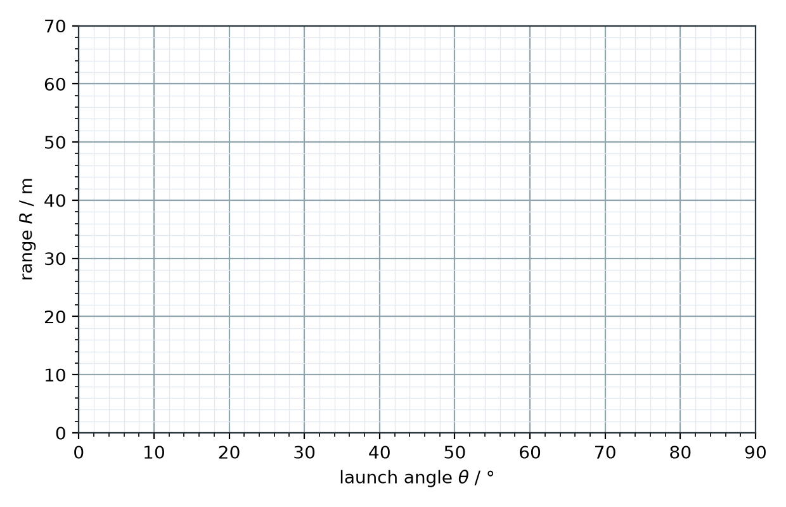
2. At what angle is the range with air largest? Why is it less than 45°?
______________________________________________________________________________________
______________________________________________________________________________________
______________________________________________________________________________________
______________________________________________________________________________________
3. Use mg = ½ρC_{d}Av_{t}² to calculate the terminal speed of a ping-pong ball (m = 2.7 g, d = 40 mm, C_{d} = 0.47, ρ = 1.20 kg m⁻³).
______________________________________________________________________________________
______________________________________________________________________________________
______________________________________________________________________________________
______________________________________________________________________________________
______________________________________________________________________________________
4. Calculate the drag force on a tennis ball (m = 58 g, d = 67 mm, C_{d} = 0.55) at 25 m s⁻¹ and compare it with its weight.
______________________________________________________________________________________
______________________________________________________________________________________
______________________________________________________________________________________
______________________________________________________________________________________
______________________________________________________________________________________
5. For which object is the vacuum model best: ping-pong ball, shuttlecock, tennis ball or steel ball? Explain.
______________________________________________________________________________________
______________________________________________________________________________________
______________________________________________________________________________________
______________________________________________________________________________________

