Worksheet — Impulse Simulation
Use with Simulation - Impulse.html · momentum and impulse (Block 6): Smart Cart and force sensor, egg into a sheet, ball, racket and club
Biljana Taneska · Physics teacher · btaneska@vis.ac.at

Name: ______________________________ Class: ________ Date: _______________
How to use this worksheet  Scan the QR code or open school.taneski.com/physics/dp/17-impulse in a browser (offline: Simulation - Impulse.html). Choose an example at the top: Cart + force sensor · Egg into a sheet · Ball, racket, club. Set values with ▼ ▲, or type a value in the box.  Choose the positive direction (+ → right or + ← left) in the controls: every velocity, momentum, force and impulse takes its sign from it. The contact plays in slow motion; ◂ / ▸ step through it. On the F–t graph the Area tool gives the impulse; tick Zoom on the contact.  Part 1 before the lab (≈ 15 min) · Part 2 during the lab (≈ 20 min) · Part 3 homework (≈ 30 min). The Tasks tab has the same three parts. Use p = mv, J = FΔt = Δp. Give answers to 3 significant figures with units. |   Scan to open

Part 1 — Pre-lab: predict, then test
Question | My prediction (before) | What the simulation showed | Physics explanation
1. 🛒 Cart, 0.500 kg at 0.62 m s⁻¹. Magnetic bumper instead of spring bumper: is the peak force larger, smaller or the same?
2. Is the impulse (area under F–t) for the magnetic bumper much larger, much smaller or about the same?
3. With clay on the bumper the cart stops at the sensor. Its impulse is about × ____ the spring bumper's.
4. 🥚 An egg is thrown at 10 m s⁻¹ into a brick wall or into a loosely held bedsheet. Which is the same: Δp, Δt or F? Which is different?

5. 🛒 Spring bumper: the cart (0.500 kg) arrives at +0.62 m s⁻¹ and leaves at −0.496 m s⁻¹ (+ is to the right). Calculate the change in momentum Δp, with its sign. Then check the readouts.
Working

6. 🥚 Calculate the average force of the sheet on a 60 g egg that arrives at 10 m s⁻¹ and is stopped in 0.10 s.
Working

7. Sketch, on the same axes, the force–time graphs you expect for the spring bumper and for the magnetic bumper. Label the peak forces and contact times you read from the simulation. Shade the impulse of one of them.
Sketch: force F / N against time t / s

Part 2 — During the lab
A · Smart Cart and force sensor (PASCO demo). Simulation: 🛒 Cart, m = 0.500 kg, u = 0.62 m s⁻¹, + → right. For each bumper press ▶ Start, tick Zoom and Area on the F–t graph, step to the end of the contact and press ● Record. Write the class Capstone values in the last column.
bumper | contact time Δt / s | peak force / N | impulse J (area) / N s | v after / m s⁻¹ | Δp = m(v − u) / N s | class Capstone J / N s
spring
magnetic
clay

8. Compare the impulse J with Δp for each bumper. What do you notice? Calculate the percentage difference between the simulation and the class value for the spring bumper.
______________________________________________________________________________________
______________________________________________________________________________________
______________________________________________________________________________________
9. Explain why the impulse with clay is only about half of the impulse with the spring bumper, although the peak forces are similar.
______________________________________________________________________________________
______________________________________________________________________________________
______________________________________________________________________________________
B · Faster carts. Spring bumper, m = 0.500 kg. Record the peak force at each speed.
u / m s⁻¹ | 0.31 | 0.62 | 0.93 | 1.24
peak force / N
contact time Δt / s

10. Describe how the peak force and the contact time depend on the speed. Use the Data tab (F_{peak}–u) to support your answer.
______________________________________________________________________________________
______________________________________________________________________________________
______________________________________________________________________________________

Part 3 — Homework
11. 🏌️ (slide 5) A golf club hits a 0.046 kg ball at rest. The force rises steadily to 800 N and falls back to zero; the contact lasts 6.0 ms (a triangle on the F–t graph). Calculate the impulse and the speed of the ball. Check: Ball → Golf ball + club.
Working

12. 🎾 (slide 8) A 0.058 kg tennis ball arrives at 20 m s⁻¹ and leaves at 30 m s⁻¹ in the opposite direction; contact 5.0 ms. Take + as the outgoing direction. Calculate Δp and the average force of the racket on the ball.
Working

13. A 0.40 kg ball hits a wall at 10 m s⁻¹ and rebounds at 8.0 m s⁻¹; contact 0.050 s. Calculate the size of the average force. Why is it larger than if the ball had stopped dead?
Working

14. 🥚 Egg, 60 g at 10 m s⁻¹. Type each stopping time into the Δt box and record the average force (Data tab).
Δt / ms | 2 | 5 | 10 | 20 | 50 | 100
1/Δt / s⁻¹
average force / N
egg cracks? (peak > 25 N)

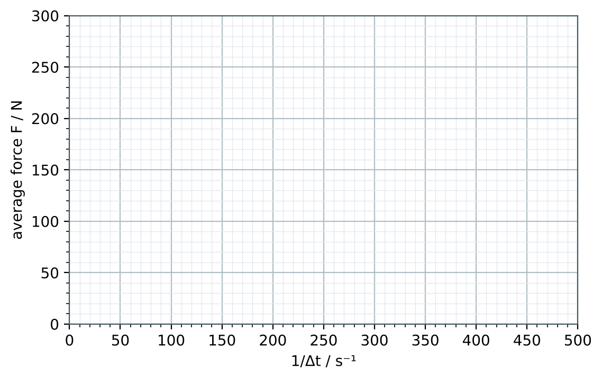
Plot the average force against 1/Δt, draw the best-fit line through the origin and find its gradient. Gradient = __________ . What does it represent?
15. In this model the peak force is π/2 × the average force. Calculate the shortest stopping time for which the egg survives (peak force below 25 N). Check your answer in the simulation.
Working

16. Use the idea of impulse to explain how a car's crumple zone and airbag protect the driver.
______________________________________________________________________________________
______________________________________________________________________________________
______________________________________________________________________________________
______________________________________________________________________________________

