Worksheet — Work Done Simulation
Use with Simulation - Work done.html · work done by a force, area under F–s graphs and the work–energy principle (Block 9)
Biljana Taneska · Physics teacher · btaneska@vis.ac.at

Name: ______________________________ Class: ________ Date: _______________
How to use this worksheet  Scan the QR code or open school.taneski.com/physics/dp/19-work-done/ in a browser (offline: Simulation - Work done.html). Choose the example at the top: Angled pull · Lift vs ramp · Smart Cart · Braking. Pick a preset in Example or set the values yourself: set a value with ▼ ▲ or type it in the box.  Press ▶ Start; ◂ / ▸ step through the motion. The middle column shows the free-body diagram and the work done by each force (or a Sankey diagram). On an F–s graph tick Area: the area is the work done.  Part 1 before the lab (≈ 15 min) · Part 2 during the lab (≈ 20 min) · Part 3 homework (≈ 30 min). The Tasks tab has the same three parts. W = Fs cos θ · W_{net} = ΔE_{k} · E_{k} = ½mv². g = 9.81 N kg⁻¹. Answers to 3 s.f. with units. | Scan to open

Part 1 — Pre-lab: predict, then test
Question | My prediction (before) | What the simulation showed | Physics explanation
1. 📐 A 5.0 N pull moves a box 1.0 m. The newton meter is at 0°, 30° or 60°. Which angle does the most work on the box?
2. ⛰️ Lift 1.0 kg up 0.30 m, or push it up a smooth 1.0 m ramp to the same height. Which needs more work? Which needs more force?
3. You carry a bag horizontally at constant velocity. Is the work done by your upward force positive, negative or zero?
4. 🚗 A car brakes with the same force from 20 m s⁻¹ and from 40 m s⁻¹. How many times longer is the braking distance at 40 m s⁻¹?
5. An elastic band is stretched twice as far, so its pull doubles too. How much more work does it do on a toy car?

6. Calculate the work done by the 5.0 N pull at 60° over 1.0 m. Check: Angled pull → Example → Hook demo: 5.0 N at 60°.
Working

7. Calculate the force needed to push the 1.0 kg box up the smooth 1.0 m ramp (height 0.30 m) at constant speed, and the work done. Compare with lifting it straight up. Check: Lift vs ramp → Hook demo presets.
Working

8. (slide 8) A 1000 kg car at 20 m s⁻¹ brakes with a force of 8000 N. Use the work–energy principle to calculate the braking distance.
Working

Part 2 — During the lab
Hook demo: pull at an angle. Simulation: Angled pull → Hook demo 0°, 30°, 60° (1.0 kg box, μ = 0.30, 5.0 N over 1.0 m). Press ▶ Start, step to the end and copy the values from the middle column and the readouts. Write the newton-meter readings from the bench in the grey column.
angle θ | newton meter (bench) / N | F cos θ / N | F_{N} / N | F_{f} / N | W by F / J | W by friction / J | W_{net} / J | E_{k} / J
0°
30°
60°

9. Why is the friction force smaller at 30° than at 0°? Why does the box still gain less kinetic energy at 60° than at 30°?
__________________________________________________________________________________________________
__________________________________________________________________________________________________
__________________________________________________________________________________________________
__________________________________________________________________________________________________
PASCO Smart Cart demo (lab 07). Simulation: Smart Cart → Class demo. Press ▶ Start; on the F–s graph tick Area and step to 0.60 m. The grey row has the class data (Capstone sample).
run | area under F–s, 0–0.60 m / J | E_{k} at 0.60 m / J | v at 0.60 m / m s⁻¹ | difference / J | difference / %
simulation
class data | 0.475 | 0.444 | 1.33

10. The kinetic energy is a little smaller than the work done by the pull. Explain why, and estimate the average friction force on the cart from the difference.
Working

11. Hook demo 3 (elastic band): use the two 'Elastic band' presets. Read the area under F–s for each and explain why doubling the stretch gives four times the work.
Working

Part 3 — Homework
12. (exit question) A 40 N force at 60° above the horizontal pulls a sled 5.0 m. Calculate the work done by the force.
Working

13. (exit question) 16 J of net work is done on a 2.0 kg trolley at rest. Calculate its final speed.
Working

14. (concept check) A box slides 2.0 m while a 5.0 N friction force acts on it. Calculate the work done by friction, with its sign.
Working

15. The slide 8 car (1000 kg) brakes from 40 m s⁻¹ with the same 8000 N. Calculate the braking distance and compare it with question 8.
Working

16. A 1200 kg car must stop from 25 m s⁻¹ within 50 m. Calculate the smallest braking force needed.
Working

17. Record the slide 8 car (1000 kg, 8000 N) at speeds from 10 to 40 m s⁻¹ (Braking → set u, ● Record). Complete the table, plot s against u² and draw the best-fit line.
u / m s⁻¹ | 10 | 15 | 20 | 25 | 30 | 35 | 40
u² / m² s⁻²
s / m

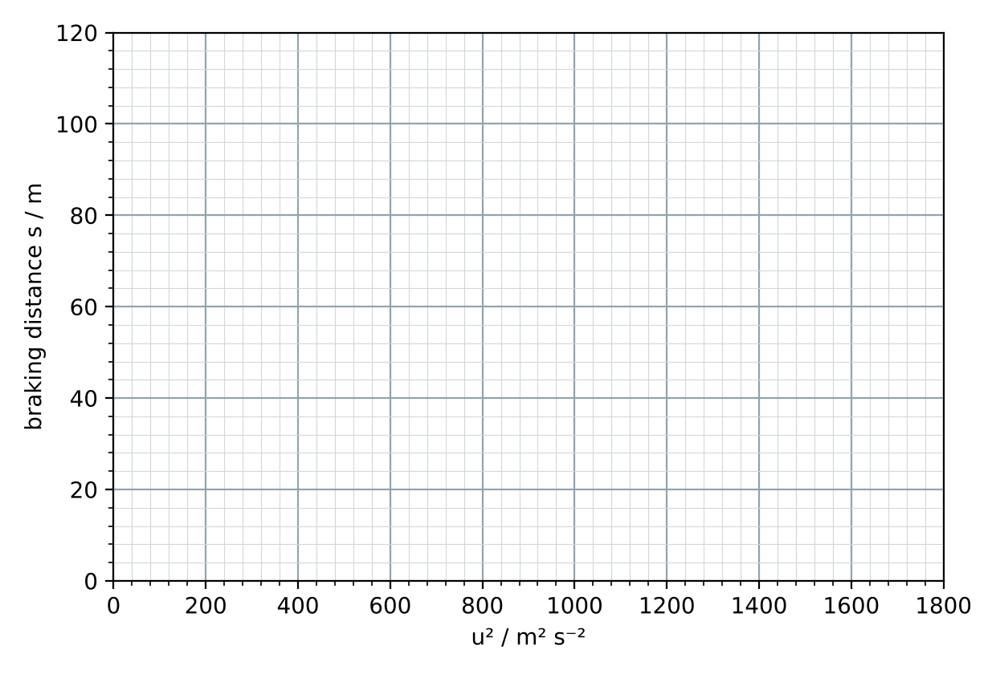
Gradient = ______________ . Show that the gradient equals m/(2F_{b}).
Working

18. Elastic band, stretch 2: the force rises steadily from 0.20 N to 2.0 N over 0.60 m. Sketch the F–s graph and calculate the work done. Check with the Area tool.
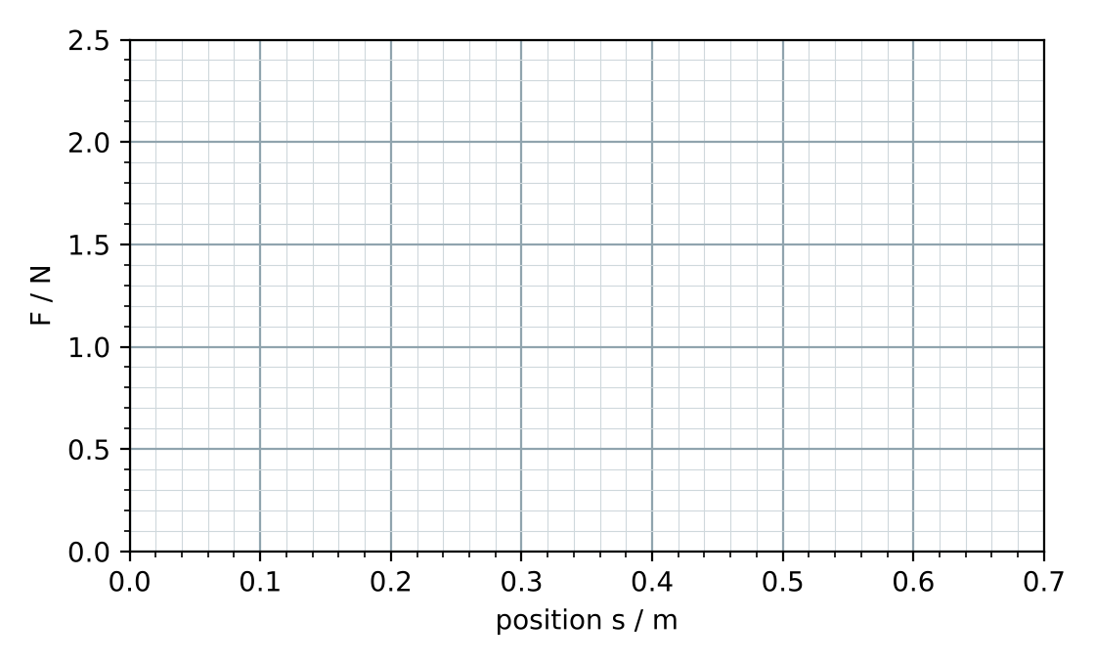
Working

19. (loading ramp) Explain why the normal force does no work on a box pushed up a ramp, and why a rough ramp needs more work than lifting the box straight up.
__________________________________________________________________________________________________
__________________________________________________________________________________________________
__________________________________________________________________________________________________

